

CSC375: Database Management Systems

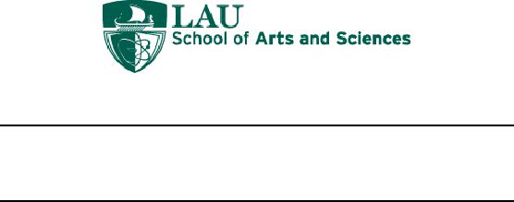

Database Design for ITS Zoological Park





By

Charbel Hbayter Ahmad Ismail

Ahmad Onaissi Rozette Hesse

Submitted on 13/11/2019

# **Table of Contents**

1. Introduction..........................................................................................................3
2. ER-Diagram.........................................................................................................5
3. Entity Types.........................................................................................................6
4. Relationships......................................................................................................15
5. ER to Relational Mapping Algorithm................................................................21
   1. Step 1: Mapping of Strong Entities………...……………………..……21
   2. Step 2: Mapping of Weak Entities…………….……………………….24
   3. Step 3: Mapping of Binary 1:1 Relationship Types……………………25
   4. Step 4: Mapping of Binary 1:N Relationship Types...…………………26
   5. Step 5: Mapping of Binary M:N Relationship Types………………….28
   6. Step 6: Mapping of Multivalued Attributes……………………………29
6. Table Structures…………………….…………………………………………32
7. Table Description……………….…………………………………………….39
8. Data Insertion with final state…………………………………………………46
9. Queries Executed…………………………………………………………...…70
10. Normalization…………………………………………………………………81
11. **Introduction**

        Houses are to people as zoological parks are to animals. As part of “Age of Enlightenment” period during the 18th century of the European history, zoos started to reflect on the habitants of animals in favor of allowing scientists to study their behavior and anatomy. Today, Zoos are meant to entertain and educate the public but have a strong emphasis on scientific research and species conservation as well. From so, it is evident that such parks represent a residence to a variety of animals that are native to all parts of the Earth. Captive breeding of endangered species makes zoos valuable places for animal survival. Thus, it is the Zoos’ responsibility to monitor and make sure the animals are safely protected, guarded, and treated well. Animals that live under the same conditions are places near each other. Animals that occupy habitants with old climates are placed in a specific location. The species of animals vary from the most common mammals such as Bears to the rarest like a White Alligator.

Rotation exhibits are in the works at zoos recently. Rotational Exhibit Lebanon ITS is a new zoological park in Lebanon that provides its visitors with a well-organized and entertaining experience. As well, it provides its animals with environments that in turn enhance animal well-being by promoting activity and curiosity, resulting in improved physical and mental fitness.

ITS has a one of kind structure bringing together all sorts of animals to the public eyes such as TheBirdWorld, ReptileWorld, AmphibianWorld, MammalWorld, ArthropodWorld, MarineLife and a park including all the fun activities for the little ones. Not only does it include those mini-worlds, but also a medical center whereby animals records are detected, analyzed, and so some medicals needs are prescribed.

For the Zoo to function properly, equipment is needed to maintain every suitable condition for the various habitants. Shoveling, watering, constant filtering, cleaning, the Zoo is an around the clock working station where no shortage is at chance of occurring. Most importantly is the idea of feeding the animals as it is a crucial part for maintaining their nutritional needs.

Like every institution, such a park depends on its employees, keepers, equipment, and founders. Employees play a vital role in keeping the Zoo up and running with providing constant handling to any problem it may face from food shortage to animal transport to and from the medical center. Zookeeper department has been set in order to facilitate paper works. It includes event managers, employee recruiters, invoices for equipment gathering, and a financial analyst. Other employees in the business department, handle transactions processed with the help of financial accountants and auditors which links them to the zookeeper department using M:N relationship.

ITS is a mini-world of the world itself, we can even refer to it as the UoD our universe of discourse, built to last in favor of making sure our animals are safe for extinction crisis, our scientists enhance research developments, and our young generation become familiar with zoology.

It is evident to note that the founders of ITS are passionate about zoology and so decided to use their degrees in computer science and bioinformatics to improve the state of the park and keep it in the advanced state. Rozette Hesse monitors the medical center and takes care of the animal’s well-being in the time where founder Ahmad Ismail takes care of every animal’s habitat and the exhibit paths that each animal needs because of his passion and knowledge of zoology along with the software engineering he applies to enhance efficiency. Charbel Hbayter, who is the most active socially tends to provide ITS with the best sources of food supplies and ensures the quality of the food chain and the equipment needed. Ahmad Kevin Onaissi, also known to be the scuba-diver of ITS takes care of all the marine animals and introduces all the visitors about ITS’s MarineOcean.

Together, the founders, along with the faculty members, ITS promises to provide development, life, and continuity not only in ITS but also all around the world.

1. **ER Diagram for ITS’s Intergalactic Zoological Park**

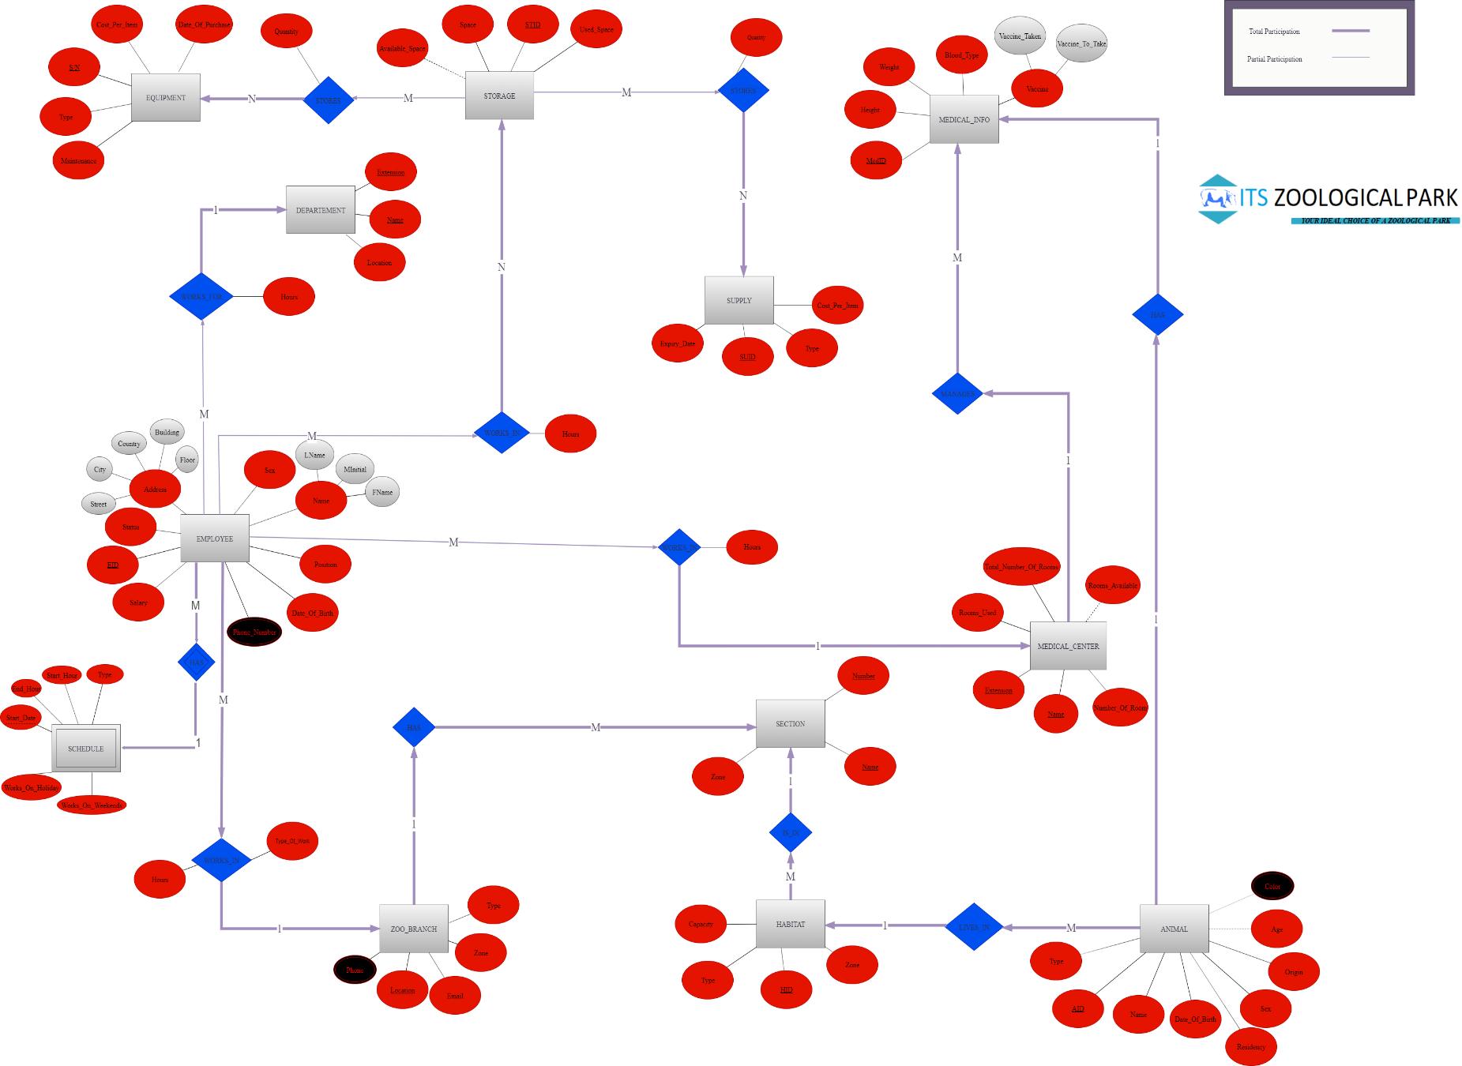

1. **Entity Types**

In this segment, we will begin by describing what each entity presents in the ER Diagram:

**ANIMAL**

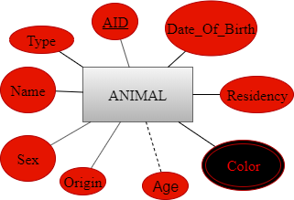

As all people know, animals are the primary elements of any zoo ever existed. Our animals are our top priority in terms of care, feeding, etc. Our “ANIMAL” entity is a strong entity that shows what variety of animals ITS provides from different parts all over the globe.

The attributes of the animal entity are:

* **AID (Animal ID):** It is the key attribute; each animal has its own unique ID which differentiates it from any other animal in the zoo.
* **Date_Of_Birth:** Demonstrates the date of birth of the animal.
* **Residency:** Since we have a wide variety of animals, each specific animal should be placed in a certain residence that makes it feel comfortable and not get it into violent contact with bigger/smaller animals.
* **Color:** A multivalued attribute that represents the color(s) of an animal.
* **Age:** A derived attribute from “**Date_Of_Birth”** that represents the current age of an animal (Updated continuously).
* **Origin:** Representsthe nationality of the animals (where they originated from).
* **Sex:** Represents whether the animals are males or females.
* **Name:** Demonstrates the animal’s name.
* **Type:** As we said, we have a wide collection of animals, all of which we monitor what species they are (Ex: Alligators, Fish, Sharks…).

**EMPLOYEE**

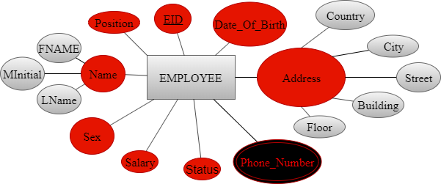

Every working place should have a lot of employees working, whether they were Full-Timers or Part-Timers. Whatever type of employees they were, ITS maintains a record for each and every single one of them that is used for mailing or visits. Thus, this is a strong entity that represents all the information related to our employees.

The entity has attributes as follows:

* **EID** **(Employee ID):** This is the key attribute. Each employee has a unique ID to him.
* **Date_Of_Birth:** Demonstratesthe birthday of the employee.
* **Address:** It is a composite attribute formed of five sub-attributes (Country, Building, Floor, City, and Street) that states where an employee is living (Used for mailing/vists).
* **Phone_Number:** Every employee may or may not have more than one phone number, which is why this attribute is multivalued, and all of which is monitored by our IT department.
* **Status:** It indicates whether the employee is single or married.
* **Salary:** Statesthe amount of money the employee is being paid.
* **Sex**: Represents whether the employees are males or females.
* **Name:** It is a composite attribute formed of three sub-attributes (Fname, MInitial, LName) which states the employees’ full name.
* **Position:** This attribute demonstrates the job title of an employee. (Ex: Finance Manager/Director, Veterinarian …)

**ZOO_BRANCHES**

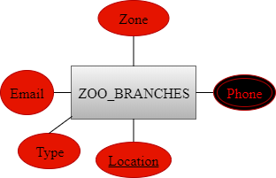

ITS has a lot of branches as we are internationally located; this strong entity is what makes our customers find us easily.

The attributes of the zoo entity are:

* **Location:** It is the key attribute that indicates where the zoo’s site is held.
* **Phone:** Since we are multi-branched, our “Phone” attribute is multi-valued.
* **Zone:** It illustrates the overall region of the zoo in square meters.
* **Email:** It represents the email which the customers can refer to in order to contact the zoo.
* **Type**: For our customers to know what specific branch to head to; our branches are set to be either closed (people walking around while the animals are locked in) or enclosed (people are locked in while the animals are set free in their habitats).

**HABITAT**

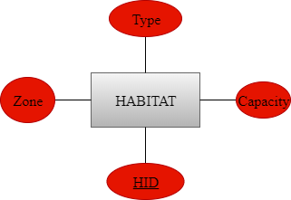

As we have stated earlier, animals are our top priority. In other words, we couldn’t care more about placing the animals as long as comfort is concerned. This strong entity represents where each animal is located.

This entity has the following attributes:

* **HID (Habitat ID)**: Each habitat has a unique ID that differentiates it from other habitats.
* **Capacity:** Exhibits what number of creatures of a particular sort can a habitat support.
* **Type:** It speaks to the kind of the regular environment (Lake, Wildlife, …).
* **Zone:** Illustrates the overall region of the habitat in m2.

**SECTION**

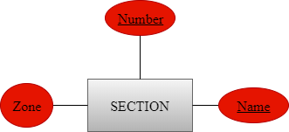

Taking a peak inside ITS, we have a lot of different sections that makes our park unique in its own way. This strong entity has 6 sections where each section indicates what it beholds.

It has the following attributes:

* **Number**: It is a key attribute that represents the section’s number
* **Name:** It is a key attribute that specifies the section’s name.

|  |  |
| --- | --- |
| **Section Number** | **Section Name** |
| 1 | Birds World |
| 2 | Reptiles World |
| 3 | Arthropods World |
| 4 | Mammals World |
| 5 | Marine life |
| 6 | Amphibians World |

* **Zone:** Illustrates the overall region of the section in m2.

**EQUIPMENT**

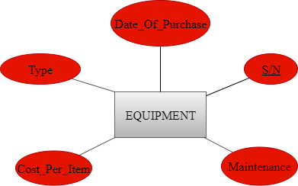

Since we provide worldwide treatments, our equipment are not locally produced, but they are carefully crafted. This strong entity keeps track of all equipment needed, purchased, and under maintenance.

This entity has the following attributes:

* **S/N (Serial Number)**: Each piece of equipment has its own serial number that is represented as a barcode which basically states everything about it.
* **Maintenance:** It shows the date of the last maintenance of this specific tool.
* **Cost_Per_Item**: It represents the cost that the zoo paid to purchase this specific tool.
* **Type**: It specifies the type of the equipment.
* **Date_Of_Purchase:** It shows the actual date that the zoo purchased this specific tool.

**STORAGE**

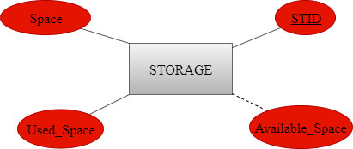

Due to our humongous franchise, we need a strong entity “STORAGE” that keeps our so-called materials safe and sound.

The attribute of this entity are:

* **STID (Storage ID):** Each storage has a unique ID.
* **Space**: Every storage has a certain capacity which sets the limit of how much items we can store in it.
* **Used_Space**: It shows how much space is already taken or used in the storage.
* **Available_Space**: This is a derived attribute (**Space & Used_Space**) that shows how much space is free to use in the storage at the moment.

**MEDICAL_INFO**

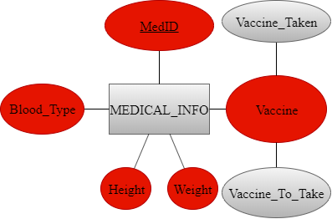

We cannot say that our animals were never sick ever since they got in to our zoo, but what makes us work ethically, is that we have a strong entity called “MEDICAL_INFO” that keeps track of all diseases that hit or may hit any animal we have.

The attributes of the entity are:

* **MedID (Medical ID):** This is a key attribute that represents the ID of the medical report.
* **Blood_Type**: It represents the blood type of the animal.
* **Height**: It shows the height of the animal.
* **Weight**: It shows the height of the animal.
* **Vaccine:** Once brought in, every animal should be treated as per the country’s medication. As a respectful zoo, ITS have made a decision to know every vaccine taken by every single animal thus we know what vaccine is ought to be given to the animal, regardless if the animal is ill or not.

**DEPARTMENT**

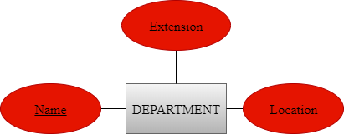

Every working place has several different departments, that takes care of different types of tasks. This strong entity keeps track of what departments ITS has.

The following attributes are matched with the entity department:

* **Name:** A key attribute representing a unique name for each department.
* **Extension:** A key attribute representing the extension number that the customer dials to reach a specific department. (For example, 1000 for IT).
* **Location:** This is a composite attribute composed of 2 sub-attributes (Building and Floor). The Building is the building where this department is located. The Floor is a number representing the floor number of this department.

**SUPPLY**

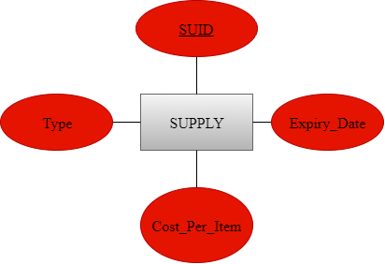

Taking into consideration our priority, animals have the right to have fresh food and clean cages on a daily basis which is why we have this strong entity that brings in fresh goods.

The attributes of this entity are as follows:

* **SUID (Supply ID)**: Each supply has a unique ID.
* **Type:** Differentiates what each type of supply is.
* **Cost_Per_Item:** Represents the cost of each type of supply.
* **Expiry_Date:** Every kind of supply has to have an expiry date which we should know about in order to finish it before it becomes corrupted.

**MEDICAL CENTER**

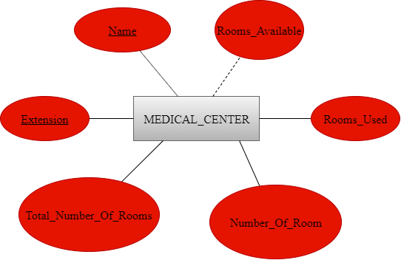

Every animal should be given the right of checkups in a timely manner which is why we have this strong entity that takes care of this thing.

The attributes of this entity are as follows:

* **Name:** Key attribute that states the name of our medical center.
* **Extension:** Key attribute that represents a unique internal phone number of the medical center.
* **Total_Number_Of_Rooms:** Represents the total number of rooms this medical center has.
* **Number_Of_Room:** Number of room the animal is located in.
* **Rooms_Used:** Indicates how many rooms of this center are occupied.
* **Rooms_Available:** This is a derived attribute (**Total_Number_Of_Rooms & Rooms_Used**) that shows how many rooms are free and not occupied.

**SCHEDULE**

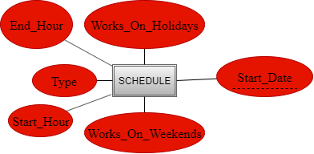

Depending on the strong entity called “EMPLOYEE”, this weak entity shows the detailed schedule of every employee our zoo has.

The attributes of this entity are:

* **Start_Date:** This is a partial key that indicates when the employee has started working at our zoo.
* **Works_On_Weekends:** Shows whether the employee works on Saturdays and Sundays or not.
* **Start_Hour:** Gives the financial department the exact time every employee has started working for the day.
* **Type:** Every schedule could be one of two types: Part-Time or Full-Time.
* **End_Hour:** Gives the financial department the exact time every employee has stopped working for the day.
* **Works_On_Holidays:** Shows whether the employee works on dedicated holidays (Prophets’ Birthday) or not.

1. **Relationships**

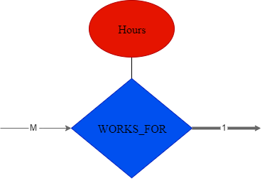

The relationship "WORKS_FOR" represents the employees working for a certain department. Since numerous employees may work for a single department, there is a many to one relation. Each department requires a minimum of one employee which classifies the participation as total for the department side and partial for the employees’ side since not all employees are going to be working simultaneously. As for the attribute "Hours”, it is the link between the employee and the relationship " WORKS_FOR " in order to keep track of the hours each employee has worked.

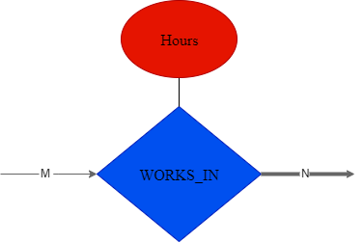

At ITS Zoological Park, there are employees that work in storehouses and their responsible is storing and managing the storehouse. Requiring many employees to get the job done on multiple storehouses, there is a many to many relationship. Partial participation from the employees is because not all employees are working together (We consider them to have shifts) and total participation for the storehouses since all of them should be working 24/7. As compared to the "WORKS_FOR" relationship, the "WORKS_IN" relationship has the attribute "Hours" that keeps track of the hours worked by the employees.

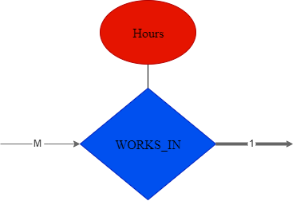

This "WORKS_IN" relationship is between employees and the medical center which will definitely have many employees and there is only one medical center thus the relationship is a many to one. In addition, the medical center requires at least one employee working at each shift. Therefore, the participation of the employees is partial while the participation of the medical center is total where it will be open 24/7. Also, the "Hours" attribute is to keep track of the hours worked by each employee.

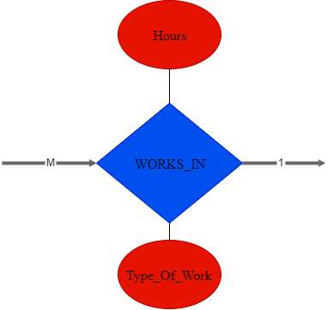

Each zoo must have several employees that are in charge of large number of tasks regarding taking care of the animals. In order to keep a zoo running in an organized manner, it must have employees working all the time. This relationship is between the employees and the tasks they are responsible for. Many employees could be assigned to the same task which is why it is a total participation on both ends, since all employees should be working until the given task is done. Concerning the attributes of this relationship, the attribute "Hours" is to keep track of the hours worked by the employees, and the attribute "Type_Of_Work" is the task each employee is responsible for.

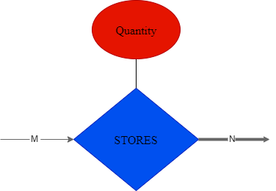

ITS Zoological Park has different resources to keep the zoo running whether it was equipment, medicine, or food for the animals. Our storehouses "STORES" the resources needed for the zoo. Each item could be stored in multiple storehouses simultaneously and each storehouse can store a large quantity of items. Thus, the relationship is many to many. The participation of the resources is total since every item should be stored in a storehouse. However, storehouses could be empty which makes the participation of the storehouse partial. The attribute "Quantity" keeps track of the quantity of the resources stored.



Storage *“*STORES*”* many supplies in a specified quantity. The relationship is many to many because supplies are stored in multiple storehouses, and each storage can store many equipment. Moreover, supplies must be stored in a storage so there is a total participation of the supplies entity in such relationship. However, a storage can be empty and might not store any supplies that makes the storage entity has a partial participation in this relationship. The attribute “Quantity” represents the quantity of resources stored.

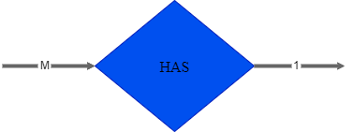

The ITS Zoological Park is divided into different sections where in each section is kept different types of animals. The relationship "HAS" is between the zoo and the sections it has. The relationship is many to one since the zoo has many sections. As for the participation, all sections should be available in the zoo and the zoo must have sections that classifies the participation as total.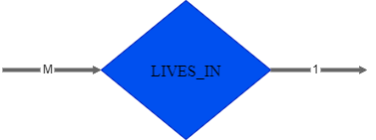

In each section there are habitats and the animals are divided among those habitats. Each animal "LIVES in" a specific habitat, more than one type of animal could live in the same habitat and each habitat will always have at least one type of animal. Thus, we could say that the relationship is many to one and the relationship is total on both ends of the relationship.

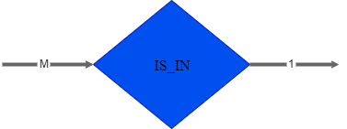

The way the habitats are divided at ITS Zoological Park are like any other zoo. The section has many different habitats to separate the animals in a secure way. Since each habitat "IS_IN" a section and each section always have many habitats we could say the participation is total on both ends and that the relationship is many to one.

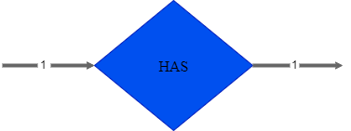

Each animal "HAS" a medical record of its own, no two animals could have the same medical record or two medical records for the same animals but every animal should have a medical record in order for the medical center to use this information correctly for researches or later sickness of the animal. Therefore, the relationship is definitely one to one and the participation is total on both ends.

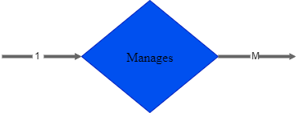

The relationship "MANAGES" is between the medical center and the medical information. The medical center manages all the medical records of all the animals at the zoo for a future use in case of sickness of the animal or future research. Therefore, the relationship is one to many and it is a total participation on both ends since all medical records must be managed by the medical center and the medical center must always have medical records of the animals.

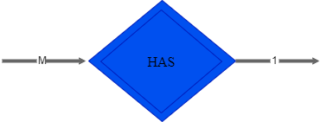

This weak relationship “HAS” is a relationship between the “EMPLOYEE” entity and the “SCHEDULE” weak entity. The reason behind the total participation on both sides and the M:1 relationship is because every employee should have one schedule only and no schedule could exist for no employee.

1. **ER to Relational Mapping Algorithm**

In order to convert our ER diagram into a relational schema, we have followed the known 7 steps:

Step 1: Mapping of Strong Entities

Step 2: Mapping of Weak Entities

Step 3: Mapping of Binary 1:1 Relation Types

Step 4: Mapping of Binary 1:N Relationship Types

Step 5: Mapping of Binary M:N Relationship Types

Step 6: Mapping of Multivalued attributes

Step 7: Mapping of N-ary Relationship Types

As for our database, we have only used the first 6 steps as we do not have any N-ary relationships.

**Step 1: Mapping of Strong Entities**

In this step, we are going to convert every strong entity into a table known as a relationship table. In this table, we will include all attributes (Except for multivalued ones). As for composite attributes, we are going to put their simple attributes.

Our strong entities are: ANIMAL, EMPLOYEE, ZOO, HABITAT, SECTION, EQUIPMENT, STORAGE, MEDICAL_INFO, DEPARTMENT, SUPPLY and MEDICAL_CENTER.

**ANIMAL:**

|  |  |  |  |  |  |  |  |
| --- | --- | --- | --- | --- | --- | --- | --- |
| AID | Date_Of_Birth | Residency | Age | Origin | Sex | Name | Type |

The ANIMAL entity has one multivalued attribute (Color) which is not represented in this table. Age is a derived attribute from the simple attribute Date_Of_Birth. As for the other attributes, they all are simple, and all are present in the table including the primary key AID.

**EMPLOYEE:**

|  |  |  |  |  |  |  |  |  |  |
| --- | --- | --- | --- | --- | --- | --- | --- | --- | --- |
| EID | Date_Of_Birth | Country | City | Street | Building | Floor | Status | Salary | Sex |
| FName | MInitial | LName | Position |

The Employee entity has a combination of most kinds of attributes. It has one multivalued attribute (Phone_Number) which is also not represented in the table, two composite attributes, Address and Name, in which they are explicitly represented by their simple attributes and several different attributes which are simple. Moreover, the table also lists the primary key which is EID.

**ZOO_BRANCH:**

|  |  |  |  |
| --- | --- | --- | --- |
| Location | Zone | Email | Type |

The Zoo entity has one multivalued attribute (Phone) which is again not listed. Other than that, the primary key Location is listed and the 3 other attributes as well.

**HABITAT:**

|  |  |  |  |
| --- | --- | --- | --- |
| HID | Capacity | Type | Zone |

The Habitat entity has HID as a primary key and has no multivalued attributes and no composite ones. They are only simple attributes and all are listed.

**SECTION:**

|  |  |  |
| --- | --- | --- |
| Number | Name | Zone |

The Section entity has 2 candidate keys (Name and Number) one of which we have chosen Number to be its primary key. No composite and no multivalued attributes exist in this entity.

**EQUIPMENT:**

|  |  |  |  |  |
| --- | --- | --- | --- | --- |
| Serial_Number | Maintenance | Cost_Per_Item | Type | Date_Of_Purchase |

The Equipment entity has Serial_Number as a primary key and 4 other simple attributes only where all are listed in the table.

**STORAGE:**

|  |  |  |  |
| --- | --- | --- | --- |
| STID | Space | Used_Space | Available_Space |

Other than STID being the primary key, there is a derived attribute (Available_Space) and two other simple attributes.

**MEDICAL_INFO:**

|  |  |  |  |  |  |
| --- | --- | --- | --- | --- | --- |
| MEDID | Blood_Type | Height | Weight | Vaccine_Taken | Vaccine_To_Take |

This entity has simple and composite attributes. Vaccine, as a composite attribute, is not listed, whereas its simple attributes (Vaccine_Taken and Vaccine_To_Take) are listed instead with the primary key MEDID.

**DEAPRTMENT:**

|  |  |  |
| --- | --- | --- |
| Extension | Name | Location |

The entity Department has 2 candidate keys (Name and Extension) where we have chosen the Name attribute to be primary.

**SUPPLY:**

|  |  |  |  |
| --- | --- | --- | --- |
| SUID | Type | Cost_Per_Item | Expiry_Date |

The Supply entity has SUID as a primary key, followed by its other simple attributes.

**MEDICAL_CENTER:**

|  |  |  |  |  |  |
| --- | --- | --- | --- | --- | --- |
| Extension | Name | Number_Of_Room | Total_Number_Of_Rooms | Rooms_Used | Rooms_Available |

For this entity, Name and Extension are 2 candidate keys in which we have selected Extension to be represented as the primary key. Moreover, Rooms_Available is a derived attribute from 2 other attributes (Total_Number_Of_Rooms & Rooms_Used).

**Step 2: Mapping of Weak Entities**

This step is identical to step 1 for weak entities, but with only one small twist. Each weak entity table will contain a foreign key which is the primary key of the strong entity it belongs to. The combination of both the foreign key and the partial key sums up to have our primary key for a weak entity.

**SCHEDULE:**

|  |  |  |  |  |  |  |
| --- | --- | --- | --- | --- | --- | --- |
| EID | Start_Date | Type | Works_On_Weekends | Works_On_Holidays | Start_Hour | End_Hour |

As a weak entity with only simple attributes and no primary key, the dominant partial key is placed as a foreign key and it made a combination with the partial key to produce a primary key. Our weak entity “SCHEDULE” is actually an “EMPLOYEE” that has a schedule. That’s why EID is used as a foreign key because “EMPLOYEE” entity is the dominant one. The combination of EID and Start_Date is itself a primary key for this weak entity.

**Step 3: Mapping Binary 1:1 Relationship Types**

In this step, we are going to use one of three approaches in order to map all 1:1 relations.

The optional approaches that we have are:

* **First approach:** Called the Foreign Key approach, which basically states that a relation must have a total participation side in order to choose that specific entity and add its’ primary key as a foreign one in the other.
* **Second approach:** Called the Merge Relation option, which is done by merging to entity types into one relation and it is more applicable when both entities are of total participation.
* **Third approach:** Called the Cross-Reference or Relationship Relation option, is an alternative by setting up a new relation with cross-referencing both the entities’ primary keys together.

In our schemas, we will be using the Foreign Key approach because it is the most suitable for us.

The 1:1 relations we have in our ER diagram is the one that connects “ANIMAL” and “MEDICAL_INFO”. For simplicity, we are going to name is **HAS1.**

**HAS1:**

|  |  |  |  |  |  |  |
| --- | --- | --- | --- | --- | --- | --- |
| MedID | Height | Weight | Blood_Type | Vaccine_To_Take | Vaccine_Taken | AID |

Every animal has medical information. Since the participation of both linked entities is total, the primary key of either entity

**Step 4: Mapping of Binary 1:N Relationship Types**

In this step, the mapping will be consisted of 2 steps. The first step is to include all simple attributes of both entities into one table. The second step is to include the primary key of the “1” entity will be included as a foreign key on the “N” entity.

The 1:N relations are: LIVES_IN, MANAGES, IS_IN, HAS2, WORKS_FOR, WORKS_IN1, WORKS_IN2.

**LIVES_IN:**

|  |  |  |  |  |  |  |  |  |
| --- | --- | --- | --- | --- | --- | --- | --- | --- |
| AID | Type | Name | Date_Of_Birth | Residency | Sex | Origin | Age | HID |

The “ANIMAL” entity is the “M” side of the relationship which proves the existence of HID, the primary key of the “1” side “HABITAT”, as a foreign key.

**MANAGES:**

|  |  |  |  |  |  |  |
| --- | --- | --- | --- | --- | --- | --- |
| MedID | Height | Weight | Blood_Type | Vaccine_To_Take | Vaccine_Taken | MCName |

This relationship links “MEDICAL_CENTER” and “MEDICAL_INFO”. MCName is the primary key of the “1” side of the relationship.

**IS_IN:**

|  |  |  |  |  |
| --- | --- | --- | --- | --- |
| HID | Zone | Type | Capacity | Section_Number |

The foreign key “Section_Number” represents the primary key of the “SECTION” entity.

**HAS2:**

|  |  |  |  |
| --- | --- | --- | --- |
| Number | Name | Zone | ZLocation |

The primary key of “ZOO_BRANCH” is a foreign key in the “SECTION”.

**WORKS_IN1:**

|  |  |  |  |  |  |  |  |  |  |
| --- | --- | --- | --- | --- | --- | --- | --- | --- | --- |
| EID | Status | Street | City | Country | Building | Floor | Sex | LName | MInitital |
| FName | Position | Date_Of_Birth | Hours | Type_Of_Work | ZBLocation |

ZBLocation is the primary key of “ZOO_BRANCH” represented as a foreign key in the “EMPLOYEE”.

**WORKS_IN2:**

|  |  |  |
| --- | --- | --- |
| EID | MCName | Hours |

This “WORKS_IN” relationship links the “EMPLOYEE” entity and the “MEDICAL_CENTER” entity. Exceptionally, we have used the 3rd approach, which is the cross-reference approach because the “EMPLOYEE” entity is not of total participation as we could face some NULL values.

**WORKS_FOR:**

|  |  |  |
| --- | --- | --- |
| EID | DName | Hours |

For the same reason as the preceding relation, this relation is also set using the 3rd approach because of the fact that the “EMPLOYEE” entity is not of a full participation on its end.

**Step 5: Mapping of Binary M:N Relationship Types**

To construct M:N relationship types, we need to include all simple attributes of the relationship including the primary keys of both entities.

The mapped M:N relationships are: S_STORAGE, E_STORAGE, and WORKS_IN3.

**S_STORGAE:**

|  |  |  |
| --- | --- | --- |
| SUID | STID | Quantity |

The linkage between “SUPPLY” and “STORAGE” includes their primary keys SUID and STID respectively as well as the attribute of the relationship itself.

**E_STORAGE:**

|  |  |  |
| --- | --- | --- |
| STID | Serial_Number | Quantity |

This linkage links “EQUIPMENT” and “STORAGE” with Serial_Number and STID as primary keys respectively with the Quantity attribute of the relationship itself.

**WORKS_IN3:**

|  |  |  |
| --- | --- | --- |
| EID | STID | Hours |

EID and STID are the primary keys of the entities “EMPLOYEE” and “STORAGE” respectively alongside the attribute Hours of the relationship.

**Step 6: Mapping of Multivalued attributes**

Multivalued attributes will contain themselves as attributes and the primary key of the strong entity it is present in.

We have 3 multivalued attributes: Phone_Number present in “EMPLOYEE”, Phone present in “ZOO_BRANCHES” and color present in “ANIMAL”.

As for the primary key concept, the alliance of the 2 attributes is indeed the primary key of that relation.

**COLOR:**

|  |  |
| --- | --- |
| AID | Color |

The “COLOR” relation holds the primary key AID of the strong entity it is in partnership with which is “ANIMAL” in our case. The primary key is formed of both Color and AID.

**ZPHONE:**

|  |  |
| --- | --- |
| Phone | ZBLocation |

The primary key of this relation is the combination of both Phone and Location, that last that is the primary key of the entity “ZOO_BRANCH”.

**PHONE:**

|  |  |
| --- | --- |
| Phone | EID |

EID is the primary key that holds the multivalued attribute “EMPLOYEE”.

**Final Displays:**

**EMPLOYEE:**

|  |  |  |  |  |  |  |  |  |  |  |  |
| --- | --- | --- | --- | --- | --- | --- | --- | --- | --- | --- | --- |
| EID | Date_Of_Birth | Country | City | Street | Building | Floor | | Status | Salary | | Sex |
| FName | MInitial | LName | Position | Hours | Type_Of_Work | | ZBLocation | | |

**ANIMAL:**

|  |  |  |  |  |  |  |  |  |
| --- | --- | --- | --- | --- | --- | --- | --- | --- |
| AID | Date_Of_Birth | Residency | Age | Origin | Sex | Name | Type | HID |

**SUPPLY:**

|  |  |  |  |
| --- | --- | --- | --- |
| SUID | Type | Cost_Per_Item | Expiry_Date |

**STORAGE:**

|  |  |  |  |
| --- | --- | --- | --- |
| STID | Space | Used_Space | Available_Space |

**EQUIPMENT:**

|  |  |  |  |  |
| --- | --- | --- | --- | --- |
| Serial_Number | Maintenance | Cost_Per_Item | Type | Date_Of_Purchase |

**DEPARTMENT:**

|  |  |  |
| --- | --- | --- |
| Extension | Name | Location |

**ZOO:**

|  |  |  |  |
| --- | --- | --- | --- |
| Location | Zone | Email | Type |

**SECTION:**

|  |  |  |  |
| --- | --- | --- | --- |
| Number | Name | Zone | ZLocation |

**HABITAT:**

|  |  |  |  |  |
| --- | --- | --- | --- | --- |
| HID | Capacity | Type | Zone | Section_Name |

**MEDICAL_CENTER:**

|  |  |  |  |  |  |
| --- | --- | --- | --- | --- | --- |
| Extension | Name | Number_Of_Room | Total_Number_Of_Rooms | Rooms_Used | Rooms_Available |

**MEDICAL_INFO:**

|  |  |  |  |  |  |  |  |
| --- | --- | --- | --- | --- | --- | --- | --- |
| MEDID | Blood_Type | Height | Weight | Vaccine_Taken | Vaccine_To_Take | Medical_Center_Name | AID |

**SCHEDULE:**

|  |  |  |  |  |  |  |
| --- | --- | --- | --- | --- | --- | --- |
| EID | Start_Date | Type | Works_On_Weekends | Works_On_Holidays | Start_Hour | End_Hour |

**S_STORGAE:**

|  |  |  |
| --- | --- | --- |
| SUID | STID | Quantity |

**E_STORAGE:**

|  |  |  |
| --- | --- | --- |
| STID | Serial_Number | Quantity |

**WORKS_IN3:**

|  |  |  |
| --- | --- | --- |
| EID | STID | Hours |

**WORKS_FOR:**

|  |  |  |
| --- | --- | --- |
| EID | DName | Hours |

**WORKS_IN2:**

|  |  |  |
| --- | --- | --- |
| EID | MCName | Hours |

**COLOR:**

|  |  |
| --- | --- |
| AID | Color |

**ZPHONE:**

|  |  |
| --- | --- |
| Phone | ZBLocation |

**PHONE:**

|  |  |
| --- | --- |
| Phone | EID |

1. **Table Structures**

In this part, we are going to translate the ER Diagram into an actual database. The database tables will be instantiated using Oracle Database Server.

**ANIMAL**

CREATE TABLE ANIMAL (

AID INTEGER NOT NULL,

TYPE VARCHAR (50) NOT NULL,

NAME VARCHAR (20) NOT NULL,

DATE_OF_BIRTH INTEGER NOT NULL,

RESIDENCY VARCHAR (20) NOT NULL,

SEX CHAR (1) NOT NULL,

ORIGIN VARCHAR (20) NOT NULL,

AGE INTEGER NOT NULL,

HID INTEGER NOT NULL,

FOREIGN KEY (HID) REFERENCES HABITAT (HID),

PRIMARY KEY (AID)

);

**EMPLOYEE**

CREATE TABLE EMPLOYEE (

EID INTEGER NOT NULL,

STATUS VARCHAR (20) NOT NULL,

STREET VARCHAR (20) NOT NULL,

CITY VARCHAR (20) NOT NULL,

COUNTRY VARCHAR (20) NOT NULL,

BUILDING VARCHAR (20) NOT NULL,

FLOOR INTEGER NOT NULL,

SEX CHAR (1) NOT NULL,

LNAME VARCHAR (20) NOT NULL,

MINITIAL CHAR (1) NOT NULL,

FNAME VARCHAR (20) NOT NULL,

POSITION VARCHAR (20) NOT NULL,

DATE_OF_BIRTH INTEGER NOT NULL,

SALARY INTEGER NOT NULL,

HOURS INTEGER NOT NULL,

TYPE_OF_WORK VARCHAR (20) NOT NULL,

ZBLOCATION VARCHAR (20) NOT NULL,

FOREIGN KEY (ZBLOCATION) REFERENCES ZOO_BRANCH (LOCATION),

PRIMARY KEY (EID)

);

**ZOO_BRANCH**

CREATE TABLE ZOO_BRANCH (

LOCATION VARCHAR (20) NOT NULL,

ZONE INTEGER NOT NULL,

TYPE VARCHAR (20) NOT NULL,

EMAIL VARCHAR (20) NOT NULL,

PRIMARY KEY (LOCATION)

);

**HABITAT**

CREATE TABLE HABITAT (

HID INTEGER NOT NULL,

ZONE INTEGER NOT NULL,

CAPACITY INTEGER NOT NULL,

TYPE VARCHAR (50) NOT NULL,

SECTION_NAME VARCHAR (20) NOT NULL,

FOREIGN KEY (SECTION_NAME) REFERENCES SECTION (NAME),

PRIMARY KEY (HID)

);

**SECTION**

CREATE TABLE SECTION (

SEC_NUMBER INTEGER NOT NULL,

NAME VARCHAR (1000) NOT NULL,

ZONE INTEGER NOT NULL,

ZBLOCATION VARCHAR (50) NOT NULL,

FOREIGN KEY ZBLOCATION REFERENCES ZOO_BRANCH (LOCATION),

PRIMARY KEY (SEC_NUMBER),

UNIQUE (NAME)

);

**EQUIPMENT**

CREATE TABLE EQUIPMENT (

SERIAL_NUMBER INTEGER NOT NULL,

TYPE VARCHAR (20),

COST_PER_ITEM INTEGER NOT NULL,

DATE_OF_PURCHASE INTEGER NOT NULL,

MAINTENANCE INTEGER,

PRIMARY KEY (SERIAL_NUMBER)

);

**STORAGE**

CREATE TABLE STORAGE (

STID INTEGER NOT NULL,

SPACE INTEGER NOT NULL,

USED_SPACE INTEGER NOT NULL,

AVAILABLE_SPACE INTEGER NOT NULL,

PRIMARY KEY (STID)

);

**MEDICAL_INFO**

CREATE TABLE MEDICAL_INFO (

MEDID INTEGER NOT NULL,

HEIGHT FLOAT NOT NULL,

WEIGHT FLOAT NOT NULL,

BLOOD_TYPE VARCHAR (3) NOT NULL,

VACCINE_TAKEN VARCHAR (2000) NOT NULL,

VACCINE_TO_TAKE VARCHAR (2000) NOT NULL,

MEDICAL_CENTER_NAME VARCHAR (20) NOT NULL,

AID INTEGER NOT NULL,

FOREIGN KEY (AID) REFERENCES ANIMAL (AID),

PRIMARY KEY (MEDID)

);

**DEPARTMENT**

CREATE TABLE DEPARTMENT (

EXTENSION INTEGER NOT NULL,

NAME VARCHAR (20) NOT NULL,

LOCATION VARCHAR (20) NOT NULL,

PRIMARY KEY (NAME),

UNIQUE (EXTENSION)

);

**SUPPLY**

CREATE TABLE SUPPLY (

SUID INTEGER NOT NULL,

COST_PER_ITEM INTEGER NOT NULL,

TYPE VARCHAR (20),

EXPIRY_DATE INTEGER NOT NULL,

PRIMARY KEY (SUID)

);

**MEDICAL_CENTER**

CREATE TABLE MEDICAL_CENTER (

EXTENSION INTEGER NOT NULL,

NAME VARCHAR (20) NOT NULL,

NUMBER_OF_ROOM INTEGER NOT NULL,

ROOMS_USED INTEGER,

ROOMS_AVAILABLE INTEGER,

TOTAL_OF_NUMBER_OF_ROOMS INTEGER NOT NULL,

PRIMARY KEY (EXTENSION),

UNIQUE (NAME)

);

**SCHEDULE**

CREATE TABLE SCHEDULE (

TYPE VARCHAR (20) NOT NULL,

START_HOUR INTEGER,

END_HOUR INTEGER,

START_DATE INTEGER NOT NULL,

WORKS_ON_HOLIDAYS NUMBER (1) NOT NULL,

WORKS_ON_WEEKENDS NUMBER (1) NOT NULL,

EMPLOYEE_EID INTEGER NOT NULL,

PRIMARY KEY (EMPLOYEE_EID, START_DATE)

);

**COLOR**

CREATE TABLE COLOR (

AID INTEGER NOT NULL,

COLOR VARCHAR (20) NOT NULL,

FOREIGN KEY (AID) REFERENCES ANIMAL (AID),

PRIMARY KEY (AID, COLOR)

);

**ZPHONE**

CREATE TABLE ZPHONE (

ZBLOCATION VARCHAR (20) NOT NULL,

PHONE INTEGER NOT NULL,

FOREIGN KEY (ZBLOCATION) REFERENCES ZOO_BRANCH (LOCATION),

PRIMARY KEY (ZBLOCATION, PHONE)

);

**PHONE**

CREATE TABLE PHONE (

EID INTEGER NOT NULL,

PHONE INTEGER NOT NULL,

FOREIGN KEY (EID) REFERENCES EMPLOYEE (EID),

PRIMARY KEY (EID, PHONE)

);

**S_STORAGE**

CREATE TABLE S_TORES (

STID INTEGER NOT NULL,

SUID INTEGER NOT NULL,

QUANTITY INTEGER NOT NULL,

FOREIGN KEY (STID) REFERENCES STORAGE (STID),

FOREIGN KEY (SUID) REFERENCES SUPPLY (SUID),

PRIMARY KEY (STID, SUID)

);

**E_STORAGE**

CREATE TABLE E_STORES (

STID INTEGER NOT NULL,

Serial_Number INTEGER NOT NULL,

QUANTITY INTEGER NOT NULL,

FOREIGN KEY (STID) REFERENCES STORAGE (STID),

FOREIGN KEY (Serial_Number) REFERENCES EQUIPMENT (Serial_Number),

PRIMARY KEY (STID, Serial_Number)

);

**WORKS_IN3**

CREATE TABLE WORKS_IN3 (

EID INTEGER NOT NULL,

STID INTEGER NOT NULL,

HOURS INTEGER NOT NULL,

FOREIGN KEY (STID) REFERENCES STORAGE (STID),

FOREIGN KEY (EID) REFERENCES EMPLOYEE (EID),

PRIMARY KEY (EID, STID)

);

**WORKS_IN2**

CREATE TABLE WORKS_IN2 (

MCNAME VARCHAR (20) NOT NULL,

EID INTEGER NOT NULL,

HOURS INTEGER NOT NULL,

FOREIGN KEY (MCNAME) REFERENCES MEDICAL_CENTER (NAME),

FOREIGN KEY (EID) REFERENCES EMPLOYEE (EID),

PRIMARY KEY (EID, MCNAME)

);

**WORKS_FOR**

CREATE TABLE WORKS_FOR (

DNAME VARCHAR (20) NOT NULL,

EID INTEGER NOT NULL,

HOURS INTEGER NOT NULL,

FOREIGN KEY (DNAME) REFERENCES DEPARTMENT (NAME),

FOREIGN KEY (EID) REFERENCES EMPLOYEE (EID),

PRIMARY KEY (DNAME, EID)

);

1. **Table Description**

**ANIMAL**

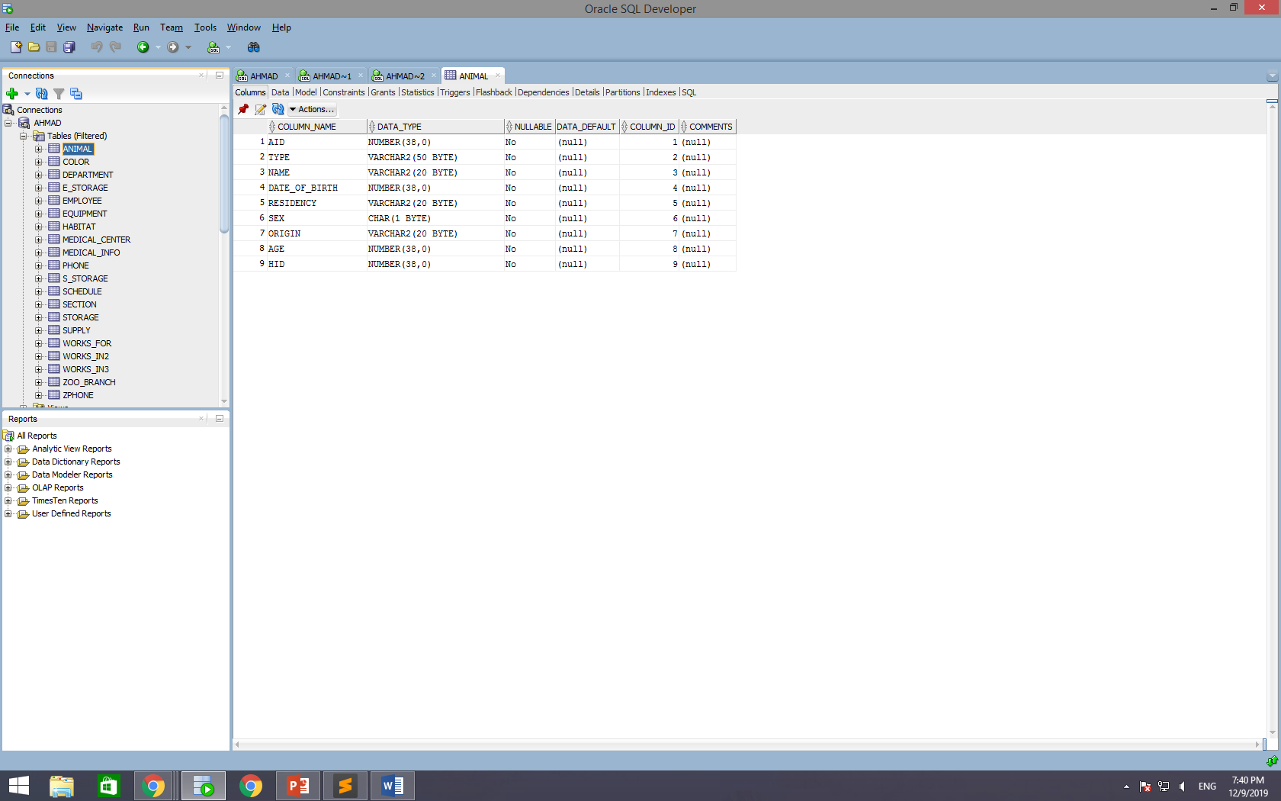

**COLOR**

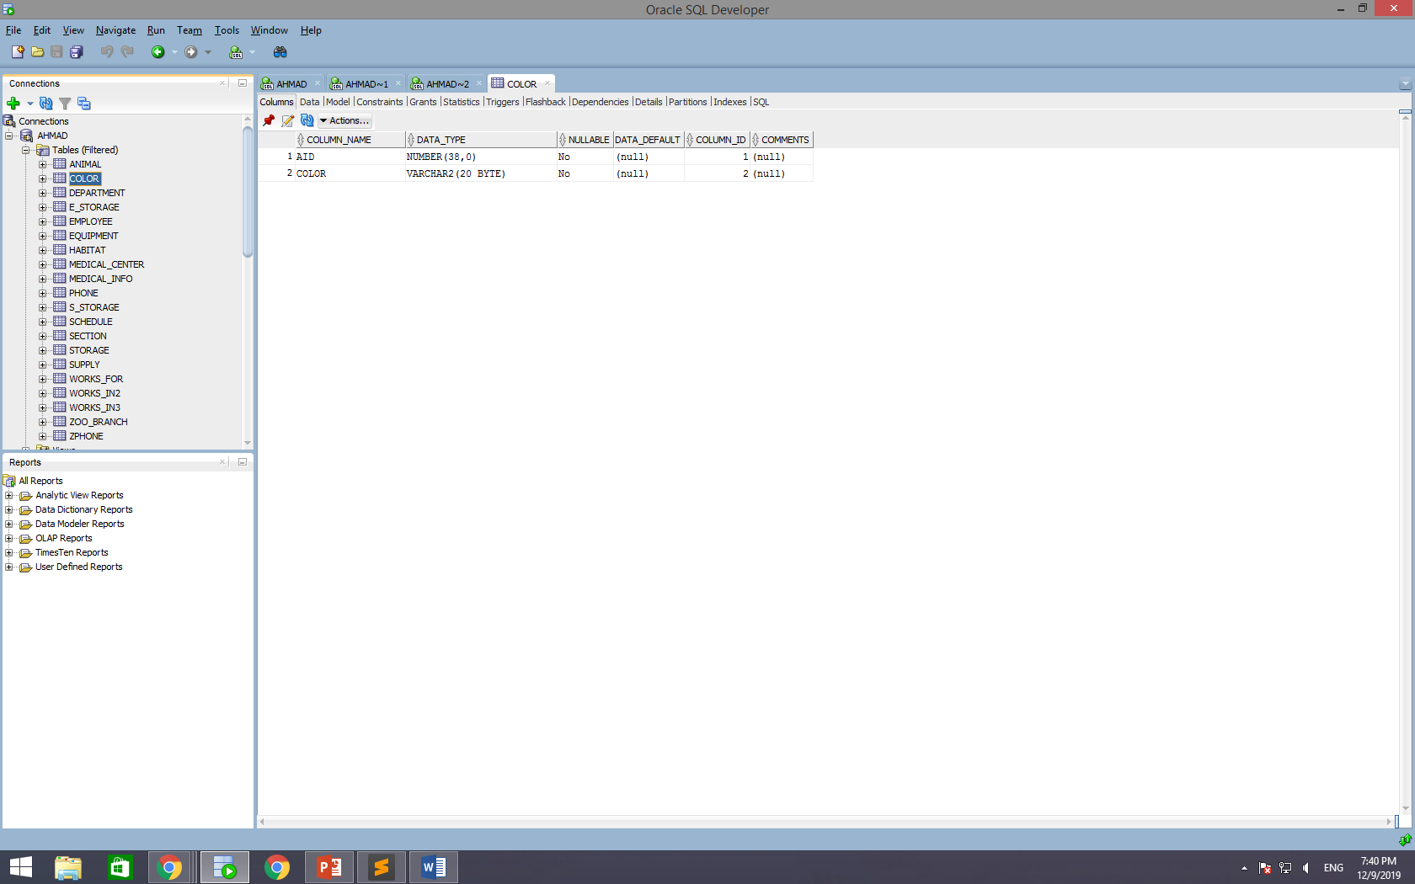

**DEPARTMENT**

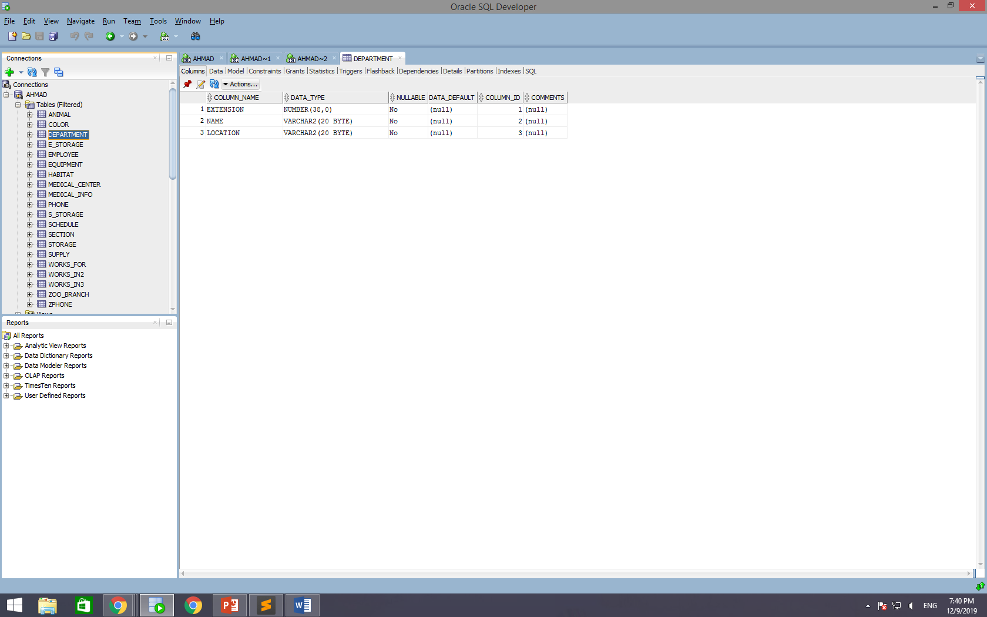

**E_STORAGE**

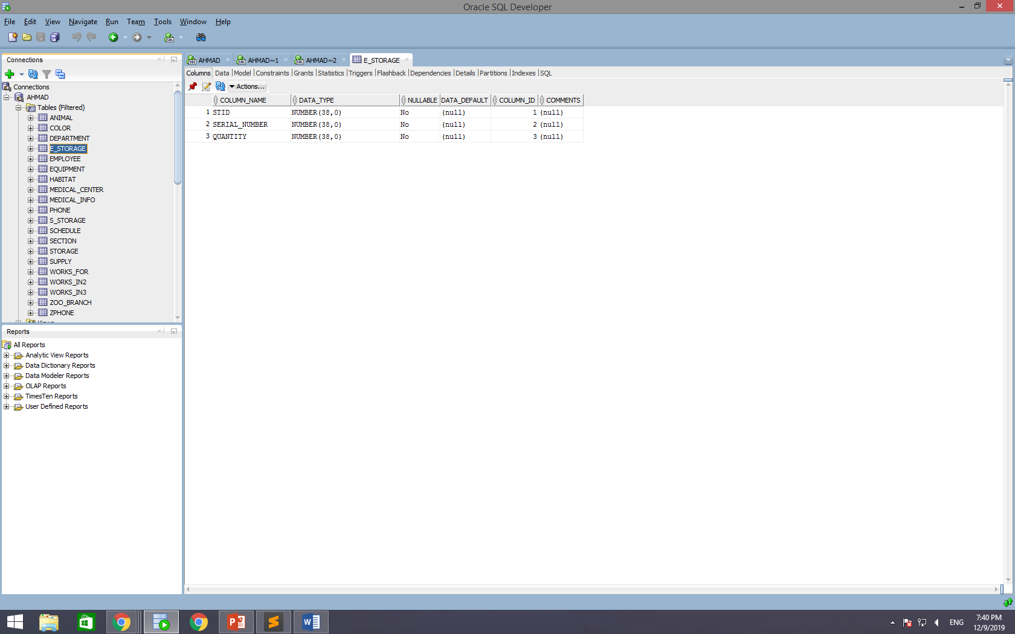

**EMPLOYEE**

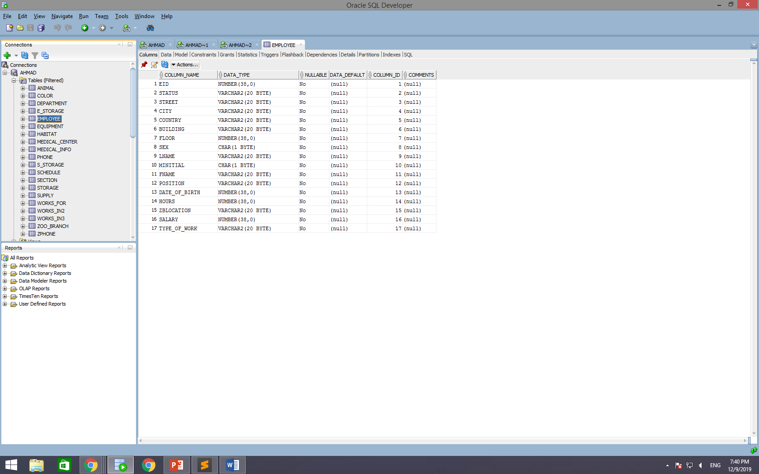

**EQUIPMENT**

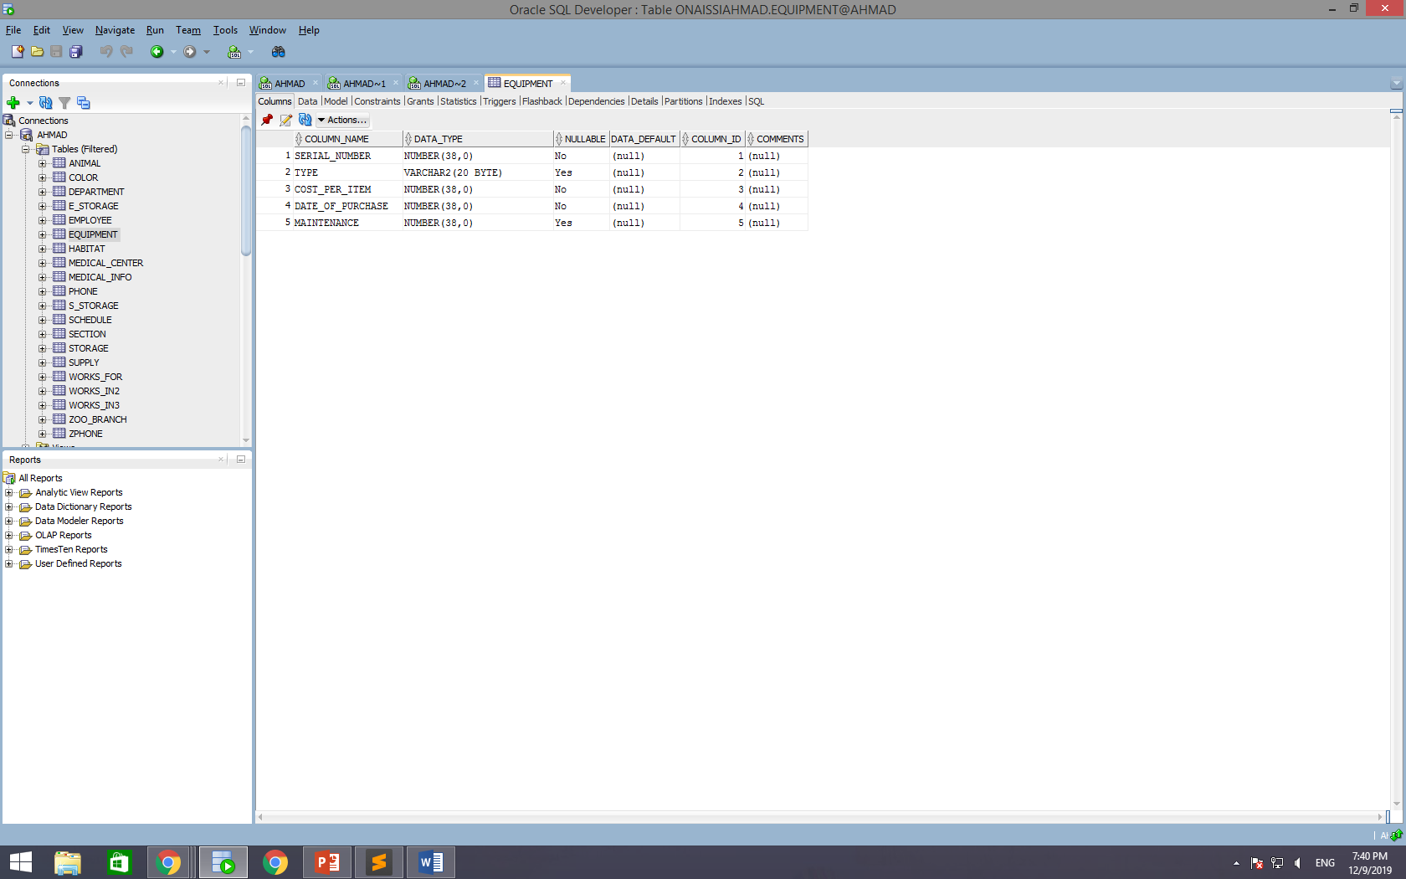

**HABITAT**

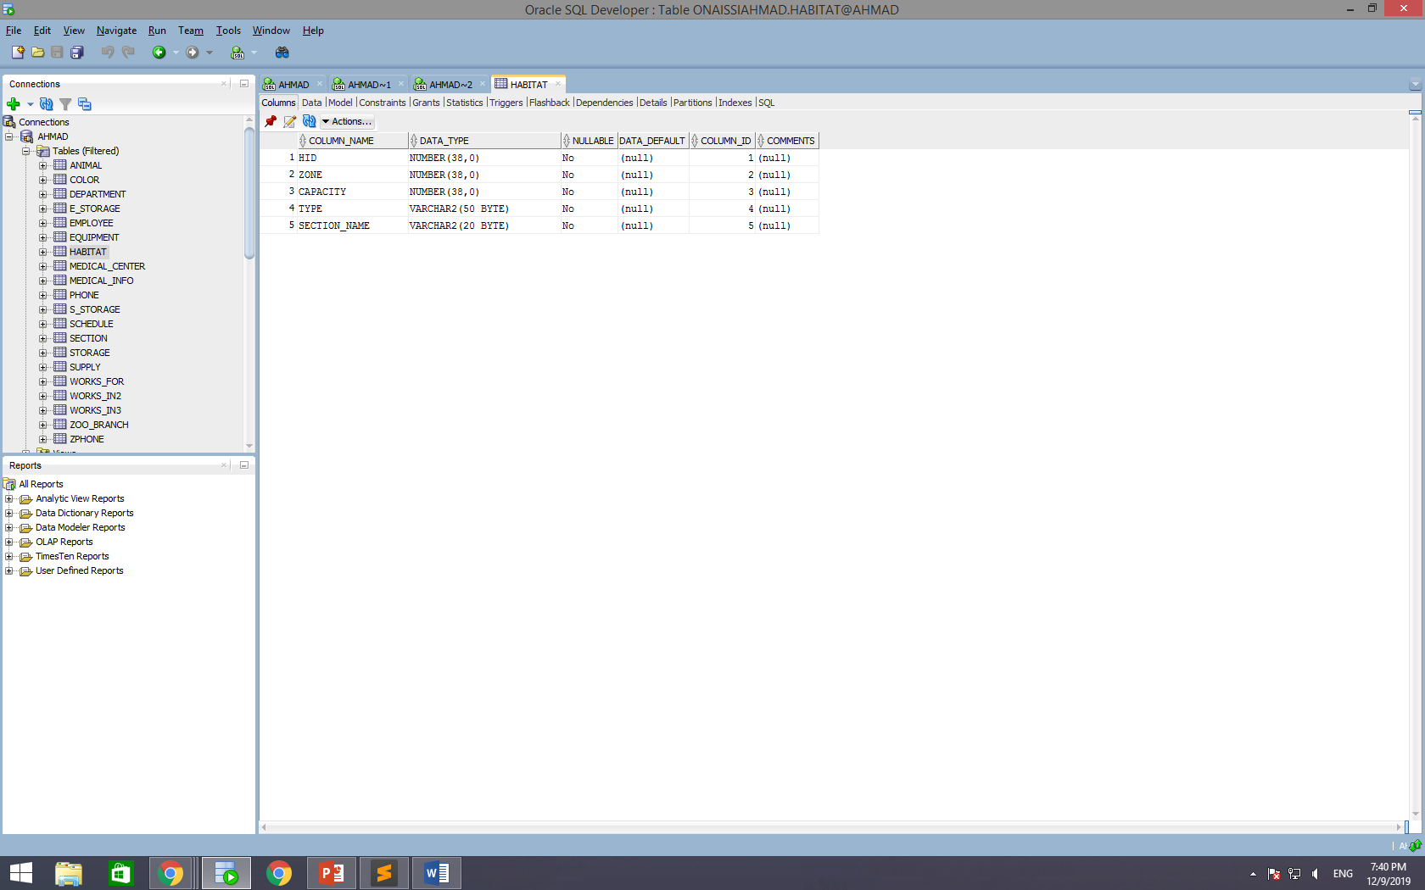

**MEDICAL_CENTER**

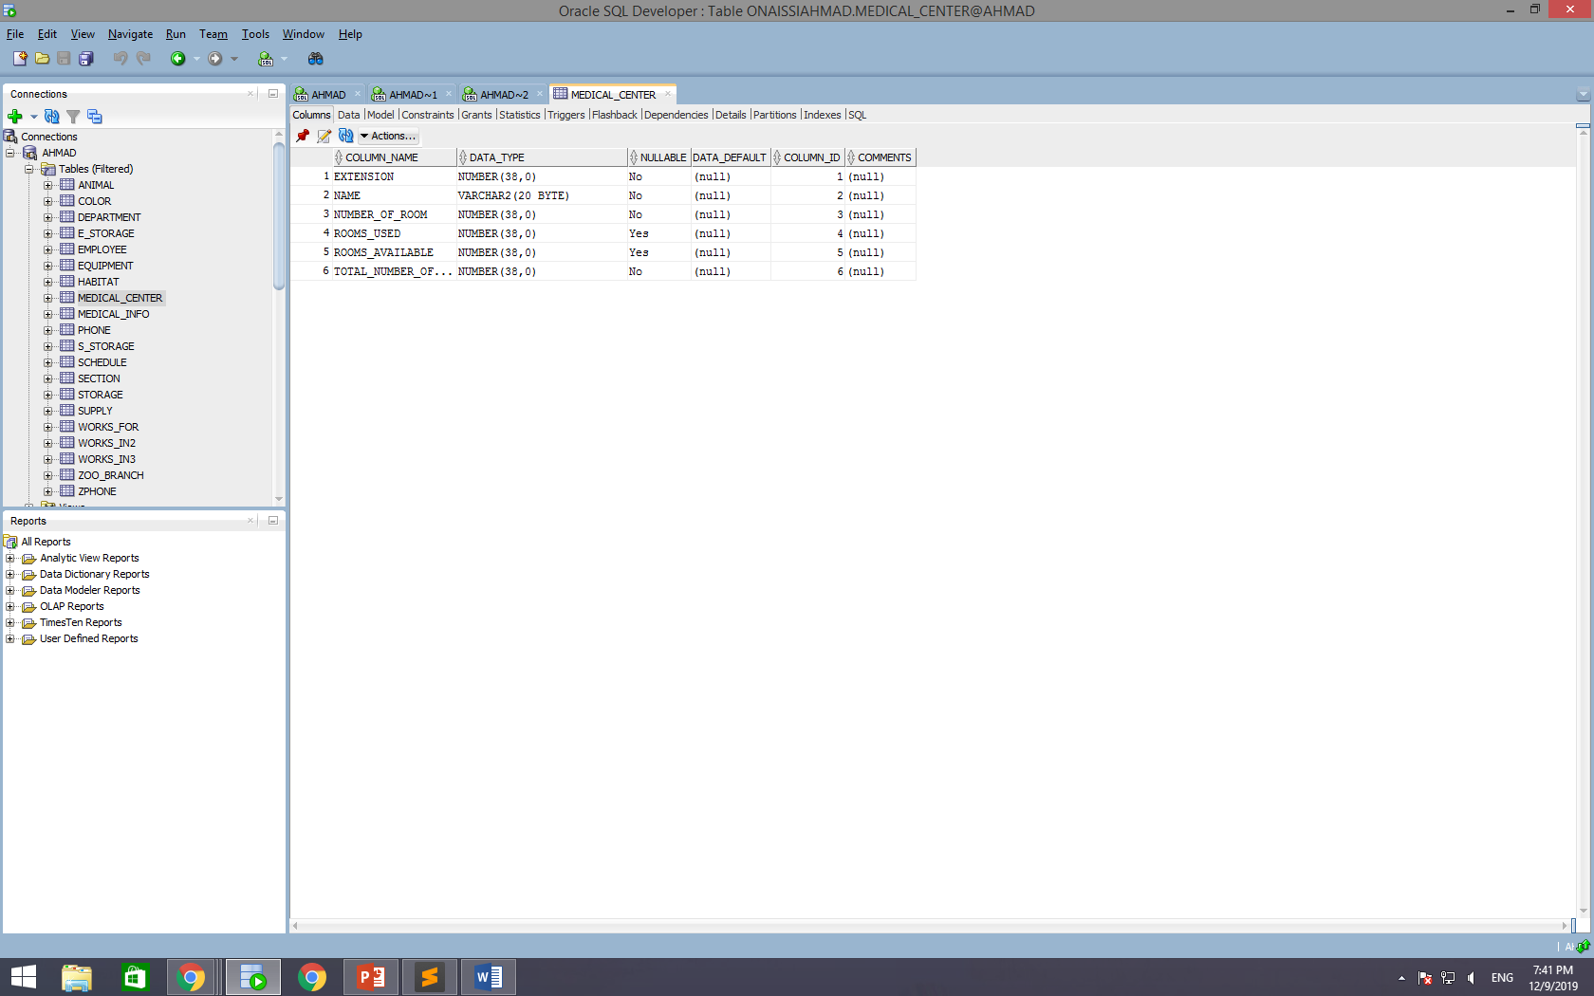

**MEDICAL_INFO**

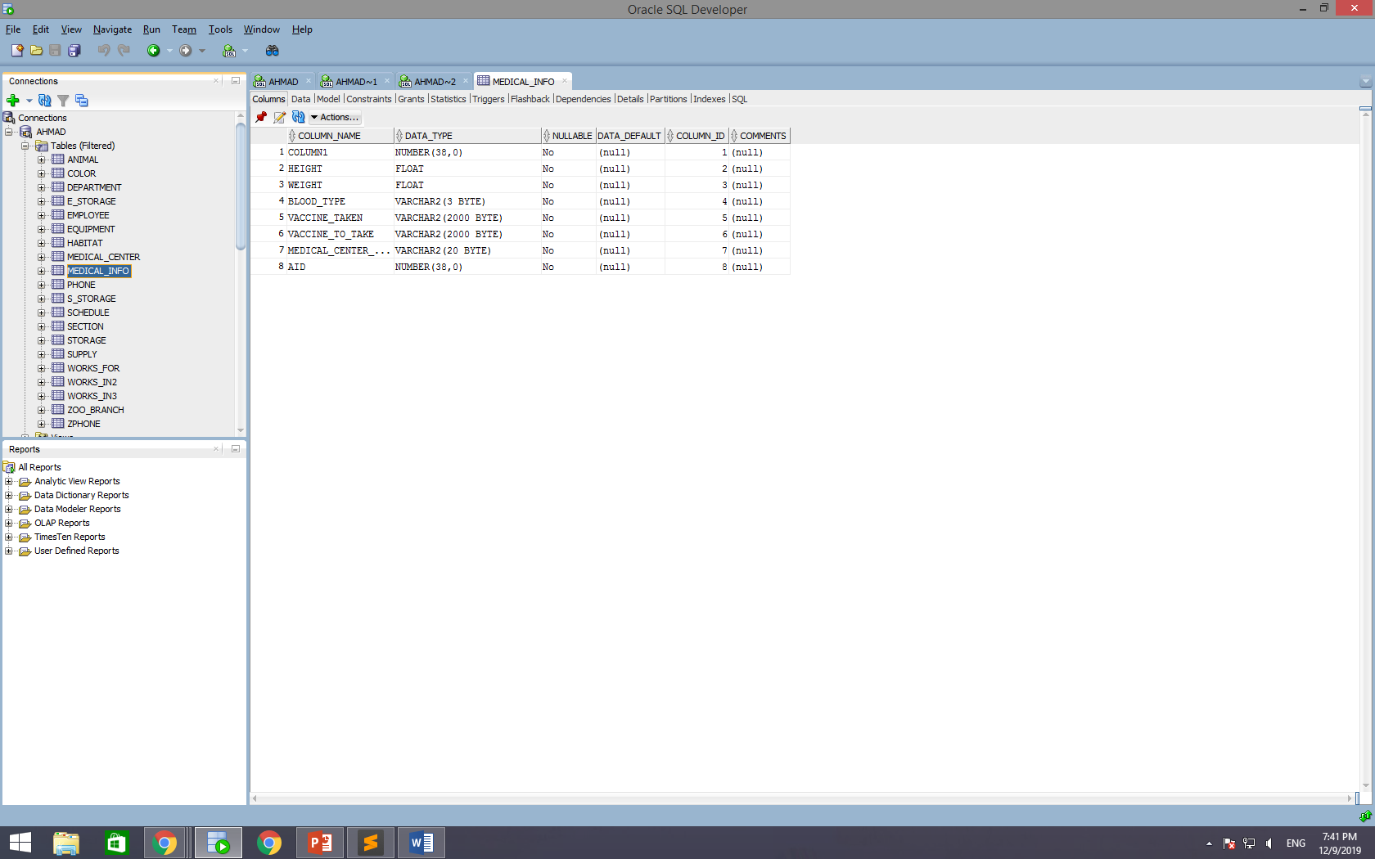

**PHONE**

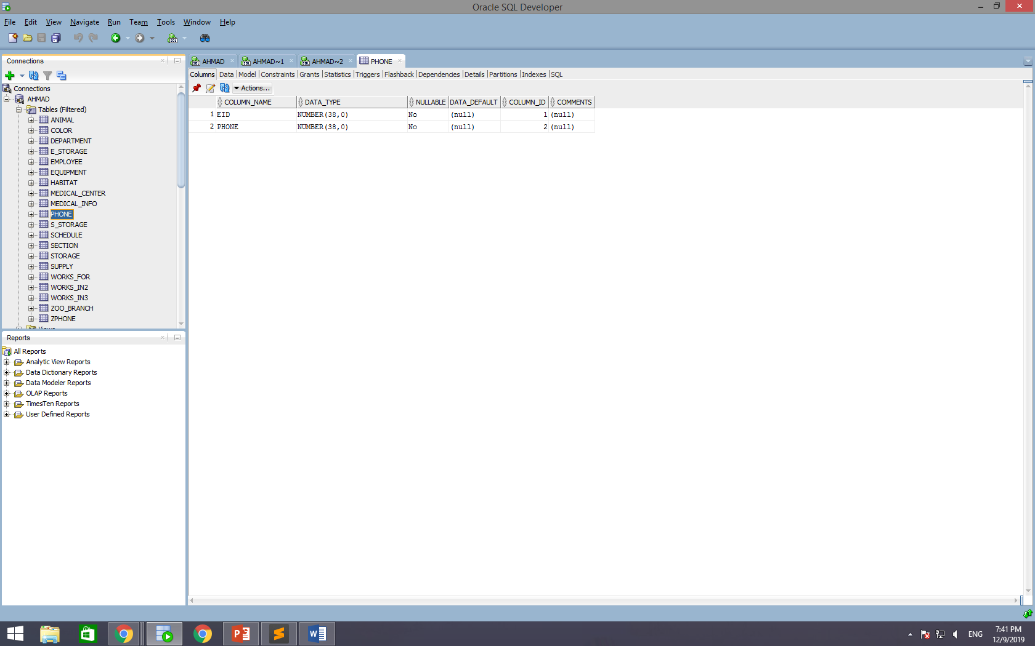

**S_STORAGE**

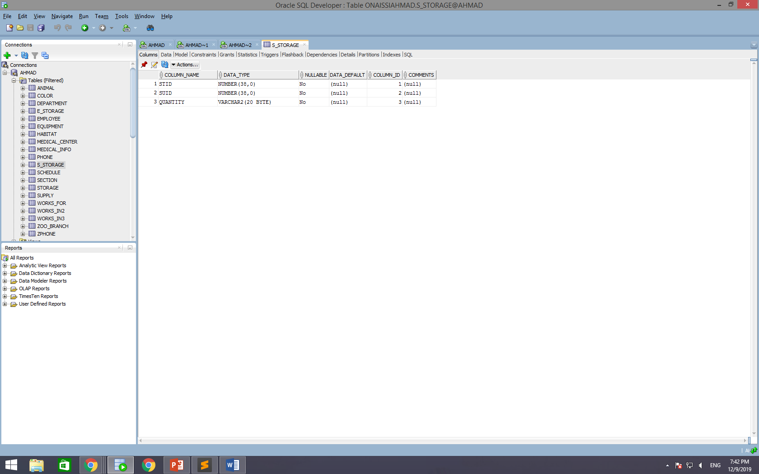

**SCHEDULE**

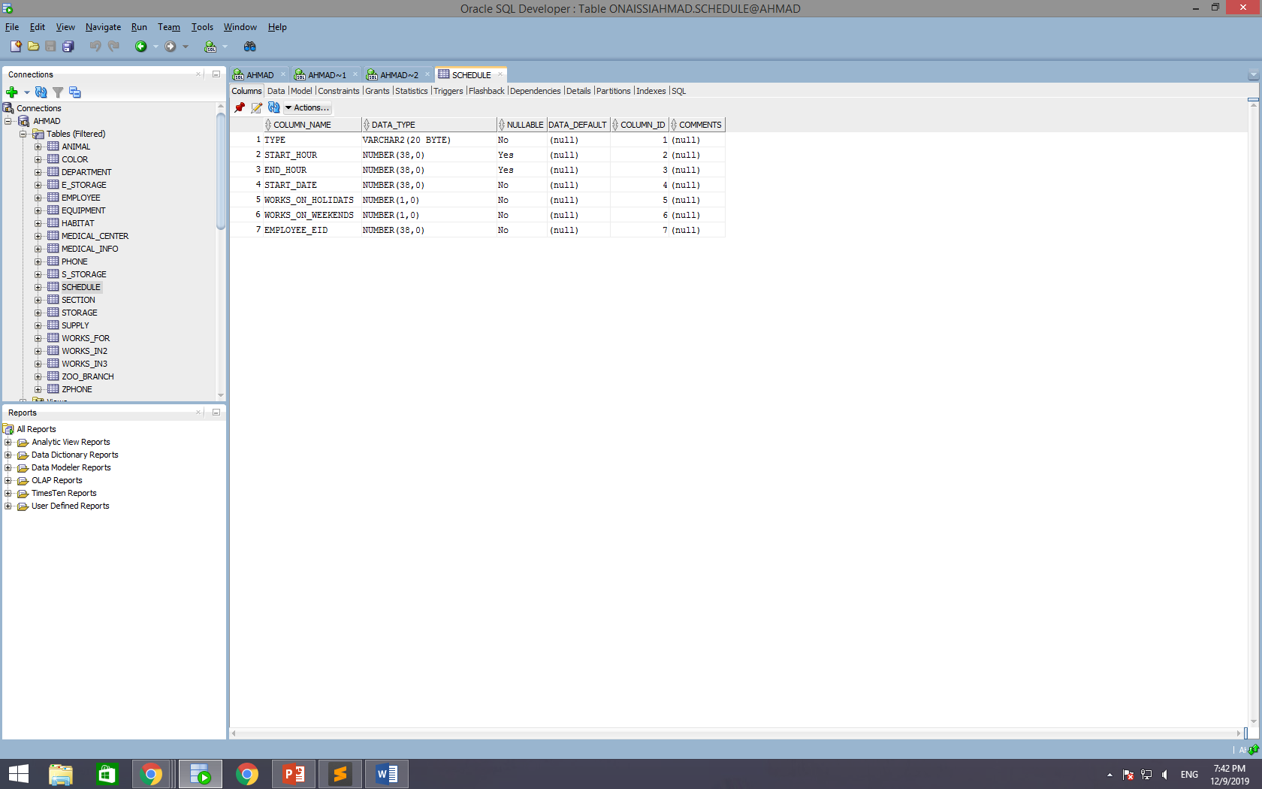

**SECTION**

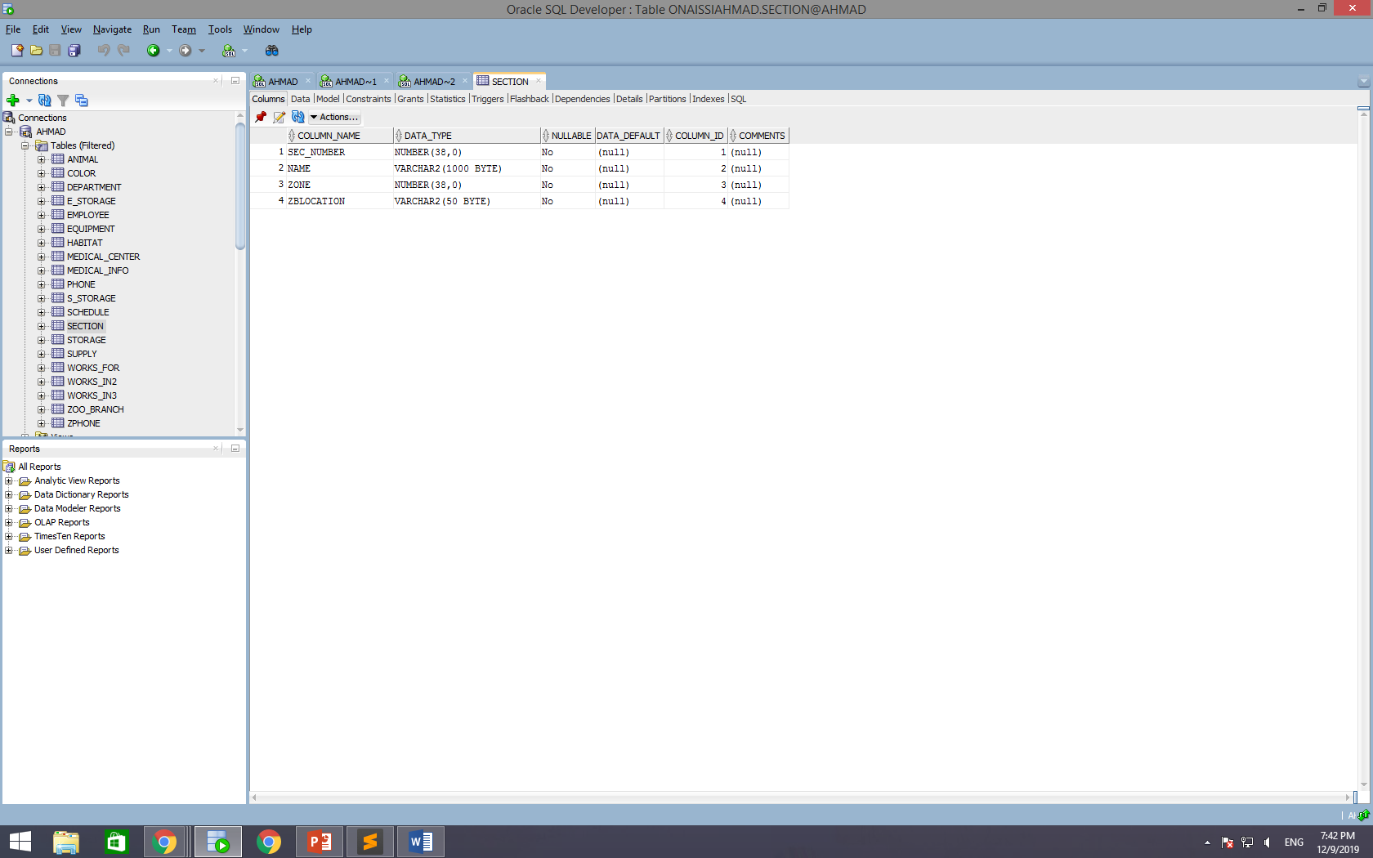

**STORAGE**

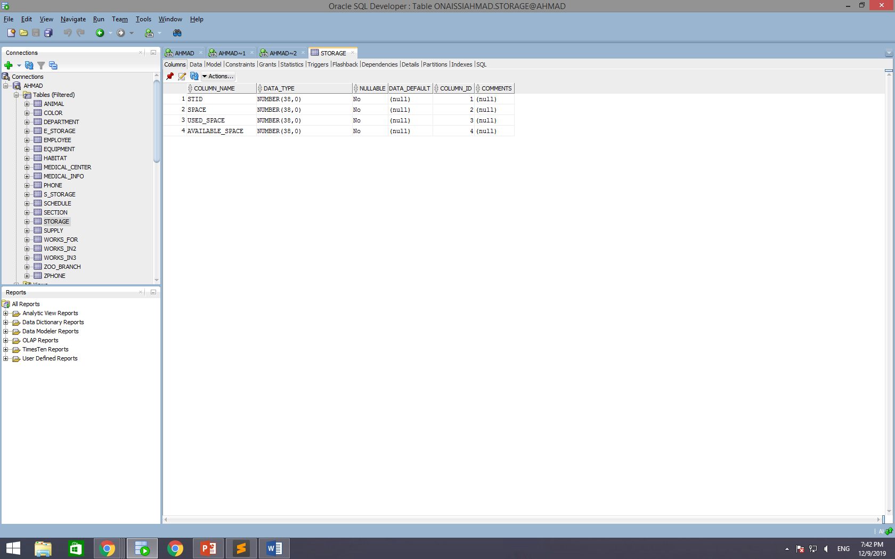

**SUPPLY**

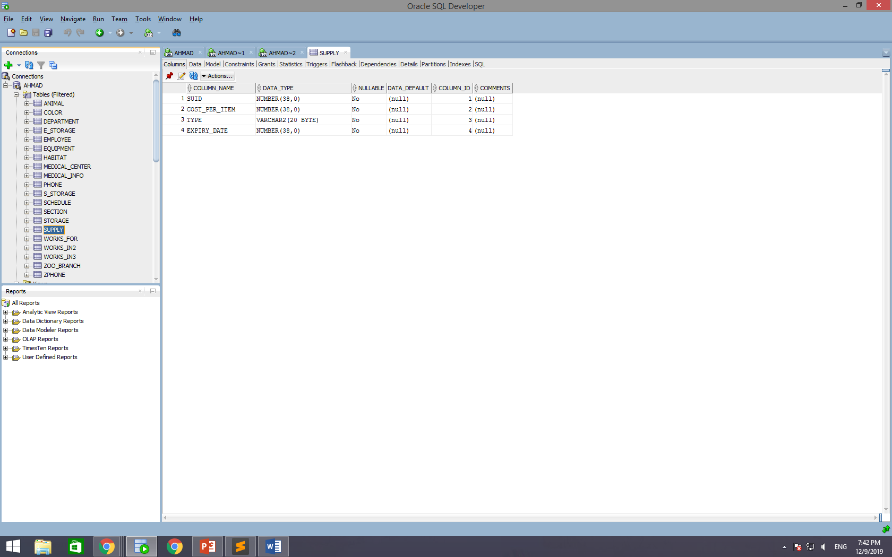

**WORKS_FOR**

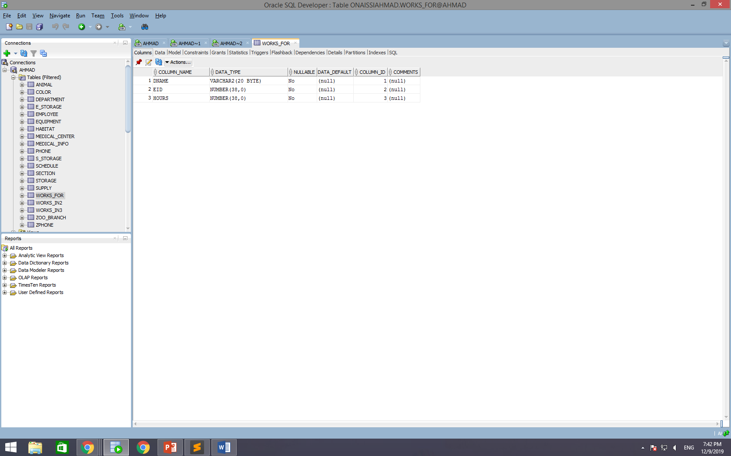

**WORKS_IN2**

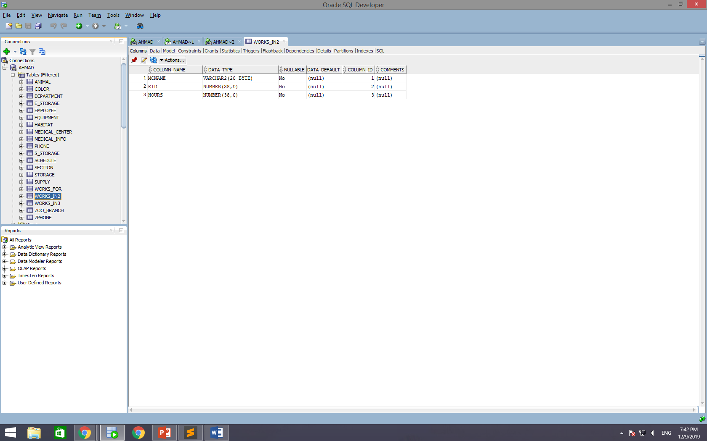

**WORKS_IN3**

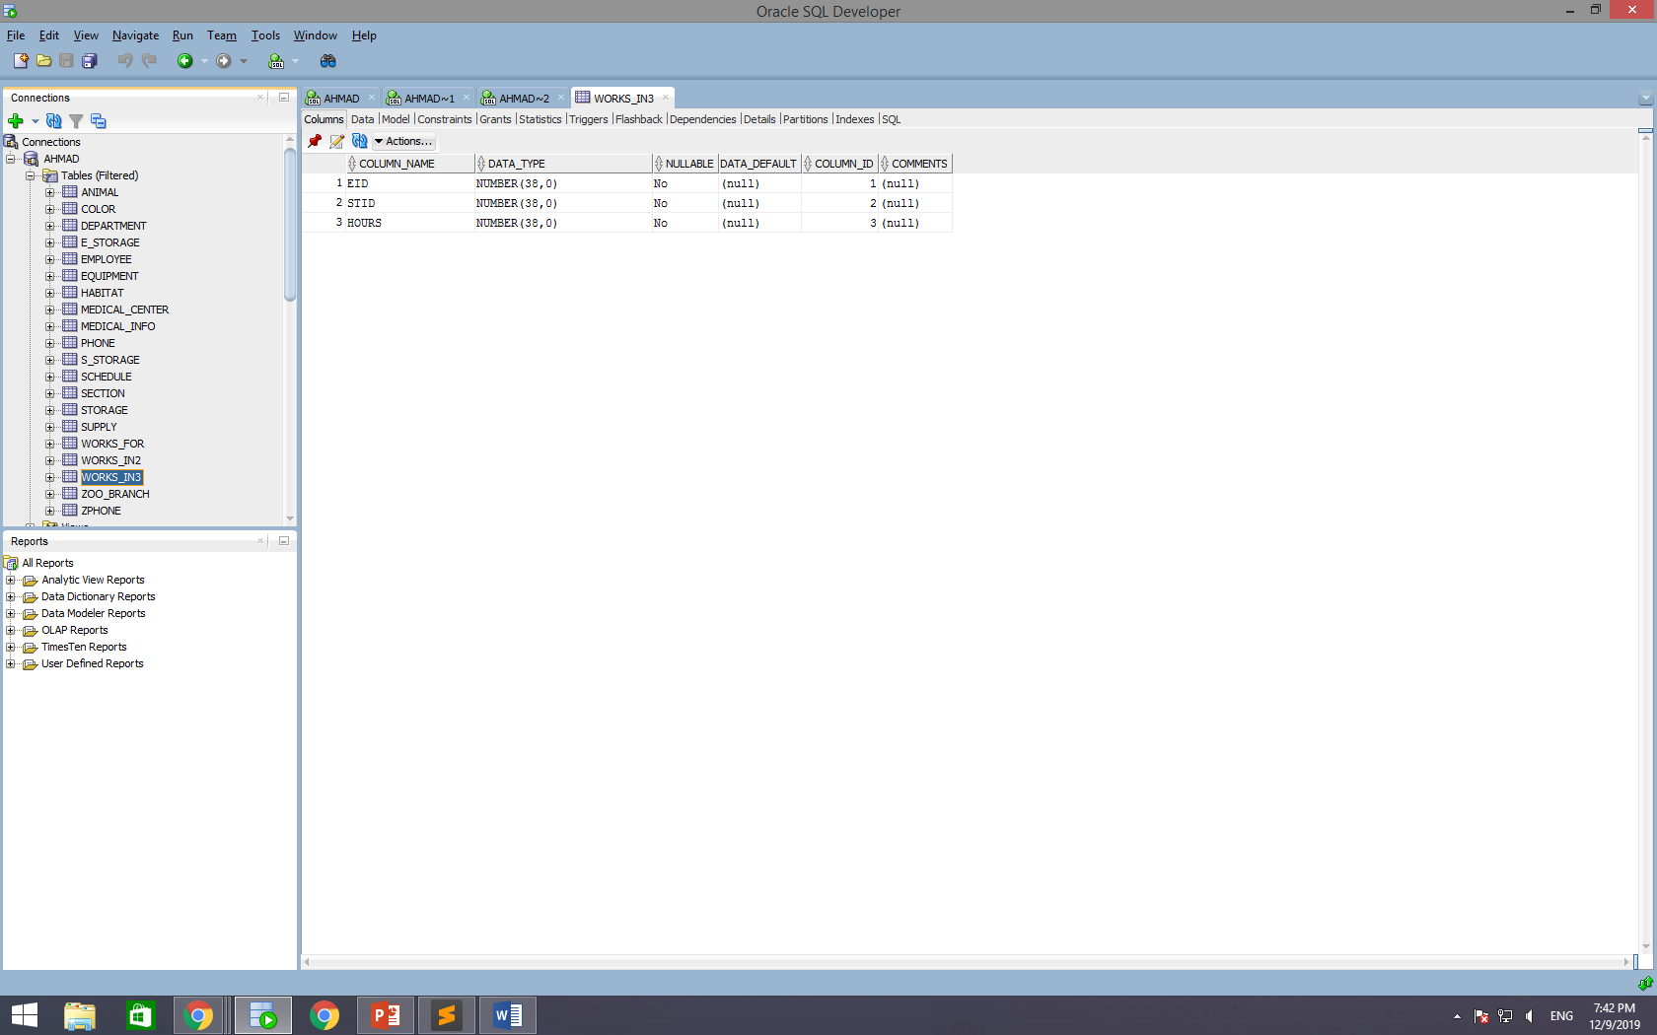

**ZOO_BRANCH**

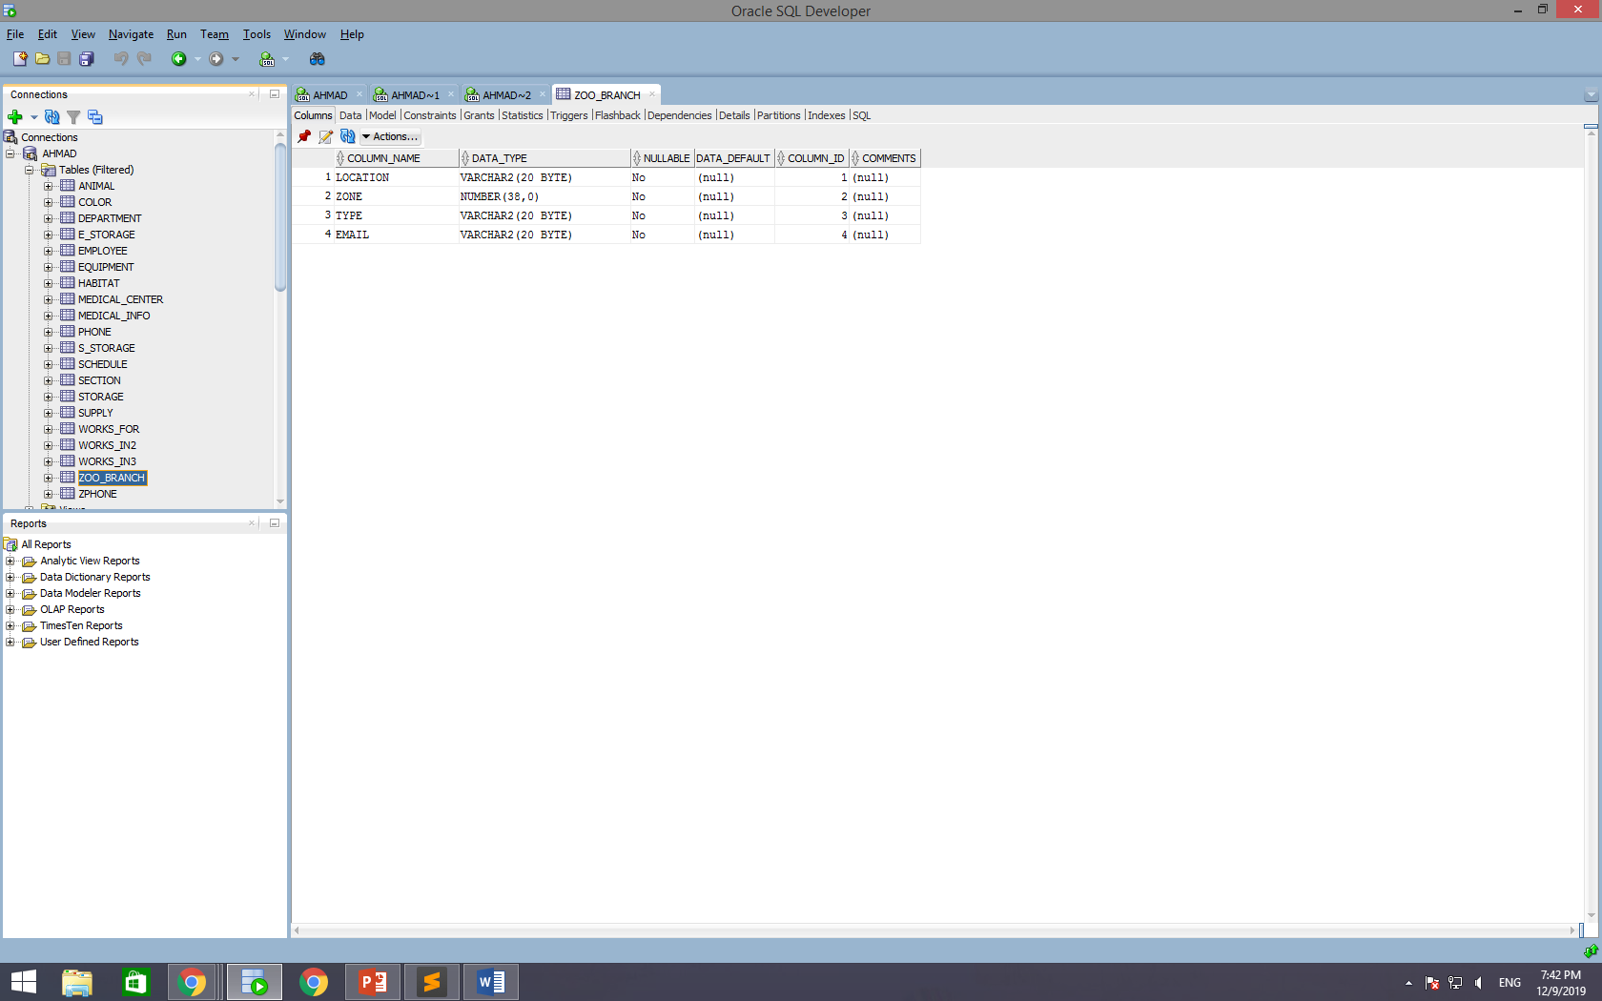

**ZPHONE**

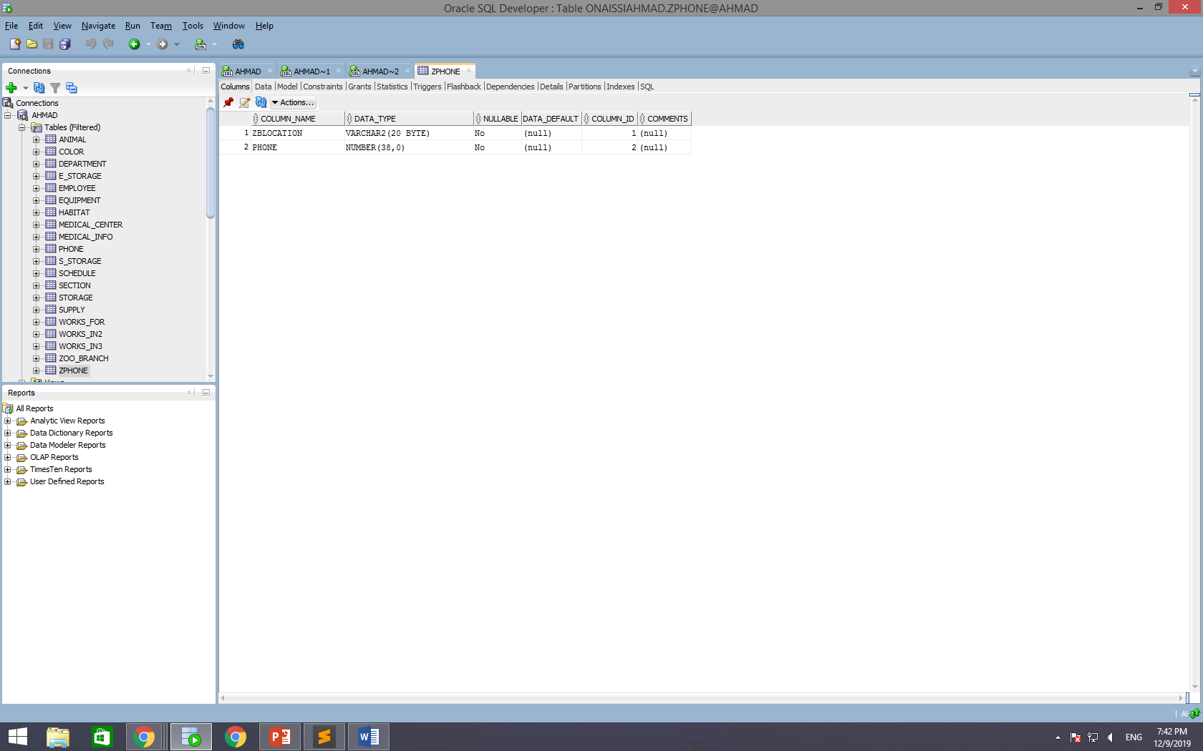

1. **Data Insertion:**

ANIMAL

INSERT INTO ANIMAL (AID, TYPE, NAME, DATE_OF_BIRTH, RESIDENCY, SEX, ORIGIN, AGE, HID)

VALUES ('0', 'PENGUIN', 'PIGO', '2015', 'FALSE', 'F', 'SOUTH POLE', '4', '1');

INSERT INTO ANIMAL (AID, TYPE, NAME, DATE_OF_BIRTH, RESIDENCY, SEX, ORIGIN, AGE, HID)

VALUES ('1', 'PIGEON', 'PIGZ', '2016', 'TRUE', 'M', 'NORTH POLE', '3', '1');

INSERT INTO ANIMAL (AID, TYPE, NAME, DATE_OF_BIRTH, RESIDENCY, SEX, ORIGIN, AGE, HID)

VALUES ('2', 'OWL', 'OLLL', '2018', 'TRUE', 'F', 'AFRICA', '1', '1');

INSERT INTO ANIMAL (AID, TYPE, NAME, DATE_OF_BIRTH, RESIDENCY, SEX, ORIGIN, AGE, HID)

VALUES ('3', 'LIZARD', 'LIZZ', '2014', 'TRUE', 'F', 'DOMINICAN REPUBLIC', '5', '2');

INSERT INTO ANIMAL (AID, TYPE, NAME, DATE_OF_BIRTH, RESIDENCY, SEX, ORIGIN, AGE, HID)

VALUES ('4', 'TURTLE', 'TOTZZ', '2010', 'TRUE', 'M', 'LEBANON', '9', '2');

INSERT INTO ANIMAL (AID, TYPE, NAME, DATE_OF_BIRTH, RESIDENCY, SEX, ORIGIN, AGE, HID)

VALUES ('5', 'SNAKE', 'TSSSS', '2007', 'FALSE', 'F', 'DUBAI', '12', '2');

INSERT INTO ANIMAL (AID, TYPE, NAME, DATE_OF_BIRTH, RESIDENCY, SEX, ORIGIN, AGE, HID)

VALUES ('6', 'SCORPION', 'SCORPSS', '2015', 'FALSE', 'M', 'ACTIVISION', '4', '3');

INSERT INTO ANIMAL (AID, TYPE, NAME, DATE_OF_BIRTH, RESIDENCY, SEX, ORIGIN, AGE, HID)

VALUES ('7', 'CRAB', 'CRABETTE', '2014', 'TRUE', 'F', 'SAUDI ARABIA', '5', '3');

INSERT INTO ANIMAL (AID, TYPE, NAME, DATE_OF_BIRTH, RESIDENCY, SEX, ORIGIN, AGE, HID)

VALUES ('8', 'BEE', 'BUZZZ', '2014', 'TRUE', 'M', 'TEXAS', '5', '3');

INSERT INTO ANIMAL (AID, TYPE, NAME, DATE_OF_BIRTH, RESIDENCY, SEX, ORIGIN, AGE, HID)

VALUES ('9', 'BAT', 'BATMAN', '2018', 'TRUE', 'M', 'GOTHAM', '1', '4');

INSERT INTO ANIMAL (AID, TYPE, NAME, DATE_OF_BIRTH, RESIDENCY, SEX, ORIGIN, AGE, HID)

VALUES ('10', 'BEAR', 'KHABIB', '2014', 'FALSE', 'M', 'RUSSIA', '5', '4');

INSERT INTO ANIMAL (AID, TYPE, NAME, DATE_OF_BIRTH, RESIDENCY, SEX, ORIGIN, AGE, HID)

VALUES ('11', 'BEE', 'BAMBI', '2013', 'TRUE', 'F', 'NORWAY', '6', '4');

INSERT INTO ANIMAL (AID, TYPE, NAME, DATE_OF_BIRTH, RESIDENCY, SEX, ORIGIN, AGE, HID)

VALUES ('12', 'WHALE', 'WHALO', '2004', 'FALSE', 'M', 'ANTARCTICA', '15', '5');

INSERT INTO ANIMAL (AID, TYPE, NAME, DATE_OF_BIRTH, RESIDENCY, SEX, ORIGIN, AGE, HID)

VALUES ('13', 'SHARK', 'SHARKIE', '2014', 'FALSE', 'F', 'PORTUGAL', '5', '5');

INSERT INTO ANIMAL (AID, TYPE, NAME, DATE_OF_BIRTH, RESIDENCY, SEX, ORIGIN, AGE, HID)

VALUES ('14', 'SEAL', 'LEON', '2011', 'FALSE', 'F', 'FRANCE', '8', '5');

INSERT INTO ANIMAL (AID, TYPE, NAME, DATE_OF_BIRTH, RESIDENCY, SEX, ORIGIN, AGE, HID)

VALUES ('15', 'FROG', 'FROGO', '2016', 'TRUE', 'M', 'GABON', '5', '6');

INSERT INTO ANIMAL (AID, TYPE, NAME, DATE_OF_BIRTH, RESIDENCY, SEX, ORIGIN, AGE, HID)

VALUES ('16', 'TOAD', 'TOD', '2017', 'TRUE', 'M', 'SPAIN', '2', '6');

INSERT INTO ANIMAL (AID, TYPE, NAME, DATE_OF_BIRTH, RESIDENCY, SEX, ORIGIN, AGE, HID)

VALUES ('17', 'NEWT', 'NOUNZZ', '2019', 'TRUE', 'F', 'DOMINICAN REPUBLIC', '1', '6');

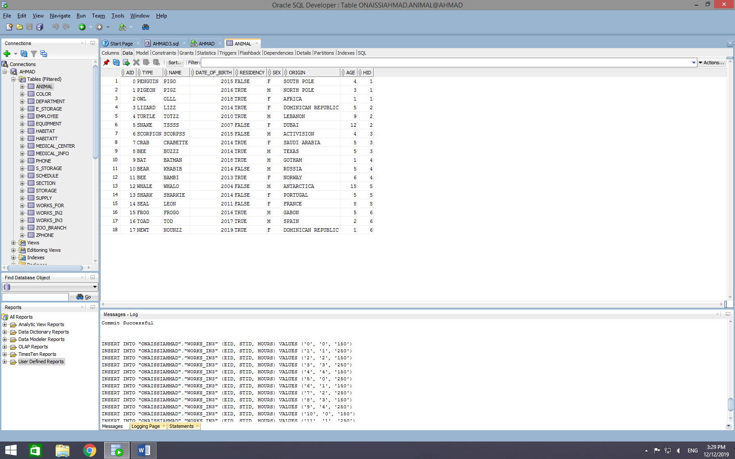

EMPLOYEE

INSERT INTO EMPLOYEE (EID, STATUS, STREET, CITY, COUNTRY, BUILDING, FLOOR, SEX, LNAME, MINITIAL, FNAME, POSITION, DATE_OF_BIRTH, HOURS, ZBLOCATION, SALARY, TYPE_OF_WORK)

VALUES ('0', 'SINGLE', 'BEYDOUN', 'ASHRAFIEH', 'LEBANON', 'KHATIB', '5', 'M', 'ISMAIL', 'M', 'AHMAD' , 'TECHNICIAN', '1999', '178', 'DUBAI','1500', 'IT');

INSERT INTO EMPLOYEE (EID, STATUS, STREET, CITY, COUNTRY, BUILDING, FLOOR, SEX, LNAME, MINITIAL, FNAME, POSITION, DATE_OF_BIRTH, HOURS, ZBLOCATION, SALARY, TYPE_OF_WORK)

VALUES ('1', 'SINGLE', 'ZGHARTA HIGHWAY', 'ZGHARTA', 'LEBANON', 'HBAYTER', '3', 'M', 'HBAYTER', 'M', 'CHARBEL' , 'MANAGER', '1999', '247', 'DUBAI', '3500, ' OFFICE WORK'');

INSERT INTO EMPLOYEE (EID, STATUS, STREET, CITY, COUNTRY, BUILDING, FLOOR, SEX, LNAME, MINITIAL, FNAME, POSITION, DATE_OF_BIRTH, HOURS, ZBLOCATION, SALARY, TYPE_OF_WORK)

VALUES ('2', 'SINGLE', 'MAAWAD', 'DAHYEH', 'LEBANON', 'MOKDAD', '1', 'M', 'ONAISSI', 'H', 'AHMAD' , 'DOORMAN', '1999', '150', 'LONDON', '1500', 'SECURITY');

INSERT INTO EMPLOYEE (EID, STATUS, STREET, CITY, COUNTRY, BUILDING, FLOOR, SEX, LNAME, MINITIAL, FNAME, POSITION, DATE_OF_BIRTH, HOURS, ZBLOCATION, SALARY, TYPE_OF_WORK)

VALUES ('3', 'SINGLE', 'AMERICA', 'HAMRA', 'LEBANON', 'SALAMEH', '2', 'F', 'HESSE', 'K', 'ROZETTE' , 'MARKETING', '1999', '250', 'LONDON', '3500', 'ADVERTISING');

INSERT INTO EMPLOYEE (EID, STATUS, STREET, CITY, COUNTRY, BUILDING, FLOOR, SEX, LNAME, MINITIAL, FNAME, POSITION, DATE_OF_BIRTH, HOURS, ZBLOCATION, SALARY, TYPE_OF_WORK)

VALUES ('4', 'MARRIED', 'SODECO', 'ASHRAFIEH', 'LEBANON', 'SODECO', '8', 'F', 'BERRO', 'A', 'SALLY' , 'FEEDER', '1999', '301', 'AFRICA', '1500', 'FEEDING');

INSERT INTO EMPLOYEE (EID, STATUS, STREET, CITY, COUNTRY, BUILDING, FLOOR, SEX, LNAME, MINITIAL, FNAME, POSITION, DATE_OF_BIRTH, HOURS, ZBLOCATION, SALARY, TYPE_OF_WORK)

VALUES ('5', 'SINGLE', 'SHEER', 'JEZZINE', 'LEBANON', 'MRAD', '2', 'F', 'KANSO', 'N', 'MARYAM' , 'TOURIST', '1999', '97', 'AFRICA', '3500', 'TOURS');

INSERT INTO EMPLOYEE (EID, STATUS, STREET, CITY, COUNTRY, BUILDING, FLOOR, SEX, LNAME, MINITIAL, FNAME, POSITION, DATE_OF_BIRTH, HOURS, ZBLOCATION, SALARY, TYPE_OF_WORK)

VALUES ('6', 'SINGLE', 'GOUREAU', 'CHEKKA', 'LEBANON', 'DERBASS', '1', 'F', 'ABBOUD', 'F', 'PASCALE' , 'HR', '1999', '128', 'CASABLANCA', '1500', 'PAPERWORK');

INSERT INTO EMPLOYEE (EID, STATUS, STREET, CITY, COUNTRY, BUILDING, FLOOR, SEX, LNAME, MINITIAL, FNAME, POSITION, DATE_OF_BIRTH, HOURS, ZBLOCATION, SALARY, TYPE_OF_WORK)

VALUES ('7', 'SINGLE', 'SADAT', 'VERDUN', 'LEBANON', 'AWWAD', '6', 'F', 'IBRAHIM', 'W', 'TIA' , 'FINANCE', '1999', '246', 'CASABLANCA', '3500', 'BUDGETING');

INSERT INTO EMPLOYEE (EID, STATUS, STREET, CITY, COUNTRY, BUILDING, FLOOR, SEX, LNAME, MINITIAL, FNAME, POSITION, DATE_OF_BIRTH, HOURS, ZBLOCATION, SALARY, TYPE_OF_WORK)

VALUES ('8', 'SINGLE', 'DBAYEH', 'MATN', 'LEBANON', 'KHATIB', '5', 'M', 'ABRAHAN', 'X', 'ADRIAN' , 'TECHNICIAN', '1999', '307', 'HONOLULU', '1500', 'IT');

INSERT INTO EMPLOYEE (EID, STATUS, STREET, CITY, COUNTRY, BUILDING, FLOOR, SEX, LNAME, MINITIAL, FNAME, POSITION, DATE_OF_BIRTH, HOURS, ZBLOCATION, SALARY, TYPE_OF_WORK)

VALUES ('9', 'SINGLE', 'BIEL', 'DOWNTOWN', 'LEBANON', 'HBAYTER', '3', 'M', 'SLEEM', 'S', 'CARLOS' , 'MANAGER', '1999', '278', 'HONOLULU', '3500', 'OFFICE WORK');

INSERT INTO EMPLOYEE (EID, STATUS, STREET, CITY, COUNTRY, BUILDING, FLOOR, SEX, LNAME, MINITIAL, FNAME, POSITION, DATE_OF_BIRTH, HOURS, ZBLOCATION, SALARY, TYPE_OF_WORK)

VALUES ('0', 'SINGLE', 'BEYDOUN', 'ASHRAFIEH', 'LEBANON', 'KHATIB', '5', 'M', 'LORAN', 'M', 'AHMAD' , 'TECHNICIAN', '1999', '100', 'FARAH', '1500', 'IT');

INSERT INTO EMPLOYEE (EID, STATUS, STREET, CITY, COUNTRY, BUILDING, FLOOR, SEX, LNAME, MINITIAL, FNAME, POSITION, DATE_OF_BIRTH, HOURS, ZBLOCATION, SALARY, TYPE_OF_WORK)

VALUES ('1', 'SINGLE', 'ZGHARTA HIGHWAY', 'ZGHARTA', 'LEBANON', 'HBAYTER', '3', 'M', 'SALIM', 'M', 'CHARBEL' , 'MANAGER', '1999', '75', 'FARAH', '3500', 'OFFICE WORK');

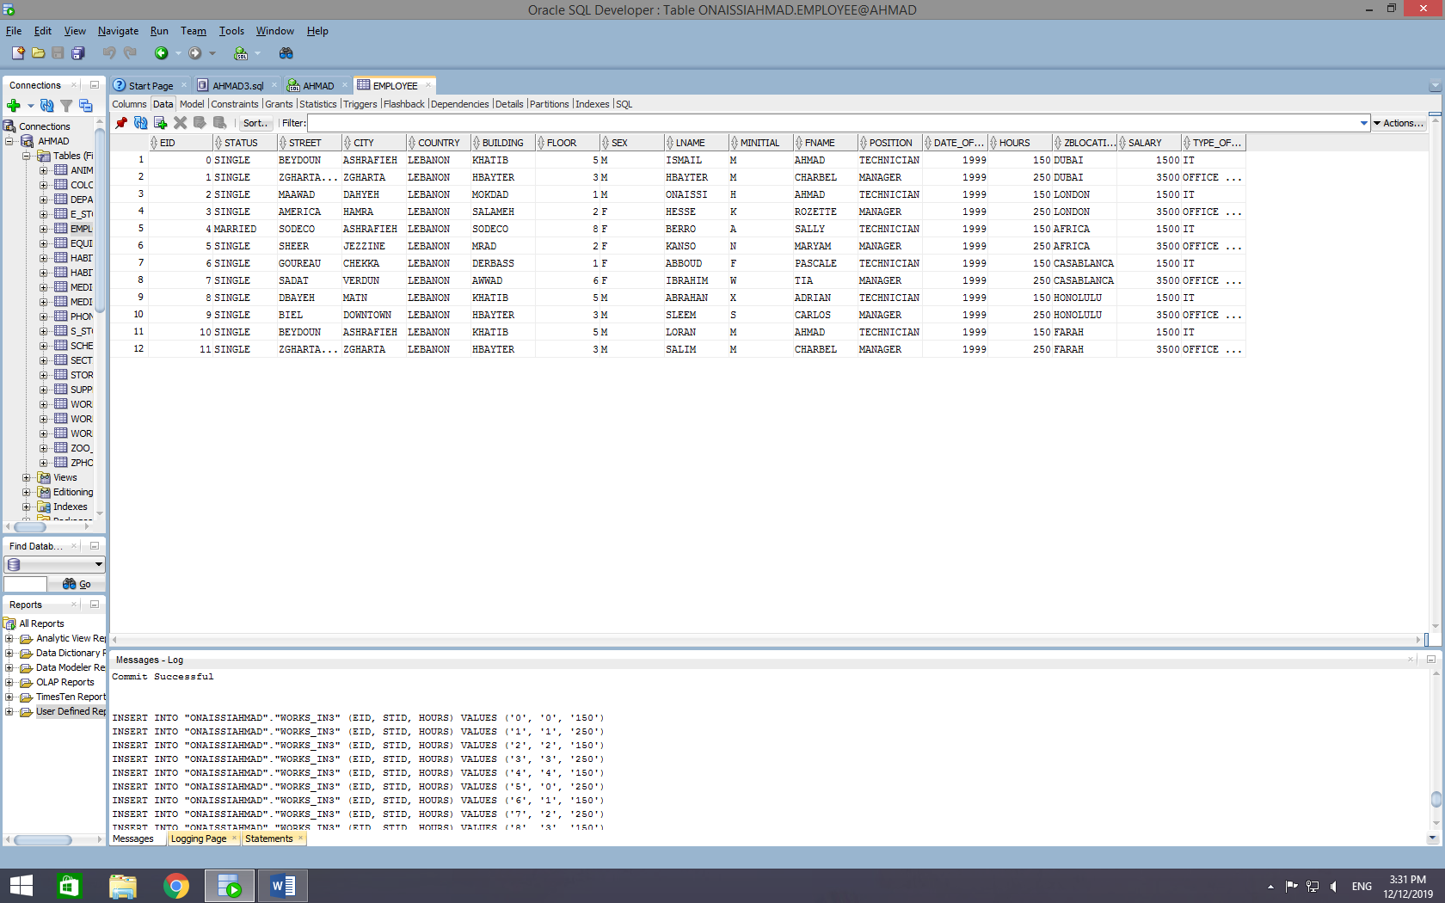

ZOO_BRANCH

INSERT INTO "ONAISSIAHMAD"."ZOO_BRANCH" (LOCATION, ZONE, TYPE, EMAIL) VALUES ('DUBAI', '500', 'CLOSED', 'AHMAD.ISMAIL05@LAU.EDU')

INSERT INTO "ONAISSIAHMAD"."ZOO_BRANCH" (LOCATION, ZONE, TYPE, EMAIL) VALUES ('LONDON', '743', 'ENCLOSED', 'HBAYTER@LAU.EDU')

INSERT INTO "ONAISSIAHMAD"."ZOO_BRANCH" (LOCATION, ZONE, TYPE, EMAIL) VALUES ('AFRICA', '852', 'CLOSED', 'ONAISSI@LAU.EDU')

INSERT INTO "ONAISSIAHMAD"."ZOO_BRANCH" (LOCATION, ZONE, TYPE, EMAIL) VALUES ('CASABLANCA', '879', 'ENCLOSED', 'HESSE@LAU.EDU')

INSERT INTO "ONAISSIAHMAD"."ZOO_BRANCH" (LOCATION, ZONE, TYPE, EMAIL) VALUES ('HONOLULU', '8476', 'CLOSED', 'HONO@LAU.EDU')

INSERT INTO "ONAISSIAHMAD"."ZOO_BRANCH" (LOCATION, ZONE, TYPE, EMAIL) VALUES ('FARAH', '789', 'ENCLOSED', 'FARAH@LAU.EDU')

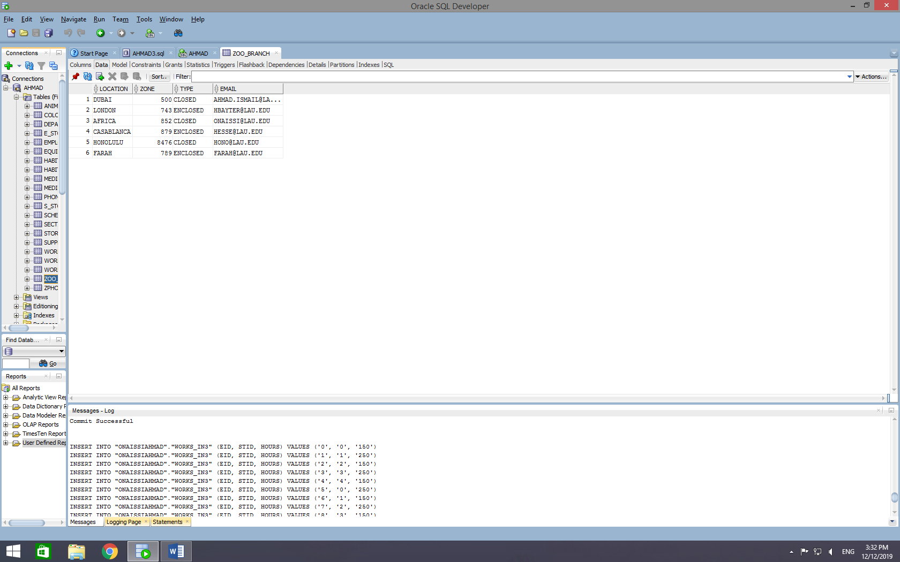

SECTION

INSERT INTO "ONAISSIAHMAD"."SECTION" (SEC_NUMBER, NAME, ZONE, ZBLOCATION) VALUES ('1', 'BIRDS WORLD', '120', 'DUBAI')

INSERT INTO "ONAISSIAHMAD"."SECTION" (SEC_NUMBER, NAME, ZONE, ZBLOCATION) VALUES ('2', 'REPTILES WORLD', '160', 'LONDON')

INSERT INTO "ONAISSIAHMAD"."SECTION" (SEC_NUMBER, NAME, ZONE, ZBLOCATION) VALUES ('3', 'ARTHROPODS WORLD', '250', 'AFRICA')

INSERT INTO "ONAISSIAHMAD"."SECTION" (SEC_NUMBER, NAME, ZONE, ZBLOCATION) VALUES ('4', 'MAMMALS WORLD', '100', 'LONDON')

INSERT INTO "ONAISSIAHMAD"."SECTION" (SEC_NUMBER, NAME, ZONE, ZBLOCATION) VALUES ('5', 'MARINE LIFE', '130', 'DUBAI')

INSERT INTO "ONAISSIAHMAD"."SECTION" (SEC_NUMBER, NAME, ZONE, ZBLOCATION) VALUES ('6', 'AMPHIBIANS WORLD', '360', 'CASABLANCA')

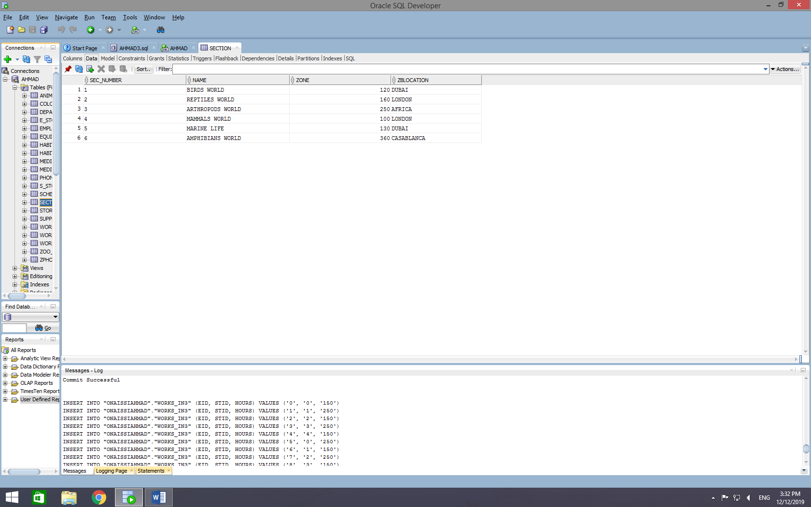

EQUIPMENT:

INSERT INTO "ONAISSIAHMAD"."EQUIPMENT" (SERIAL_NUMBER, TYPE, COST_PER_ITEM, DATE_OF_PURCHASE, MAINTENANCE) VALUES ('0', 'ATV', '3500', '2015', '2018')

INSERT INTO "ONAISSIAHMAD"."EQUIPMENT" (SERIAL_NUMBER, TYPE, COST_PER_ITEM, DATE_OF_PURCHASE) VALUES ('1', 'LAWN MOWER', '150', '2019')

INSERT INTO "ONAISSIAHMAD"."EQUIPMENT" (SERIAL_NUMBER, TYPE, COST_PER_ITEM, DATE_OF_PURCHASE) VALUES ('2', 'SUITS', '1000', '2018')

INSERT INTO "ONAISSIAHMAD"."EQUIPMENT" (SERIAL_NUMBER, TYPE, COST_PER_ITEM, DATE_OF_PURCHASE) VALUES ('3', 'BUCKETS', '50', '2010')

INSERT INTO "ONAISSIAHMAD"."EQUIPMENT" (SERIAL_NUMBER, TYPE, COST_PER_ITEM, DATE_OF_PURCHASE) VALUES ('4', 'AXE', '125', '2016')

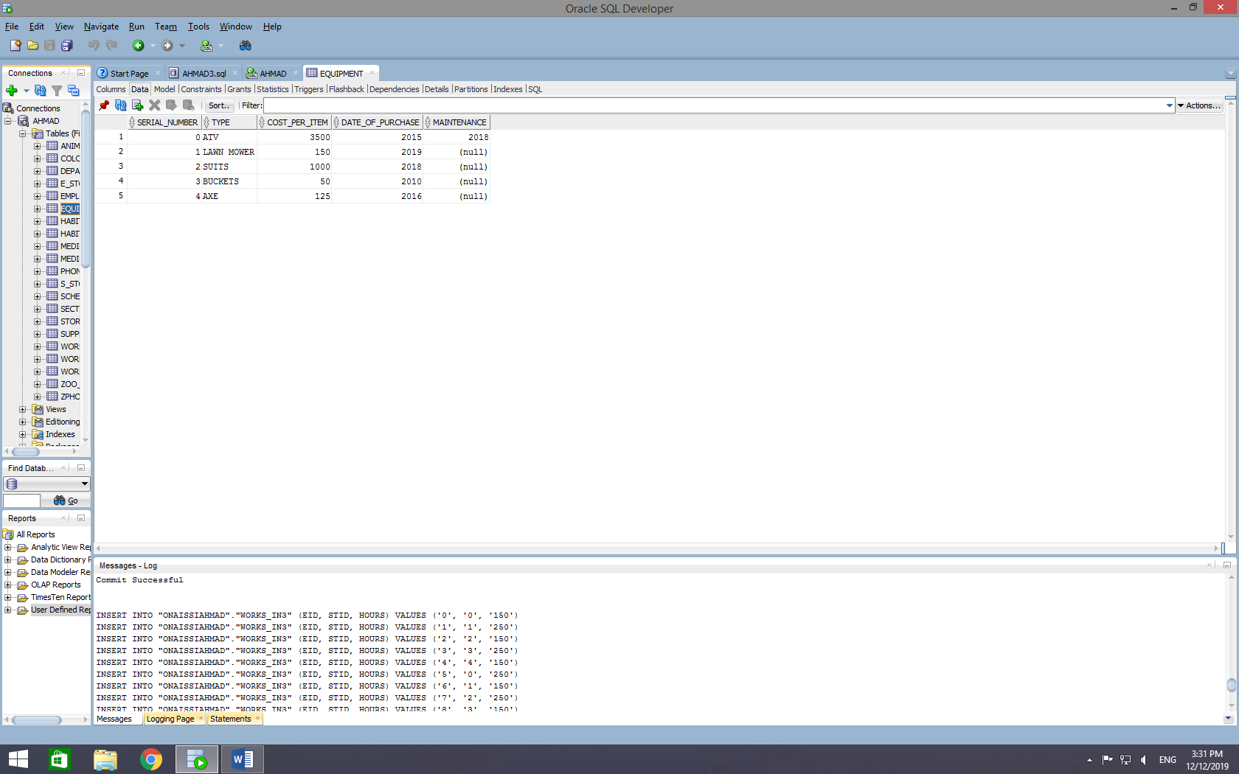

STORAGE

INSERT INTO "ONAISSIAHMAD"."STORAGE" (STID, SPACE, USED_SPACE, AVAILABLE_SPACE) VALUES ('0', '500', '250', '250')

INSERT INTO "ONAISSIAHMAD"."STORAGE" (STID, SPACE, USED_SPACE, AVAILABLE_SPACE) VALUES ('1', '100', '43', '57')

INSERT INTO "ONAISSIAHMAD"."STORAGE" (STID, SPACE, USED_SPACE, AVAILABLE_SPACE) VALUES ('2', '260', '60', '200')

INSERT INTO "ONAISSIAHMAD"."STORAGE" (STID, SPACE, USED_SPACE, AVAILABLE_SPACE) VALUES ('3', '980', '360', '620')

INSERT INTO "ONAISSIAHMAD"."STORAGE" (STID, SPACE, USED_SPACE, AVAILABLE_SPACE) VALUES ('4', '850', '250', '600')

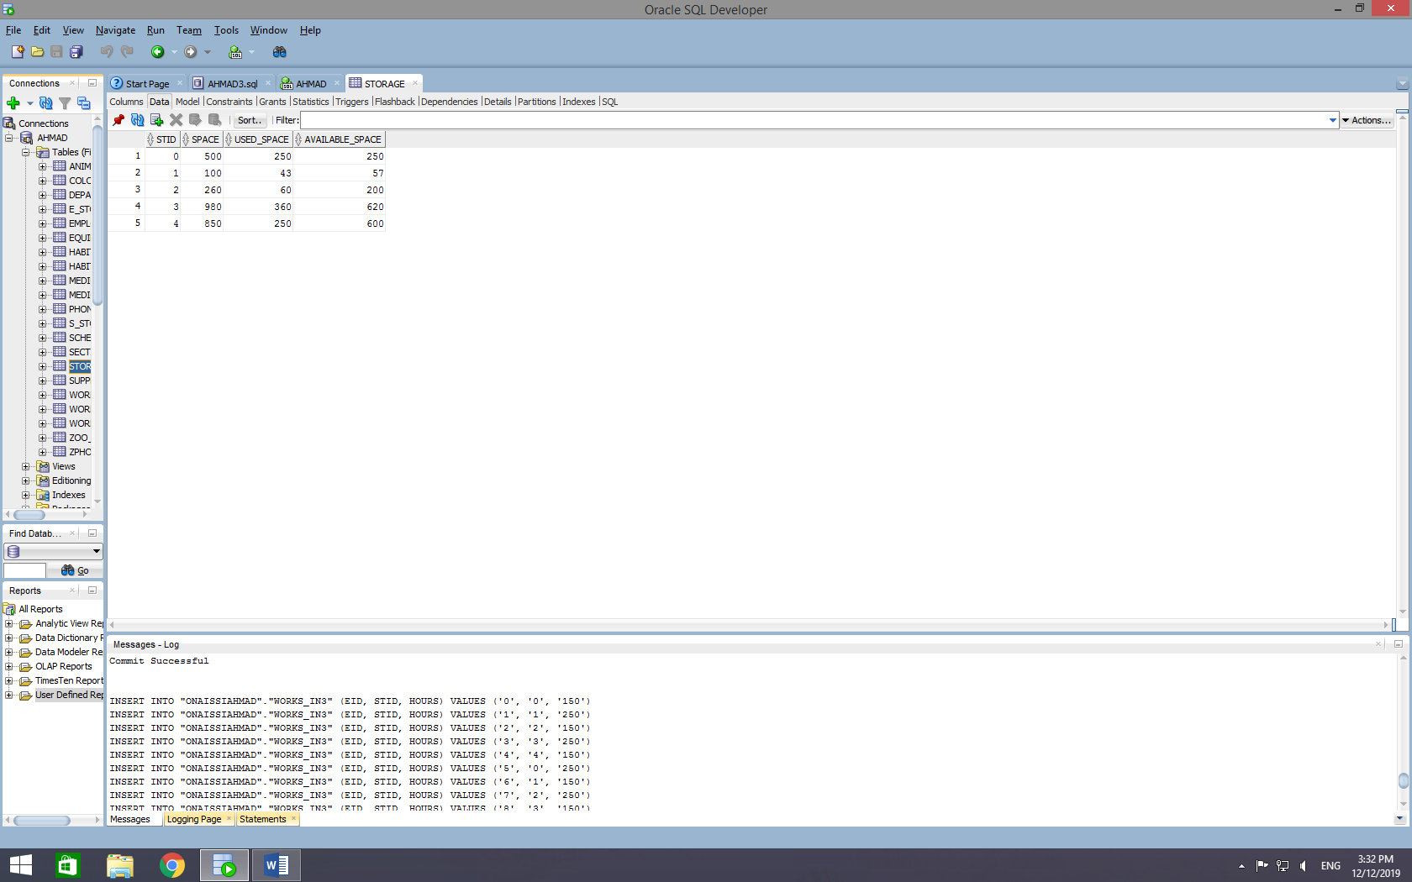

MEDICAL_CENTER

INSERT INTO "ONAISSIAHMAD"."MEDICAL_CENTER" (EXTENSION, NAME, NUMBER_OF_ROOM, ROOMS_USED, ROOMS_AVAILABLE, TOTAL_NUMBER_OF_ROOMS) VALUES ('1252', 'HEALTH CARE', '5', '12', '8', '20')

INSERT INTO "ONAISSIAHMAD"."MEDICAL_CENTER" (EXTENSION, NAME, NUMBER_OF_ROOM, ROOMS_USED, ROOMS_AVAILABLE, TOTAL_NUMBER_OF_ROOMS) VALUES ('1074', 'ICU', '7', '13', '2', '15')

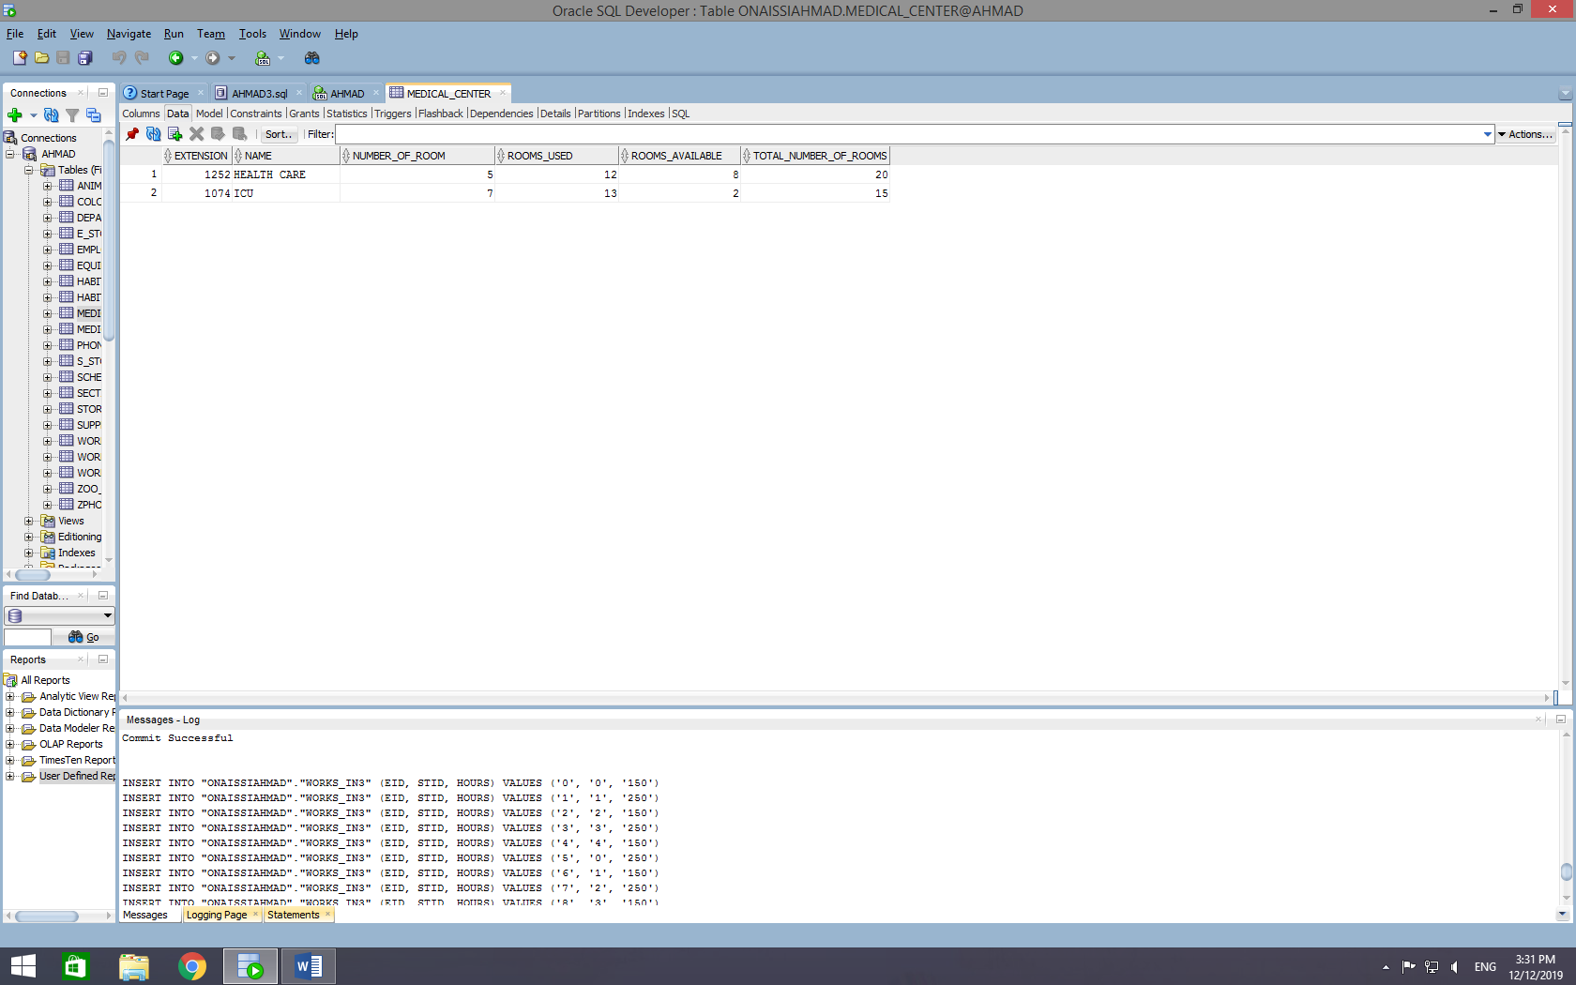

DEPARTMENT

INSERT INTO DEPARTMENT (EXTENSION, NAME, LOCATION)

VALUES ('1000', 'IT', 'SORORA BUILDING');

INSERT INTO DEPARTMENT (EXTENSION, NAME, LOCATION)

VALUES ('1780', 'HR', 'AREA 27');

INSERT INTO DEPARTMENT (EXTENSION, NAME, LOCATION)

VALUES ('18001', 'ANIMAL PROGRAMS', 'Argentina Street');

INSERT INTO DEPARTMENT (EXTENSION, NAME, LOCATION)

VALUES ('595904', 'FINANCES', 'Argentina Street');

INSERT INTO DEPARTMENT (EXTENSION, NAME, LOCATION)

VALUES ('1499', 'OPERATION MANAGEMENT', 'Barbara Area');

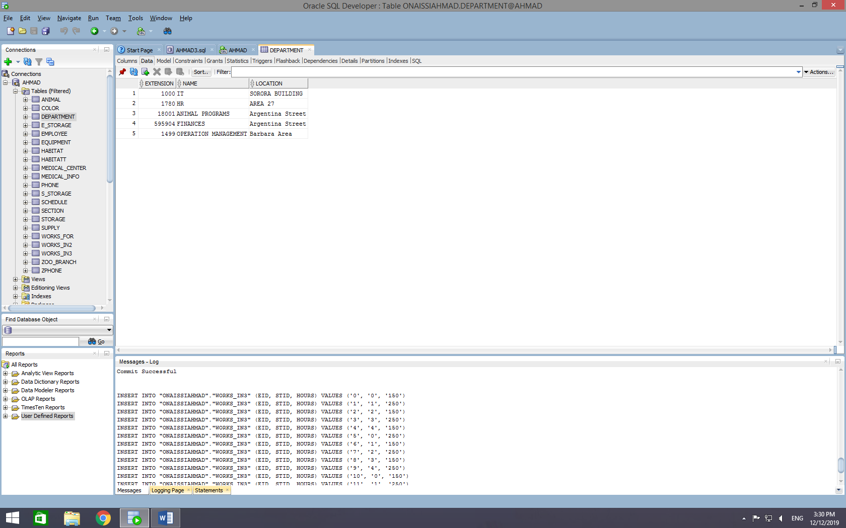

Supply

INSERT INTO SUPPLY (SUID, COST_PER_ITEM, TYPE, EXPIRY_DATE)

VALUES ('001', '2', 'SEEDS', '2022');

INSERT INTO SUPPLY (SUID, COST_PER_ITEM, TYPE, EXPIRY_DATE)

VALUES ('017', '30', 'MEAT', '2019');

INSERT INTO SUPPLY (SUID, COST_PER_ITEM, TYPE, EXPIRY_DATE)

VALUES ('041', '11', 'WOOD', '2030');

INSERT INTO SUPPLY (SUID, COST_PER_ITEM, TYPE, EXPIRY_DATE)

VALUES ('003', '3', 'WHEAT', '2020');

INSERT INTO SUPPLY (SUID, COST_PER_ITEM, TYPE, EXPIRY_DATE)

VALUES ('002', '1', 'WATER', '2030');

INSERT INTO SUPPLY (SUID, COST_PER_ITEM, TYPE, EXPIRY_DATE)

VALUES ('004', '2', 'GRAVEL', '2050');

INSERT INTO SUPPLY (SUID, COST_PER_ITEM, TYPE, EXPIRY_DATE)

VALUES ('005', '34', 'M1_VACCINE', '2021');

INSERT INTO SUPPLY (SUID, COST_PER_ITEM, TYPE, EXPIRY_DATE)

VALUES ('006', '12', 'ANTI-BIOTICS', '2022');

INSERT INTO SUPPLY (SUID, COST_PER_ITEM, TYPE, EXPIRY_DATE)

VALUES ('008', '200', 'PROTEIN_BIOTICS', '2025');

INSERT INTO SUPPLY (SUID, COST_PER_ITEM, TYPE, EXPIRY_DATE)

VALUES ('009', '4', 'RED_DOSE', '2020');

INSERT INTO SUPPLY (SUID, COST_PER_ITEM, TYPE, EXPIRY_DATE)

VALUES ('012', '67', 'CO_VACCINE', '2023');

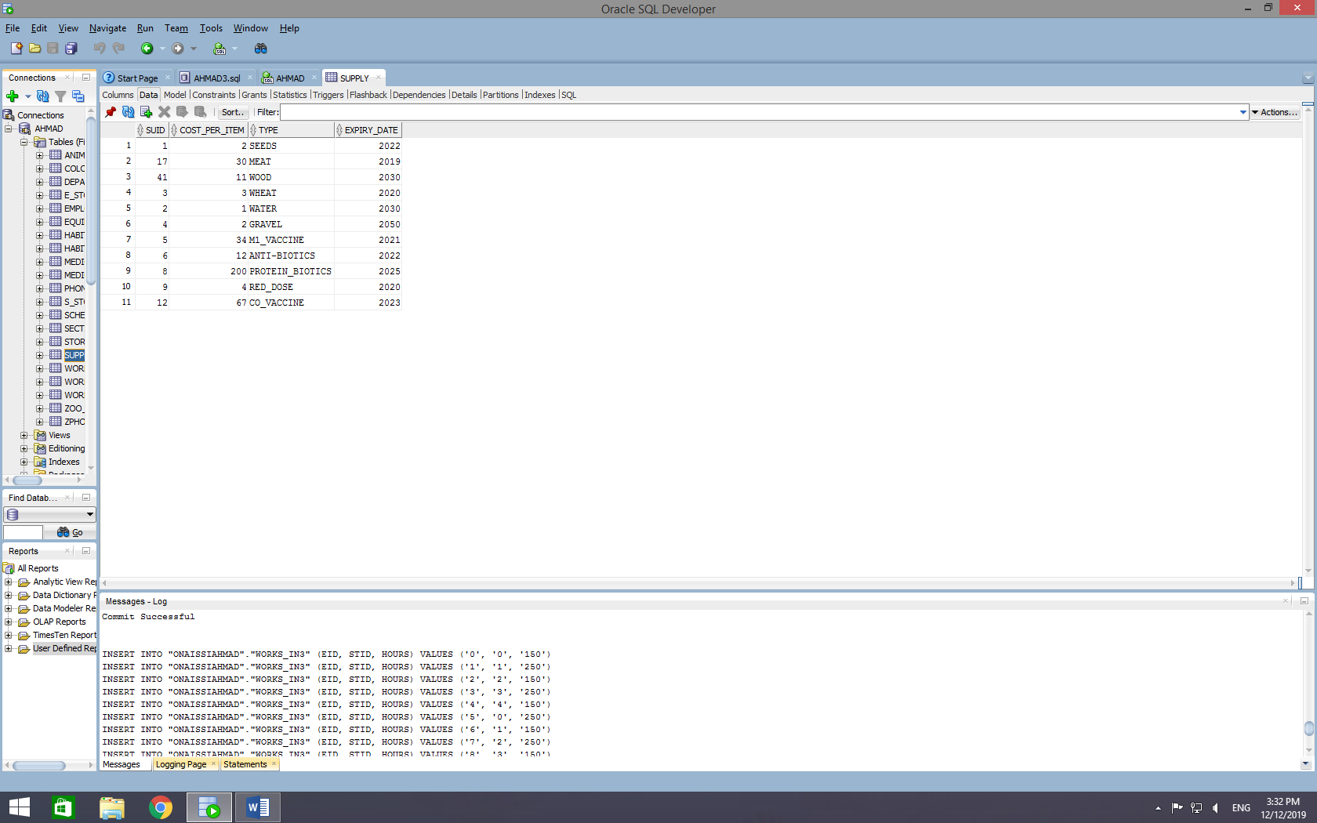

HABITATT

INSERT INTO "ONAISSIAHMAD"."HABITATT" (HID, ZONE, CAPACITY, TYPE, SECTION_NAME) VALUES ('1', '120', '12', 'TREES', 'BIRDS WORLD')

INSERT INTO "ONAISSIAHMAD"."HABITATT" (HID, ZONE, CAPACITY, TYPE, SECTION_NAME) VALUES ('2', '160', '65', 'WILDLIFE', 'REPTILES WORLD')

INSERT INTO "ONAISSIAHMAD"."HABITATT" (HID, ZONE, CAPACITY, TYPE, SECTION_NAME) VALUES ('3', '250', '84', 'FOREST', 'ARTHROPODS WORLD')

INSERT INTO "ONAISSIAHMAD"."HABITATT" (HID, ZONE, CAPACITY, TYPE, SECTION_NAME) VALUES ('4', '100', '35', 'WILDLIFE', 'MAMMALS WORLD')

INSERT INTO "ONAISSIAHMAD"."HABITATT" (HID, ZONE, CAPACITY, TYPE, SECTION_NAME) VALUES ('5', '130', '68', 'LAKE', 'MARINE LIFE')

INSERT INTO "ONAISSIAHMAD"."HABITATT" (HID, ZONE, CAPACITY, TYPE, SECTION_NAME) VALUES ('6', '360', '260', 'WILDLIFE', 'AMPHIBIANS WORLD')

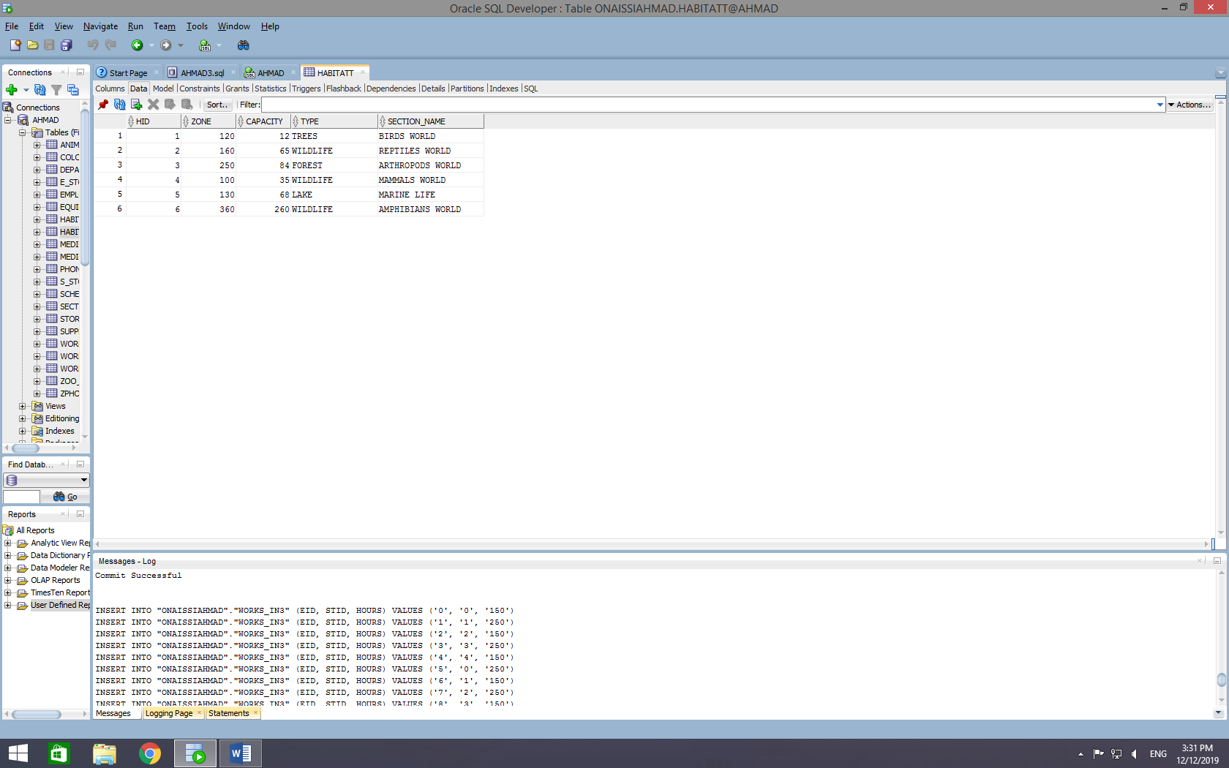

E_STORAGE

INSERT INTO "ONAISSIAHMAD"."E_STORAGE" (STID, SERIAL_NUMBER, QUANTITY) VALUES ('0', '0', '58')

INSERT INTO "ONAISSIAHMAD"."E_STORAGE" (STID, SERIAL_NUMBER, QUANTITY) VALUES ('3', '2', '92')

INSERT INTO "ONAISSIAHMAD"."E_STORAGE" (STID, SERIAL_NUMBER, QUANTITY) VALUES ('0', '2', '192')

INSERT INTO "ONAISSIAHMAD"."E_STORAGE" (STID, SERIAL_NUMBER, QUANTITY) VALUES ('1', '1', '24')

INSERT INTO "ONAISSIAHMAD"."E_STORAGE" (STID, SERIAL_NUMBER, QUANTITY) VALUES ('1', '3', '19')

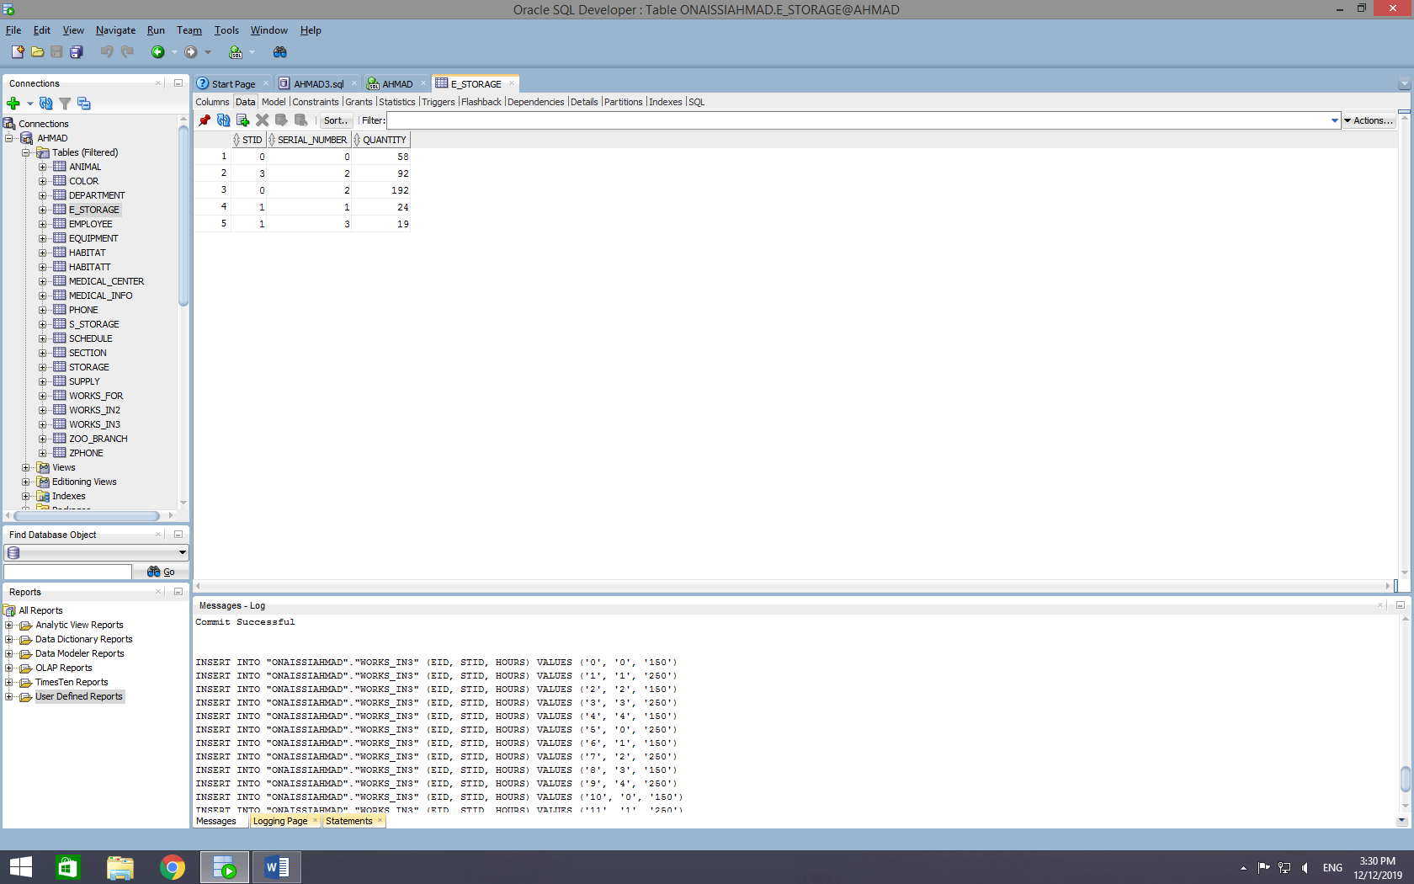

COLOR

INSERT INTO "ONAISSIAHMAD"."COLOR" (AID, COLOR) VALUES ('0', 'BLACK')

INSERT INTO "ONAISSIAHMAD"."COLOR" (AID, COLOR) VALUES ('1', 'RED')

INSERT INTO "ONAISSIAHMAD"."COLOR" (AID, COLOR) VALUES ('2', 'BLUE')

INSERT INTO "ONAISSIAHMAD"."COLOR" (AID, COLOR) VALUES ('3', 'BROWN')

INSERT INTO "ONAISSIAHMAD"."COLOR" (AID, COLOR) VALUES ('4', 'WHITE')

INSERT INTO "ONAISSIAHMAD"."COLOR" (AID, COLOR) VALUES ('5', 'GREY')

INSERT INTO "ONAISSIAHMAD"."COLOR" (AID, COLOR) VALUES ('6', 'DARK GREY')

INSERT INTO "ONAISSIAHMAD"."COLOR" (AID, COLOR) VALUES ('7', 'LIGHT BLUE')

INSERT INTO "ONAISSIAHMAD"."COLOR" (AID, COLOR) VALUES ('8', 'CAUCASIAN')

INSERT INTO "ONAISSIAHMAD"."COLOR" (AID, COLOR) VALUES ('9', 'TAN')

INSERT INTO "ONAISSIAHMAD"."COLOR" (AID, COLOR) VALUES ('10', 'YELLOW')

INSERT INTO "ONAISSIAHMAD"."COLOR" (AID, COLOR) VALUES ('11', 'GREEN')

INSERT INTO "ONAISSIAHMAD"."COLOR" (AID, COLOR) VALUES ('12', 'PINK')

INSERT INTO "ONAISSIAHMAD"."COLOR" (AID, COLOR) VALUES ('13', 'PURPLE')

INSERT INTO "ONAISSIAHMAD"."COLOR" (AID, COLOR) VALUES ('14', 'ORANGE')

INSERT INTO "ONAISSIAHMAD"."COLOR" (AID, COLOR) VALUES ('15', 'DARK BROWN')

INSERT INTO "ONAISSIAHMAD"."COLOR" (AID, COLOR) VALUES ('16', 'RED')

INSERT INTO "ONAISSIAHMAD"."COLOR" (AID, COLOR) VALUES ('17', 'MATTE BLACK')

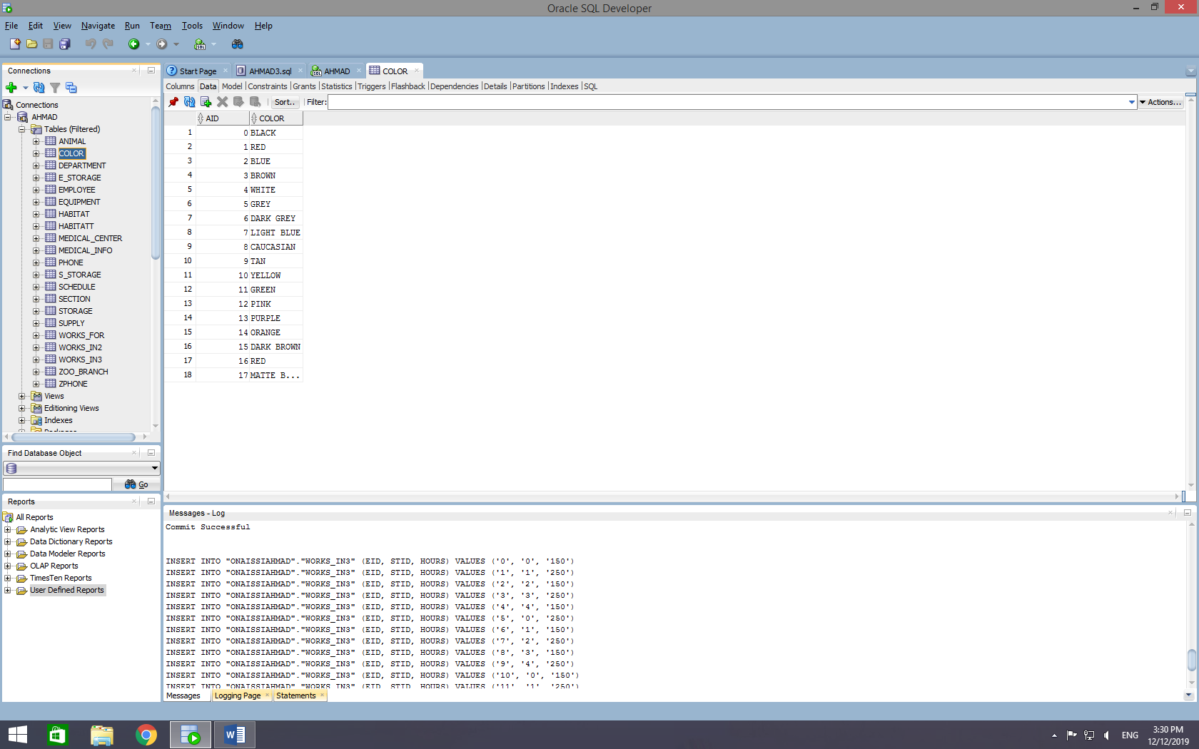

ZPHONE

INSERT INTO "ONAISSIAHMAD"."ZPHONE" (ZBLOCATION, PHONE) VALUES ('DUBAI', '101')

INSERT INTO "ONAISSIAHMAD"."ZPHONE" (ZBLOCATION, PHONE) VALUES ('LONDON', '102')

INSERT INTO "ONAISSIAHMAD"."ZPHONE" (ZBLOCATION, PHONE) VALUES ('AFRICA', '103')

INSERT INTO "ONAISSIAHMAD"."ZPHONE" (ZBLOCATION, PHONE) VALUES ('CASABLANCA', '104')

INSERT INTO "ONAISSIAHMAD"."ZPHONE" (ZBLOCATION, PHONE) VALUES ('HONOLULU', '105')

INSERT INTO "ONAISSIAHMAD"."ZPHONE" (ZBLOCATION, PHONE) VALUES ('FARAH', '106')

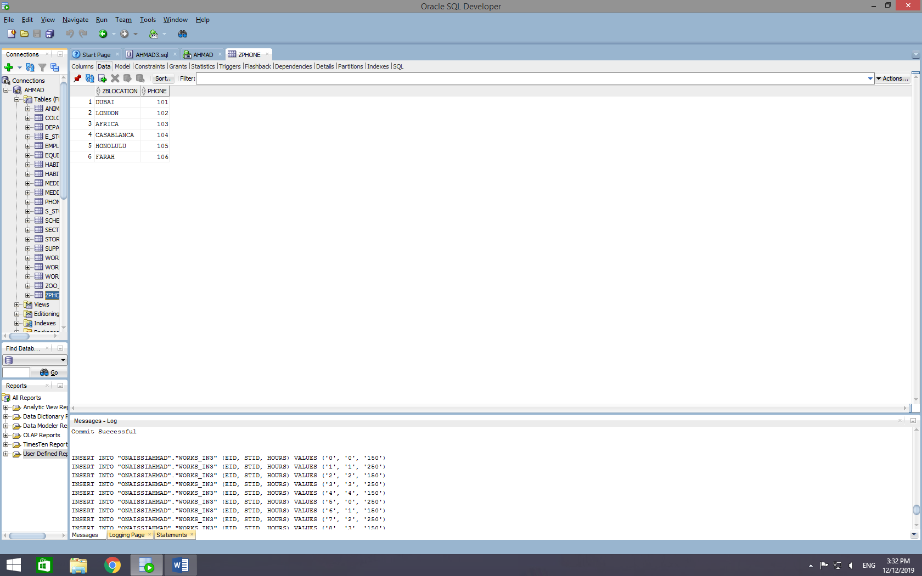

MEDICAL_INFO

INSERT INTO "ONAISSIAHMAD"."MEDICAL_INFO" (MEDID, HEIGHT, WEIGHT, BLOOD_TYPE, VACCINE_TAKEN, VACCINE_TO_TAKE, MEDICAL_CENTER_NAME, AID) VALUES ('0', '12.5', '25.6', 'AB', 'CDV', 'NULL', 'ICU', '0')

INSERT INTO "ONAISSIAHMAD"."MEDICAL_INFO" (MEDID, HEIGHT, WEIGHT, BLOOD_TYPE, VACCINE_TAKEN, VACCINE_TO_TAKE, MEDICAL_CENTER_NAME, AID) VALUES ('1', '14', '75.8', 'A', 'CPV', 'CAV', 'HEALTH CARE', '1')

INSERT INTO "ONAISSIAHMAD"."MEDICAL_INFO" (MEDID, HEIGHT, WEIGHT, BLOOD_TYPE, VACCINE_TAKEN, VACCINE_TO_TAKE, MEDICAL_CENTER_NAME, AID) VALUES ('2', '21.25', '46.2', 'B', 'CAV', 'CDV', 'ICU', '2')

INSERT INTO "ONAISSIAHMAD"."MEDICAL_INFO" (MEDID, HEIGHT, WEIGHT, BLOOD_TYPE, VACCINE_TAKEN, VACCINE_TO_TAKE, MEDICAL_CENTER_NAME, AID) VALUES ('3', '26', '90.5', 'O', 'CPI', 'NULL', 'HEALTH CARE', '3')

INSERT INTO "ONAISSIAHMAD"."MEDICAL_INFO" (MEDID, HEIGHT, WEIGHT, BLOOD_TYPE, VACCINE_TAKEN, VACCINE_TO_TAKE, MEDICAL_CENTER_NAME, AID) VALUES ('4', '10', '60.6', 'A', 'CR', 'CL', 'ICU', '4')

INSERT INTO "ONAISSIAHMAD"."MEDICAL_INFO" (MEDID, HEIGHT, WEIGHT, BLOOD_TYPE, VACCINE_TAKEN, VACCINE_TO_TAKE, MEDICAL_CENTER_NAME, AID) VALUES ('5', '21.25', '63.3', 'A', 'CR', 'CDV', 'HEALTH CARE', '5')

INSERT INTO "ONAISSIAHMAD"."MEDICAL_INFO" (MEDID, HEIGHT, WEIGHT, BLOOD_TYPE, VACCINE_TAKEN, VACCINE_TO_TAKE, MEDICAL_CENTER_NAME, AID) VALUES ('6', '21', '39', 'AB', 'CL', 'NULL', 'ICU', '6')

INSERT INTO "ONAISSIAHMAD"."MEDICAL_INFO" (MEDID, HEIGHT, WEIGHT, BLOOD_TYPE, VACCINE_TAKEN, VACCINE_TO_TAKE, MEDICAL_CENTER_NAME, AID) VALUES ('7', '10', '35', 'AB', 'CDV', 'NULL', 'HEALTH CARE', '7')

INSERT INTO "ONAISSIAHMAD"."MEDICAL_INFO" (MEDID, HEIGHT, WEIGHT, BLOOD_TYPE, VACCINE_TAKEN, VACCINE_TO_TAKE, MEDICAL_CENTER_NAME, AID) VALUES ('8', '10', '30', 'O', 'CPR', 'CDA', 'ICU', '8')

INSERT INTO "ONAISSIAHMAD"."MEDICAL_INFO" (MEDID, HEIGHT, WEIGHT, BLOOD_TYPE, VACCINE_TAKEN, VACCINE_TO_TAKE, MEDICAL_CENTER_NAME, AID) VALUES ('9', '11', '29', 'B', 'CRE', 'CDA', 'HEALTH CARE', '9')

INSERT INTO "ONAISSIAHMAD"."MEDICAL_INFO" (MEDID, HEIGHT, WEIGHT, BLOOD_TYPE, VACCINE_TAKEN, VACCINE_TO_TAKE, MEDICAL_CENTER_NAME, AID) VALUES ('10', '14', '36.6', 'B', 'CDA', 'CRE', 'ICU', '10')

INSERT INTO "ONAISSIAHMAD"."MEDICAL_INFO" (MEDID, HEIGHT, WEIGHT, BLOOD_TYPE, VACCINE_TAKEN, VACCINE_TO_TAKE, MEDICAL_CENTER_NAME, AID) VALUES ('11', '17', '40.7', 'A', 'CAD', 'CR', 'HEALTH CARE', '11')

INSERT INTO "ONAISSIAHMAD"."MEDICAL_INFO" (MEDID, HEIGHT, WEIGHT, BLOOD_TYPE, VACCINE_TAKEN, VACCINE_TO_TAKE, MEDICAL_CENTER_NAME, AID) VALUES ('12', '5', '49.8', 'B', 'CER', 'CDV', 'ICU', '12')

INSERT INTO "ONAISSIAHMAD"."MEDICAL_INFO" (MEDID, HEIGHT, WEIGHT, BLOOD_TYPE, VACCINE_TAKEN, VACCINE_TO_TAKE, MEDICAL_CENTER_NAME, AID) VALUES ('13', '31', '50.5', 'A', 'CR', 'CPV', 'HEALTH CARE', '13')

INSERT INTO "ONAISSIAHMAD"."MEDICAL_INFO" (MEDID, HEIGHT, WEIGHT, BLOOD_TYPE, VACCINE_TAKEN, VACCINE_TO_TAKE, MEDICAL_CENTER_NAME, AID) VALUES ('14', '6', '47.2', 'A', 'CDV', 'CAV', 'ICU', '14')

INSERT INTO "ONAISSIAHMAD"."MEDICAL_INFO" (MEDID, HEIGHT, WEIGHT, BLOOD_TYPE, VACCINE_TAKEN, VACCINE_TO_TAKE, MEDICAL_CENTER_NAME, AID) VALUES ('15', '15', '51.2', 'A', 'CDA', 'CL', 'HEALTH CARE', '15')

INSERT INTO "ONAISSIAHMAD"."MEDICAL_INFO" (MEDID, HEIGHT, WEIGHT, BLOOD_TYPE, VACCINE_TAKEN, VACCINE_TO_TAKE, MEDICAL_CENTER_NAME, AID) VALUES ('16', '12', '60.2', 'AB', 'CPV', 'NULL', 'ICU', '16')

INSERT INTO "ONAISSIAHMAD"."MEDICAL_INFO" (MEDID, HEIGHT, WEIGHT, BLOOD_TYPE, VACCINE_TAKEN, VACCINE_TO_TAKE, MEDICAL_CENTER_NAME, AID) VALUES ('17', '10', '40.1', 'O', 'CAV', 'NULL', 'HEALTH CARE', '17')

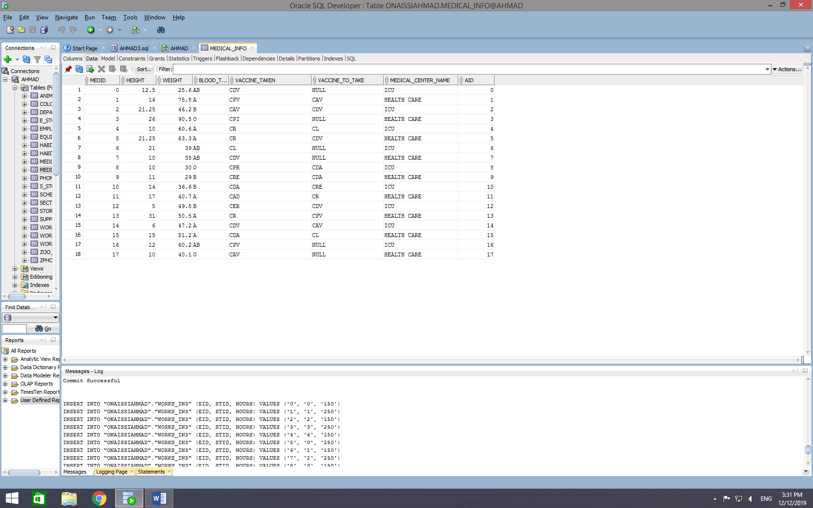

S_STORAGE

INSERT INTO "ONAISSIAHMAD"."S_STORAGE" (STID, SUID, QUANTITY) VALUES ('0', '1', '24')

INSERT INTO "ONAISSIAHMAD"."S_STORAGE" (STID, SUID, QUANTITY) VALUES ('1', '17', '30')

INSERT INTO "ONAISSIAHMAD"."S_STORAGE" (STID, SUID, QUANTITY) VALUES ('2', '41', '12')

INSERT INTO "ONAISSIAHMAD"."S_STORAGE" (STID, SUID, QUANTITY) VALUES ('3', '3', '19')

INSERT INTO "ONAISSIAHMAD"."S_STORAGE" (STID, SUID, QUANTITY) VALUES ('4', '2', '31')

INSERT INTO "ONAISSIAHMAD"."S_STORAGE" (STID, SUID, QUANTITY) VALUES ('0', '4', '26')

INSERT INTO "ONAISSIAHMAD"."S_STORAGE" (STID, SUID, QUANTITY) VALUES ('1', '5', '10')

INSERT INTO "ONAISSIAHMAD"."S_STORAGE" (STID, SUID, QUANTITY) VALUES ('2', '6', '17')

INSERT INTO "ONAISSIAHMAD"."S_STORAGE" (STID, SUID, QUANTITY) VALUES ('3', '8', '14')

INSERT INTO "ONAISSIAHMAD"."S_STORAGE" (STID, SUID, QUANTITY) VALUES ('4', '9', '19')

INSERT INTO "ONAISSIAHMAD"."S_STORAGE" (STID, SUID, QUANTITY) VALUES ('0', '12', '16')

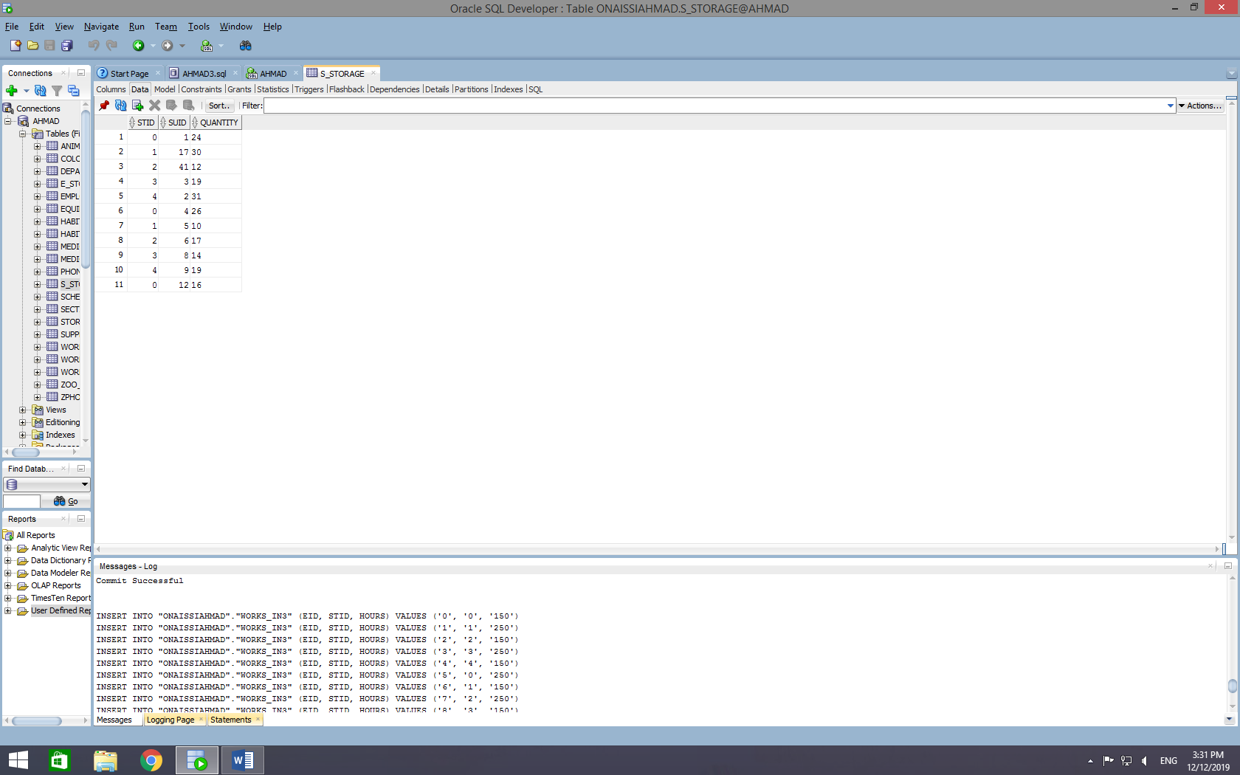

SCHEDULE

INSERT INTO "ONAISSIAHMAD"."SCHEDULE" (TYPE, START_HOUR, END_HOUR, START_DATE, WORKS_ON_HOLIDATS, WORKS_ON_WEEKENDS, EMPLOYEE_EID) VALUES ('PT', '8', '16', '1', '1', '0', '0')

INSERT INTO "ONAISSIAHMAD"."SCHEDULE" (TYPE, START_HOUR, END_HOUR, START_DATE, WORKS_ON_HOLIDATS, WORKS_ON_WEEKENDS, EMPLOYEE_EID) VALUES ('PT', '8', '16', '9', '0', '1', '1')

INSERT INTO "ONAISSIAHMAD"."SCHEDULE" (TYPE, START_HOUR, END_HOUR, START_DATE, WORKS_ON_HOLIDATS, WORKS_ON_WEEKENDS, EMPLOYEE_EID) VALUES ('FT', '8', '16', '12', '0', '1', '2')

INSERT INTO "ONAISSIAHMAD"."SCHEDULE" (TYPE, START_HOUR, END_HOUR, START_DATE, WORKS_ON_HOLIDATS, WORKS_ON_WEEKENDS, EMPLOYEE_EID) VALUES ('PT', '8', '16', '21', '0', '1', '3')

INSERT INTO "ONAISSIAHMAD"."SCHEDULE" (TYPE, START_HOUR, END_HOUR, START_DATE, WORKS_ON_HOLIDATS, WORKS_ON_WEEKENDS, EMPLOYEE_EID) VALUES ('FT', '8', '16', '5', '1', '0', '4')

INSERT INTO "ONAISSIAHMAD"."SCHEDULE" (TYPE, START_HOUR, END_HOUR, START_DATE, WORKS_ON_HOLIDATS, WORKS_ON_WEEKENDS, EMPLOYEE_EID) VALUES ('FT', '8', '16', '10', '0', '1', '5')

INSERT INTO "ONAISSIAHMAD"."SCHEDULE" (TYPE, START_HOUR, END_HOUR, START_DATE, WORKS_ON_HOLIDATS, WORKS_ON_WEEKENDS, EMPLOYEE_EID) VALUES ('PT', '8', '16', '2', '0', '1', '6')

INSERT INTO "ONAISSIAHMAD"."SCHEDULE" (TYPE, START_HOUR, END_HOUR, START_DATE, WORKS_ON_HOLIDATS, WORKS_ON_WEEKENDS, EMPLOYEE_EID) VALUES ('FT', '8', '16', '6', '1', '0', '7')

INSERT INTO "ONAISSIAHMAD"."SCHEDULE" (TYPE, START_HOUR, END_HOUR, START_DATE, WORKS_ON_HOLIDATS, WORKS_ON_WEEKENDS, EMPLOYEE_EID) VALUES ('PT', '8', '16', '16', '1', '0', '8')

INSERT INTO "ONAISSIAHMAD"."SCHEDULE" (TYPE, START_HOUR, END_HOUR, START_DATE, WORKS_ON_HOLIDATS, WORKS_ON_WEEKENDS, EMPLOYEE_EID) VALUES ('FT', '8', '16', '18', '1', '0', '9')

INSERT INTO "ONAISSIAHMAD"."SCHEDULE" (TYPE, START_HOUR, END_HOUR, START_DATE, WORKS_ON_HOLIDATS, WORKS_ON_WEEKENDS, EMPLOYEE_EID) VALUES ('PT', '8', '16', '29', '0', '1', '10')

INSERT INTO "ONAISSIAHMAD"."SCHEDULE" (TYPE, START_HOUR, END_HOUR, START_DATE, WORKS_ON_HOLIDATS, WORKS_ON_WEEKENDS, EMPLOYEE_EID) VALUES ('FT', '8', '16', '31', '1', '0', '11')

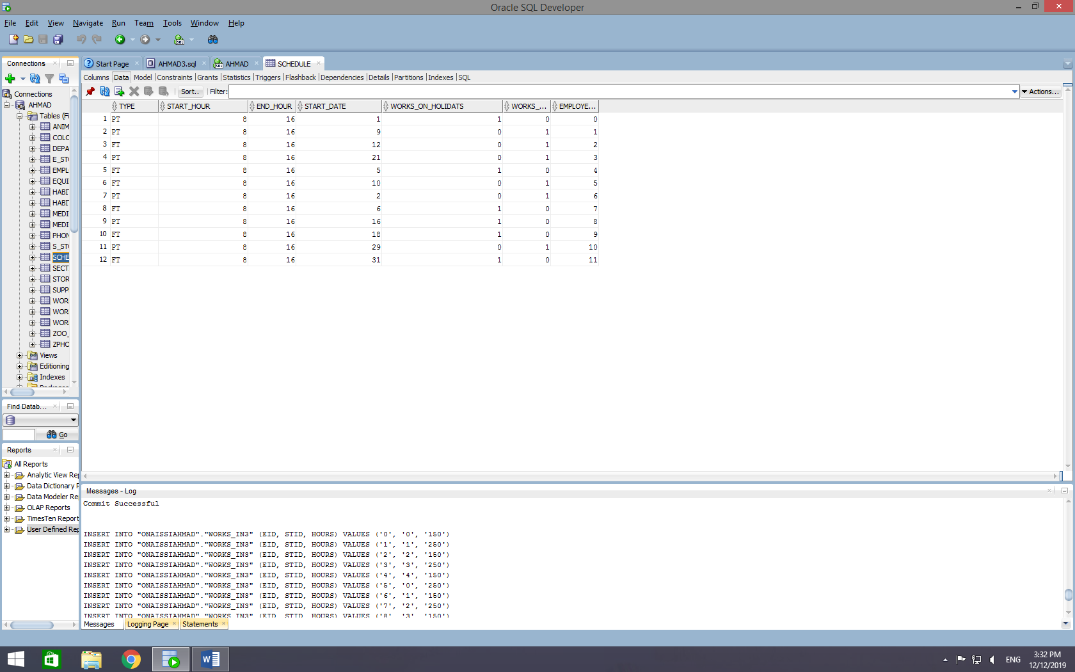

WORKS_FOR

INSERT INTO "ONAISSIAHMAD"."WORKS_FOR" (DNAME, EID, HOURS) VALUES ('IT', '0', '150')

INSERT INTO "ONAISSIAHMAD"."WORKS_FOR" (DNAME, EID, HOURS) VALUES ('HR', '1', '250')

INSERT INTO "ONAISSIAHMAD"."WORKS_FOR" (DNAME, EID, HOURS) VALUES ('ANIMAL PROGRAMS', '2', '150')

INSERT INTO "ONAISSIAHMAD"."WORKS_FOR" (DNAME, EID, HOURS) VALUES ('FINANCES', '3', '250')

INSERT INTO "ONAISSIAHMAD"."WORKS_FOR" (DNAME, EID, HOURS) VALUES ('OPERATION MANAGEMENT', '4', '150')

INSERT INTO "ONAISSIAHMAD"."WORKS_FOR" (DNAME, EID, HOURS) VALUES ('IT', '5', '250')

INSERT INTO "ONAISSIAHMAD"."WORKS_FOR" (DNAME, EID, HOURS) VALUES ('HR', '6', '150')

INSERT INTO "ONAISSIAHMAD"."WORKS_FOR" (DNAME, EID, HOURS) VALUES ('ANIMAL PROGRAMS', '7', '250')

INSERT INTO "ONAISSIAHMAD"."WORKS_FOR" (DNAME, EID, HOURS) VALUES ('FINANCES', '8', '150')

INSERT INTO "ONAISSIAHMAD"."WORKS_FOR" (DNAME, EID, HOURS) VALUES ('OPERATION MANAGEMENT', '9', '250')

INSERT INTO "ONAISSIAHMAD"."WORKS_FOR" (DNAME, EID, HOURS) VALUES ('IT', '10', '150')

INSERT INTO "ONAISSIAHMAD"."WORKS_FOR" (DNAME, EID, HOURS) VALUES ('HR', '11', '250')

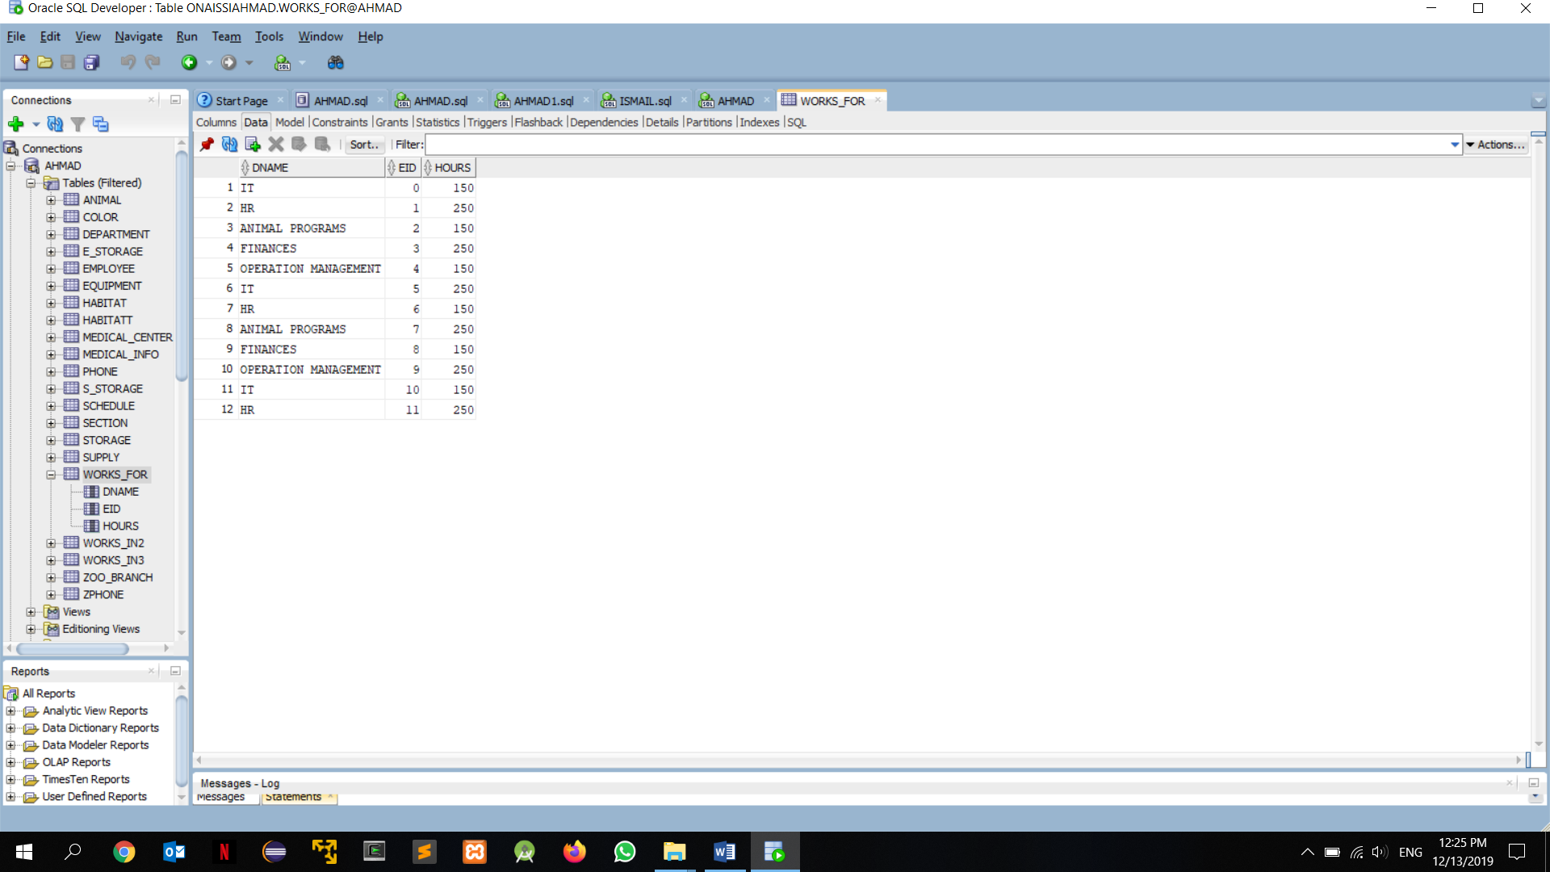

WORKS_IN2

INSERT INTO "ONAISSIAHMAD"."WORKS_IN2" (MCNAME, EID, HOURS) VALUES ('HEALTH CARE', '0', '150')

INSERT INTO "ONAISSIAHMAD"."WORKS_IN2" (MCNAME, EID, HOURS) VALUES ('ICU', '1', '250')

INSERT INTO "ONAISSIAHMAD"."WORKS_IN2" (MCNAME, EID, HOURS) VALUES ('HEALTH CARE', '2', '150')

INSERT INTO "ONAISSIAHMAD"."WORKS_IN2" (MCNAME, EID, HOURS) VALUES ('ICU', '3', '250')

INSERT INTO "ONAISSIAHMAD"."WORKS_IN2" (MCNAME, EID, HOURS) VALUES ('HEALTH CARE', '4', '150')

INSERT INTO "ONAISSIAHMAD"."WORKS_IN2" (MCNAME, EID, HOURS) VALUES ('ICU', '5', '250')

INSERT INTO "ONAISSIAHMAD"."WORKS_IN2" (MCNAME, EID, HOURS) VALUES ('HEALTH CARE', '6', '150')

INSERT INTO "ONAISSIAHMAD"."WORKS_IN2" (MCNAME, EID, HOURS) VALUES ('ICU', '7', '250')

INSERT INTO "ONAISSIAHMAD"."WORKS_IN2" (MCNAME, EID, HOURS) VALUES ('HEALTH CARE', '8', '150')

INSERT INTO "ONAISSIAHMAD"."WORKS_IN2" (MCNAME, EID, HOURS) VALUES ('ICU', '9', '250')

INSERT INTO "ONAISSIAHMAD"."WORKS_IN2" (MCNAME, EID, HOURS) VALUES ('HEALTH CARE', '10', '150')

INSERT INTO "ONAISSIAHMAD"."WORKS_IN2" (MCNAME, EID, HOURS) VALUES ('ICU', '11', '250')

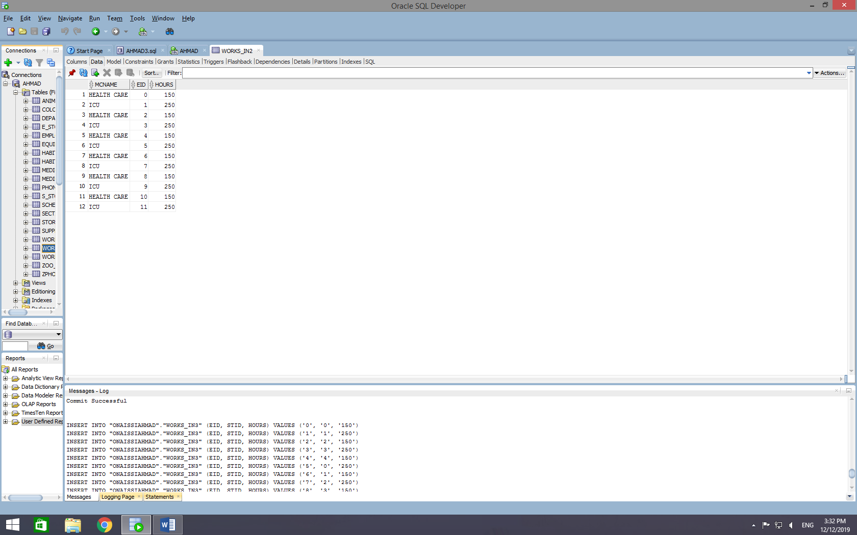

WORKS_IN3

INSERT INTO "ONAISSIAHMAD"."WORKS_IN3" (EID, STID, HOURS) VALUES ('0', '0', '150')

INSERT INTO "ONAISSIAHMAD"."WORKS_IN3" (EID, STID, HOURS) VALUES ('1', '1', '250')

INSERT INTO "ONAISSIAHMAD"."WORKS_IN3" (EID, STID, HOURS) VALUES ('2', '2', '150')

INSERT INTO "ONAISSIAHMAD"."WORKS_IN3" (EID, STID, HOURS) VALUES ('3', '3', '250')

INSERT INTO "ONAISSIAHMAD"."WORKS_IN3" (EID, STID, HOURS) VALUES ('4', '4', '150')

INSERT INTO "ONAISSIAHMAD"."WORKS_IN3" (EID, STID, HOURS) VALUES ('5', '0', '250')

INSERT INTO "ONAISSIAHMAD"."WORKS_IN3" (EID, STID, HOURS) VALUES ('6', '1', '150')

INSERT INTO "ONAISSIAHMAD"."WORKS_IN3" (EID, STID, HOURS) VALUES ('7', '2', '250')

INSERT INTO "ONAISSIAHMAD"."WORKS_IN3" (EID, STID, HOURS) VALUES ('8', '3', '150')

INSERT INTO "ONAISSIAHMAD"."WORKS_IN3" (EID, STID, HOURS) VALUES ('9', '4', '250')

INSERT INTO "ONAISSIAHMAD"."WORKS_IN3" (EID, STID, HOURS) VALUES ('10', '0', '150')

INSERT INTO "ONAISSIAHMAD"."WORKS_IN3" (EID, STID, HOURS) VALUES ('11', '1', '250')

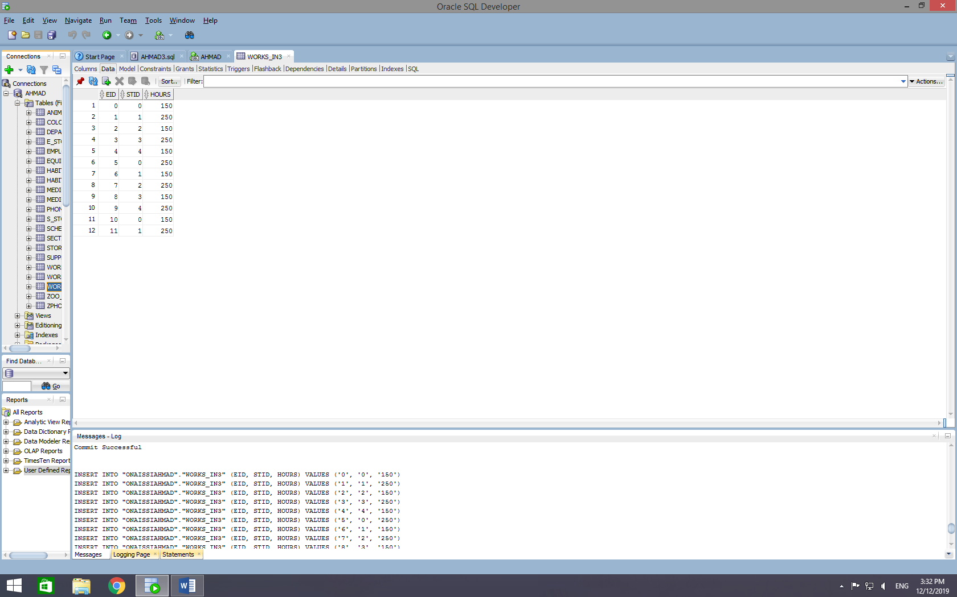

1. **Queries Executed**

Scenario 1:

Due to an electrical mass, all the security doors have been opened as well as habitat doors. Immediately, our board members contacted our DBA and reported a problem. The DBA suggested a solution in which we can retrieve every animal ID, its type and what habitat it belongs to. He issued a query that might help.

Query:

SELECT AID, TYPE, HID

FROM ANIMAL

WHERE HID IN (SELECT HID

FROM HABITATT

WHERE SECTION_NAME IN (SELECT NAME

FROM SECTION

)

)

ORDER BY HID;

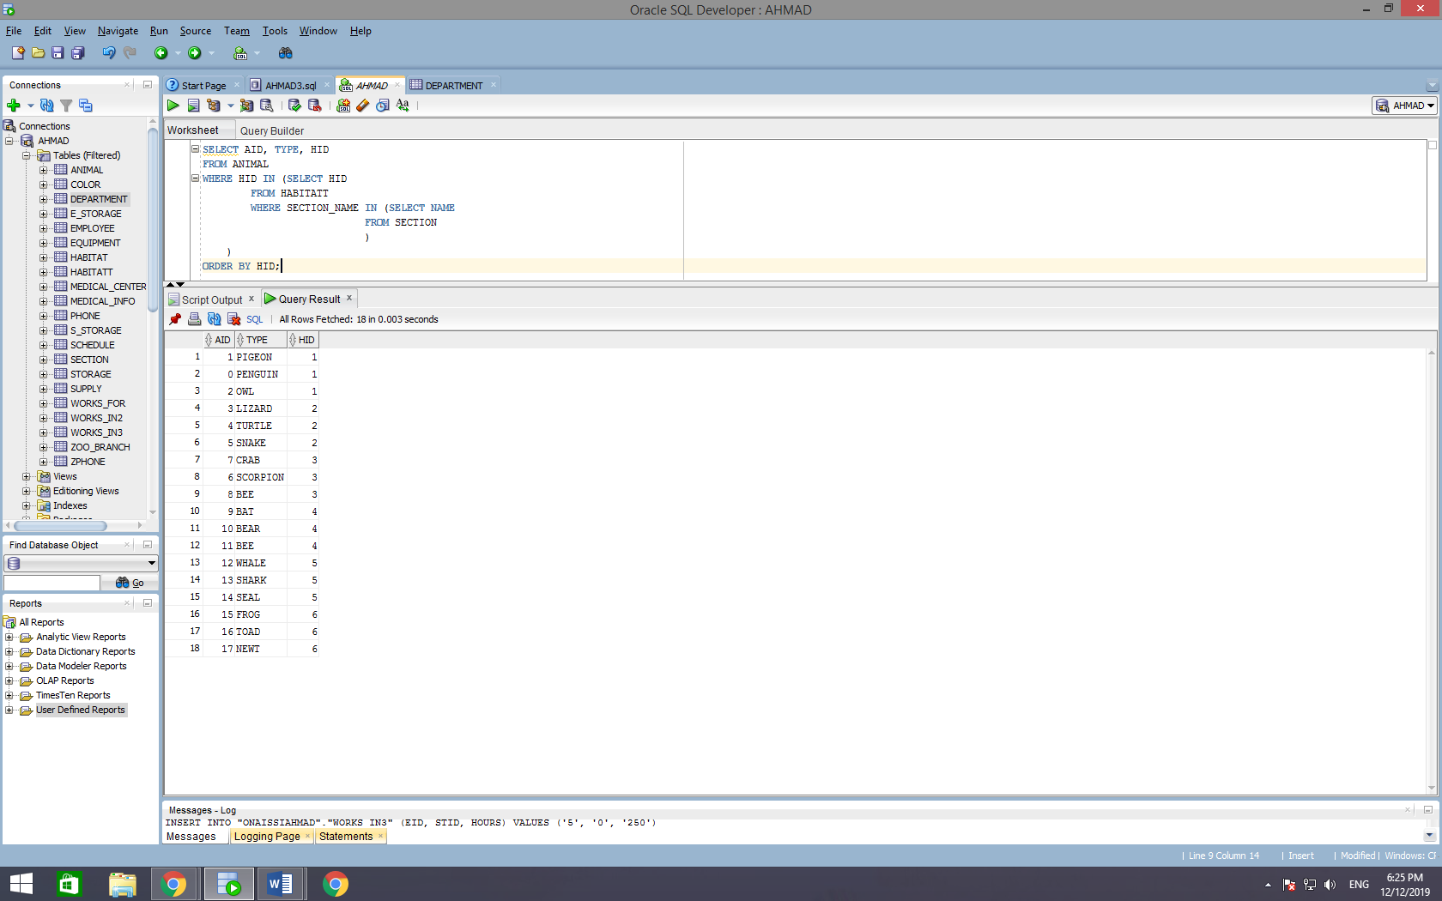

Scenario 2:

The board members of our zoo were invited to a meeting and were given some big news. After many years of waiting for such a news feed, the donators of our zoo have finally considered giving us a bonus of donations. Instead of donation a million dollars each year, they have added another 100 thousand in order to compensate the employees of our zoo. However, the board members thought to themselves, “Why don’t we have a record of the employees that have been working way too many overtimes in the medical centers and have a salary below a 1000$?”. At that time, the DBA enthusiastically said: “Say no more!” and issued this query:

Query:

SELECT FNAME, MINITIAL, LNAME, SALARY

FROM EMPLOYEE, DEPARTMENT, WORKS_FOR

WHERE EMPLOYEE.SALARY < 2000

AND EMPLOYEE.EID = WORKS_FOR.EID

AND WORKS_FOR.DNAME = DEPARTMENT.NAME

AND DEPARTMENT.EXTENSION = '1000';

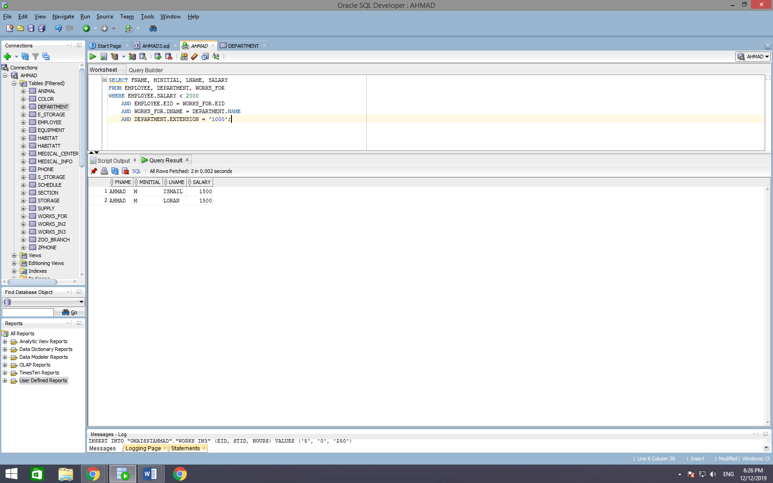

Scenario 3:

One of our medical center recruits have came across a stranded cat, injured and left alone on the pier. His warm heart couldn’t bear the idea of leaving her alone all so small and may or may not die, so he decided to bring her in. After running the medical tests required, the medical team needed to know what animals where of the same blood type and with the same age or older (AB and 6 respectively) so they can donate. The DBA had issued this query hoping he could do his best to help the little kitten.

Query:

SELECT HABITATT.HID, ANIMAL.TYPE, SECTION.NAME

FROM ANIMAL, HABITATT, SECTION

WHERE ANIMAL.HID = HABITATT.HID

AND HABITATT.SECTION_NAME = SECTION.NAME

AND ANIMAL.AID IN (SELECT ANIMAL.AID

FROM ANIMAL, COLOR, MEDICAL_INFO

WHERE ANIMAL.AID = COLOR.AID AND COLOR.COLOR = 'YELLOW' AND MEDICAL_INFO.BLOOD_TYPE = 'A' AND MEDICAL_INFO.VACCINE_TO_TAKE = 'CL'

)

ORDER BY HID;

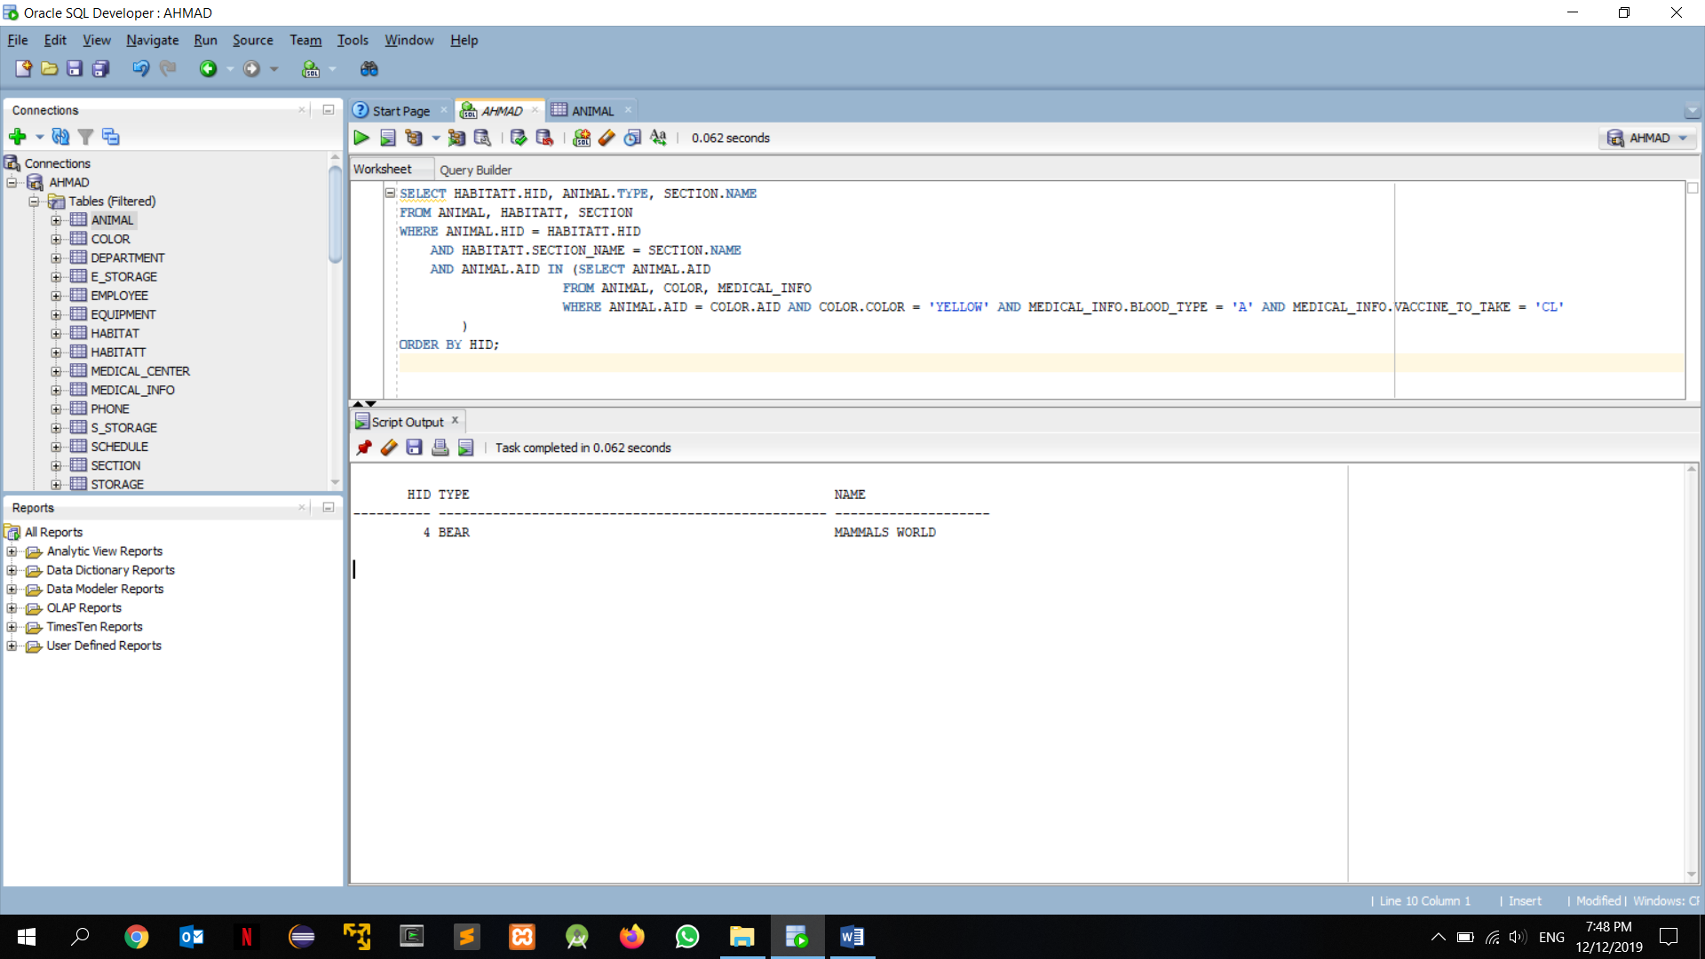

Scenario 4:

Going back to the movie called “Rise of the Planet of the Apes”, we have an animal that doesn’t like to sit still in his habitat, so he always runs away. But unlike the star animal of that movie, the owl that has ran away from its cage, likes to hang out with animals of specific character traits. The animals must have these traits:

* + 1. Blood type: O
    2. Red color
    3. Has no vaccines to take

The DBA issued a query that gets the animals with these specific traits that will surely help locating the missing owl.

Query:

SELECT EMPLOYEE.FNAME, EMPLOYEE.MINITIAL, EMPLOYEE.LNAME, SCHEDULE.START_DATE

FROM EMPLOYEE, SCHEDULE

WHERE EMPLOYEE.EID = SCHEDULE.EMPLOYEE_EID AND SCHEDULE.START_DATE < 17;

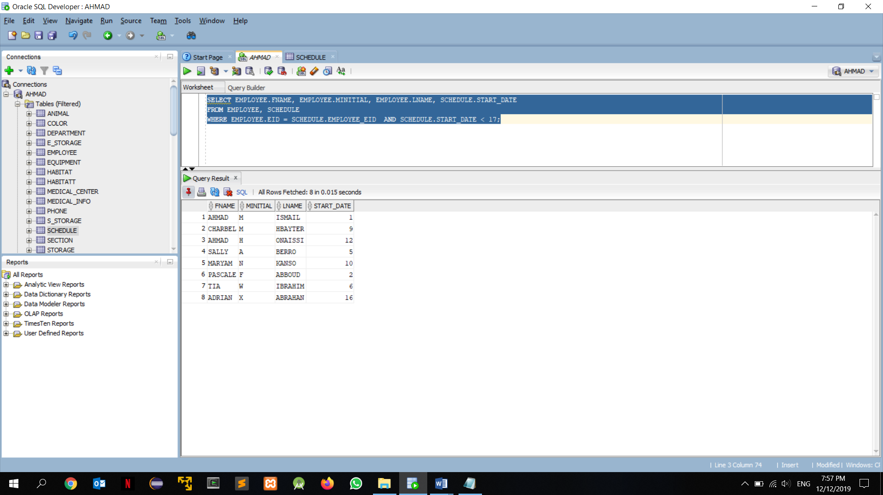

Scenario 5:

A robbery took place in one of our branches after the addition of some new members to the team of employees. The owner of the zoo wants to know the full name of the employees that has been recruited in the last year. The DBA created a query that made him catch some suspects and maybe eventually catch the thief.

Query:

SELECT ANIMAL.AID, ANIMAL.DATE_OF_BIRTH, ANIMAL.AGE, MEDICAL_INFO.BLOOD_TYPE

FROM ANIMAL, MEDICAL_INFO

WHERE ANIMAL.AID = MEDICAL_INFO.AID AND MEDICAL_INFO.BLOOD_TYPE = 'AB' AND ANIMAL.AGE <= 6

ORDER BY AID;

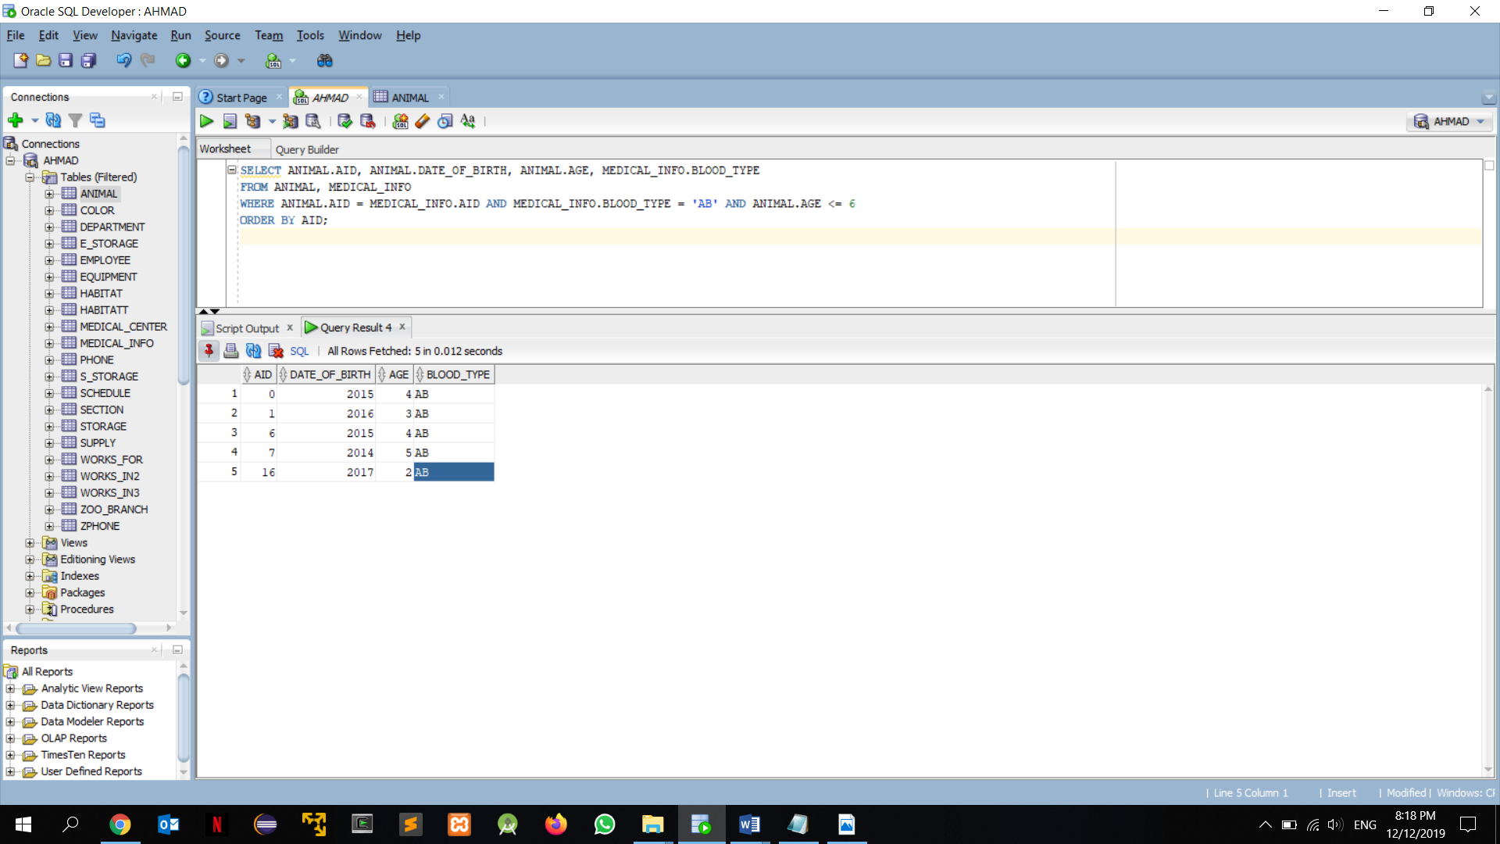

Scenario 6:

The International Animal committee has made their annual tour around the zoos present all around the world so they can see if the zoo is taking well care of their animals. But this time, the committee has more than one condition:

1. They want to know the IDs of all animals that usually live in cold areas
2. They want their blood type to be AB and O specifically
3. They want them to have black, red and brown colors.

Query:

SELECT AID

FROM ANIMAL

MINUS( SELECT ANIMAL.AID

FROM ANIMAL

WHERE ANIMAL.ORIGIN = 'LEBANON' AND ANIMAL.ORIGIN = 'SAUDI ARABIA' AND ANIMAL.ORIGIN = 'AFRICA' AND ANIMAL.ORIGIN = 'DUBAI' AND ANIMAL.ORIGIN = 'ACTIVISION' AND ANIMAL.ORIGIN = 'TEXAS' AND ANIMAL.ORIGIN = 'GOTHAM' AND ANIMAL.ORIGIN = 'RUSSIA' AND ANIMAL.ORIGIN = 'NORWAY' AND ANIMAL.ORIGIN = 'PORTUGAL' AND ANIMAL.ORIGIN = 'FRANCE' AND ANIMAL.ORIGIN = 'GABON'

UNION

SELECT ANIMAL.AID

FROM ANIMAL, MEDICAL_INFO

WHERE ANIMAL.AID = MEDICAL_INFO.AID AND MEDICAL_INFO.BLOOD_TYPE = 'A' AND MEDICAL_INFO.BLOOD_TYPE = 'B'

UNION

SELECT ANIMAL.AID

FROM ANIMAL, COLOR

WHERE ANIMAL.AID = COLOR.AID AND COLOR.COLOR <> 'BLACK' AND COLOR.COLOR <> 'MATTE BLACK' AND COLOR.COLOR <> 'BROWN' AND COLOR.COLOR <> 'RED'

);

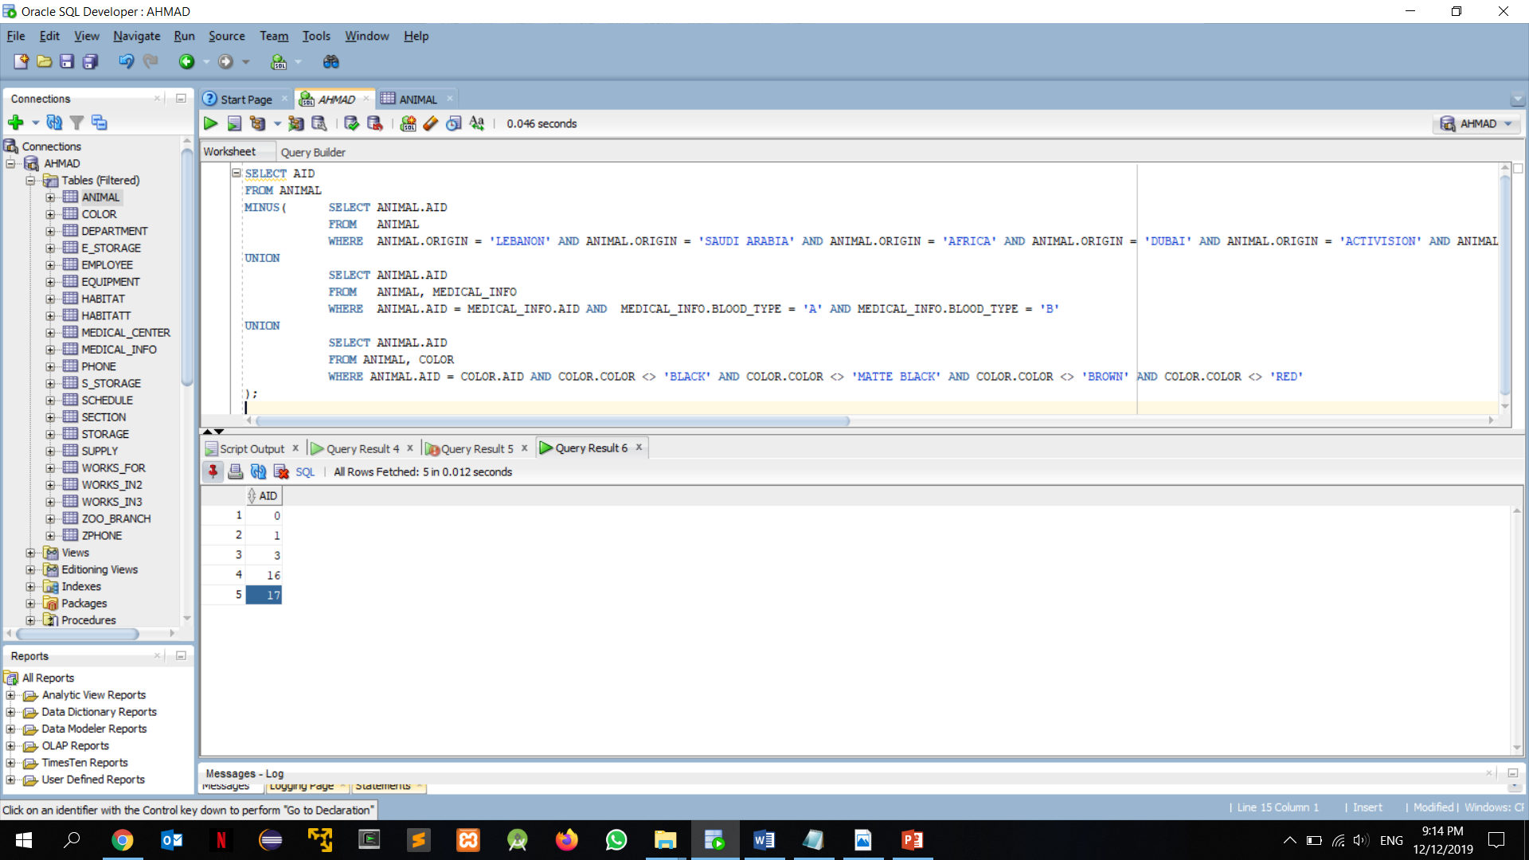

Scenario 7:

Some animals in our zoo were poisoned for some reason. The medical team found out that it was food poison. After several medical tests, they have concluded that the meat was expired. Our board members were very disappointed in which they have contacted the DBA and asked for a query that would retrieve the employees responsible maintaining the storages in where the meat is kept.

Query:

SELECT EMPLOYEE.EID, EMPLOYEE.FNAME, EMPLOYEE.MINITIAL, EMPLOYEE.LNAME

FROM EMPLOYEE

WHERE EID IN ( SELECT WORKS_IN3.EID

FROM EMPLOYEE, WORKS_IN3

WHERE EMPLOYEE.EID = WORKS_IN3.EID AND STID IN (SELECT S_STORAGE.STID

FROM WORKS_IN3, S_STORAGE

WHERE WORKS_IN3.STID=S_STORAGE.STID AND SUID IN (SELECT SUPPLY.SUID

FROM S_STORAGE,SUPPLY

WHERE S_STORAGE.SUID=SUPPLY.SUID AND SUPPLY.TYPE='MEAT')));

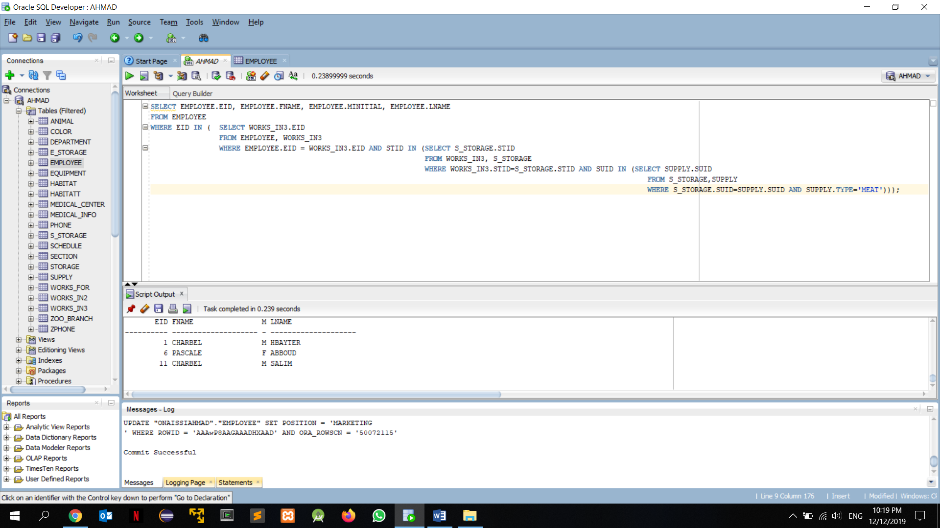

Scenario 8:

Dubai is currently passing through a tough economic crisis. The accountants and financial auditors suggested that we should minimize our expenses and drop the budget allocated to each part of the zoo. The board members agreed on this idea, however, they made some adjustments.

1. Lower the salaries of the new members of the employees’ team
2. Decrease supply and equipment budgets

The DBA issued a query that finds out how much are being spent on new employees, equipment and supplies.

Query: SELECT EMPLOYEE.EID,EMPLOYEE.FNAME,EMPLOYEE.LNAME,ZOO_BRANCH.EMAIL,EMPLOYEE.SALARY

FROM ZOO_BRANCH,EMPLOYEE

WHERE ZOO_BRANCH.LOCATION=EMPLOYEE.ZBLOCATION AND EMPLOYEE.HOURS IN (SELECT EMPLOYEE.HOURS

FROM EMPLOYEE

WHERE EMPLOYEE.HOURS>='250' AND EMPLOYEE.ZBLOCATION='LONDON'

GROUP BY EMPLOYEE.HOURS);

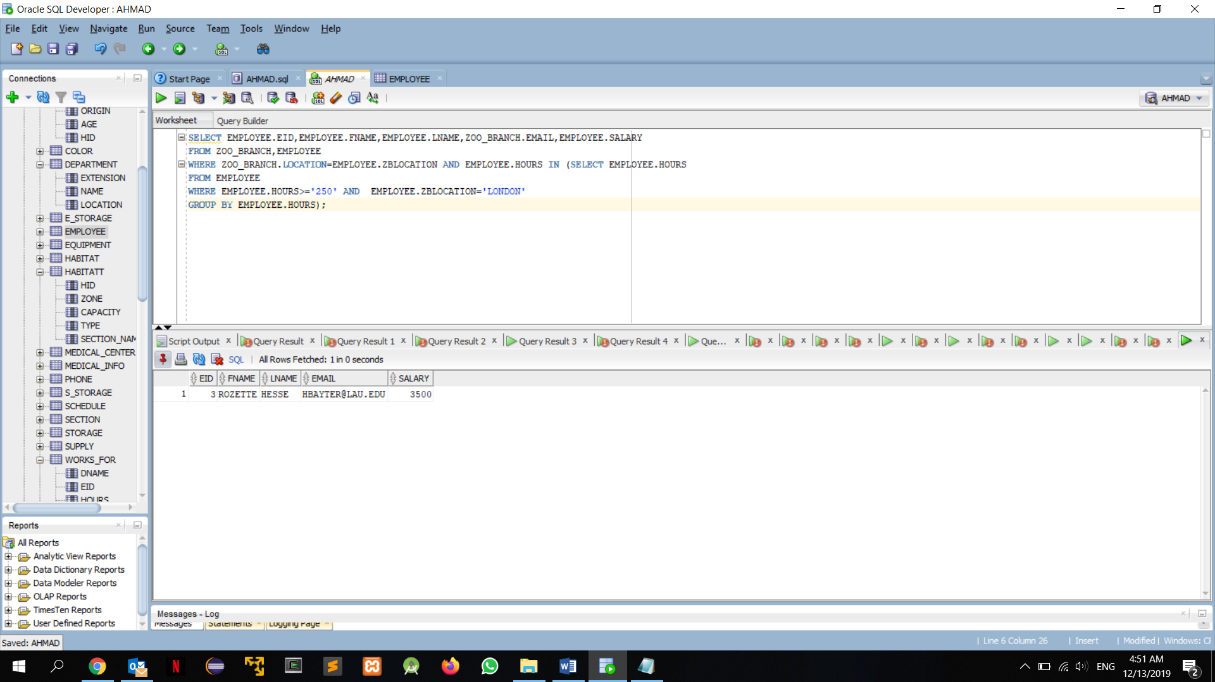

Scenario 9:

Our zoologists have brought in a new animal which has a humungous size. Unfortunately, the bear we just had cannot fit in its usual section “MAMMALS WORLD” therefore we decided to choose a new territory for it to fit. Luck was on our side and had another section that could fit it nearby. Our employees checked the “REPTILES WORLD” and checked if there were any other places for it.

Query:

SELECT COUNT(*)

FROM HABITATT, SECTION

WHERE HABITATT.ZONE > 130 AND SECTION.NAME = 'REPTILES WORLD' AND HABITATT.SECTION_NAME = SECTION.NAME;

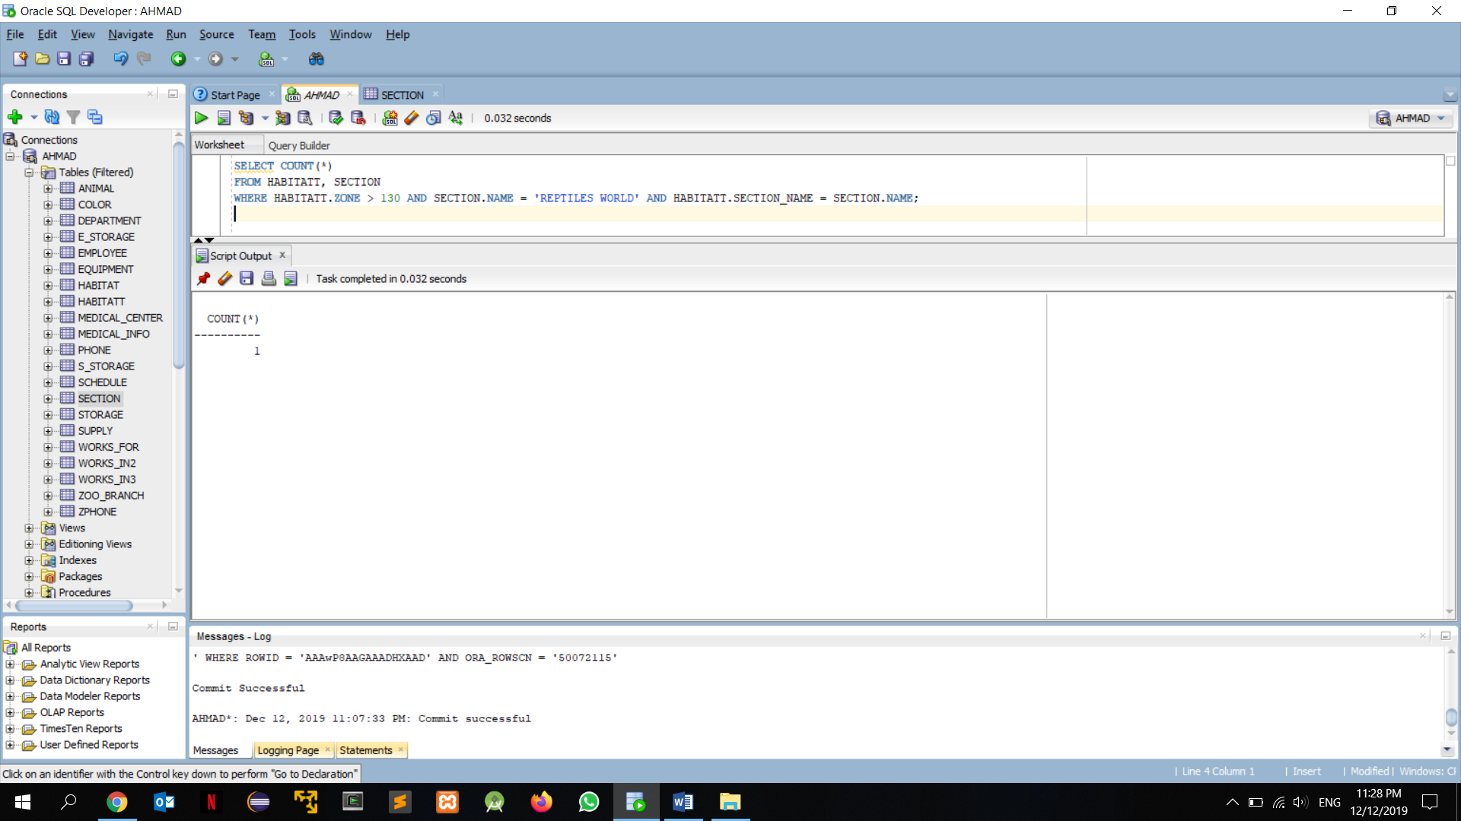

Scenario 10:

The manager got some good news where he got a bonus on the budget. Every once in a while, the manager asks the DBA to construct a query that lets him know if any habitat is understaffed so he could hire another employee to fill in the empty spot. This time, the manager wanted another checkup on a shorter notice but the DBA was well prepared.

Query:

SELECT HABITATT.HID,COUNT(EMPLOYEE.EID)

FROM EMPLOYEE,SECTION,HABITATT

WHERE EMPLOYEE.ZBLOCATION=SECTION.ZBLOCATION AND SECTION.NAME=HABITATT.SECTION_NAME AND SECTION.ZBLOCATION IN(

SELECT SECTION.ZBLOCATION

FROM SECTION,HABITATT

WHERE SECTION.NAME=HABITATT.SECTION_NAME AND HABITATT.SECTION_NAME IN(SELECT HABITATT.SECTION_NAME

FROM HABITATT))GROUP BY HABITATT.HID

ORDER BY HABITATT.HID;

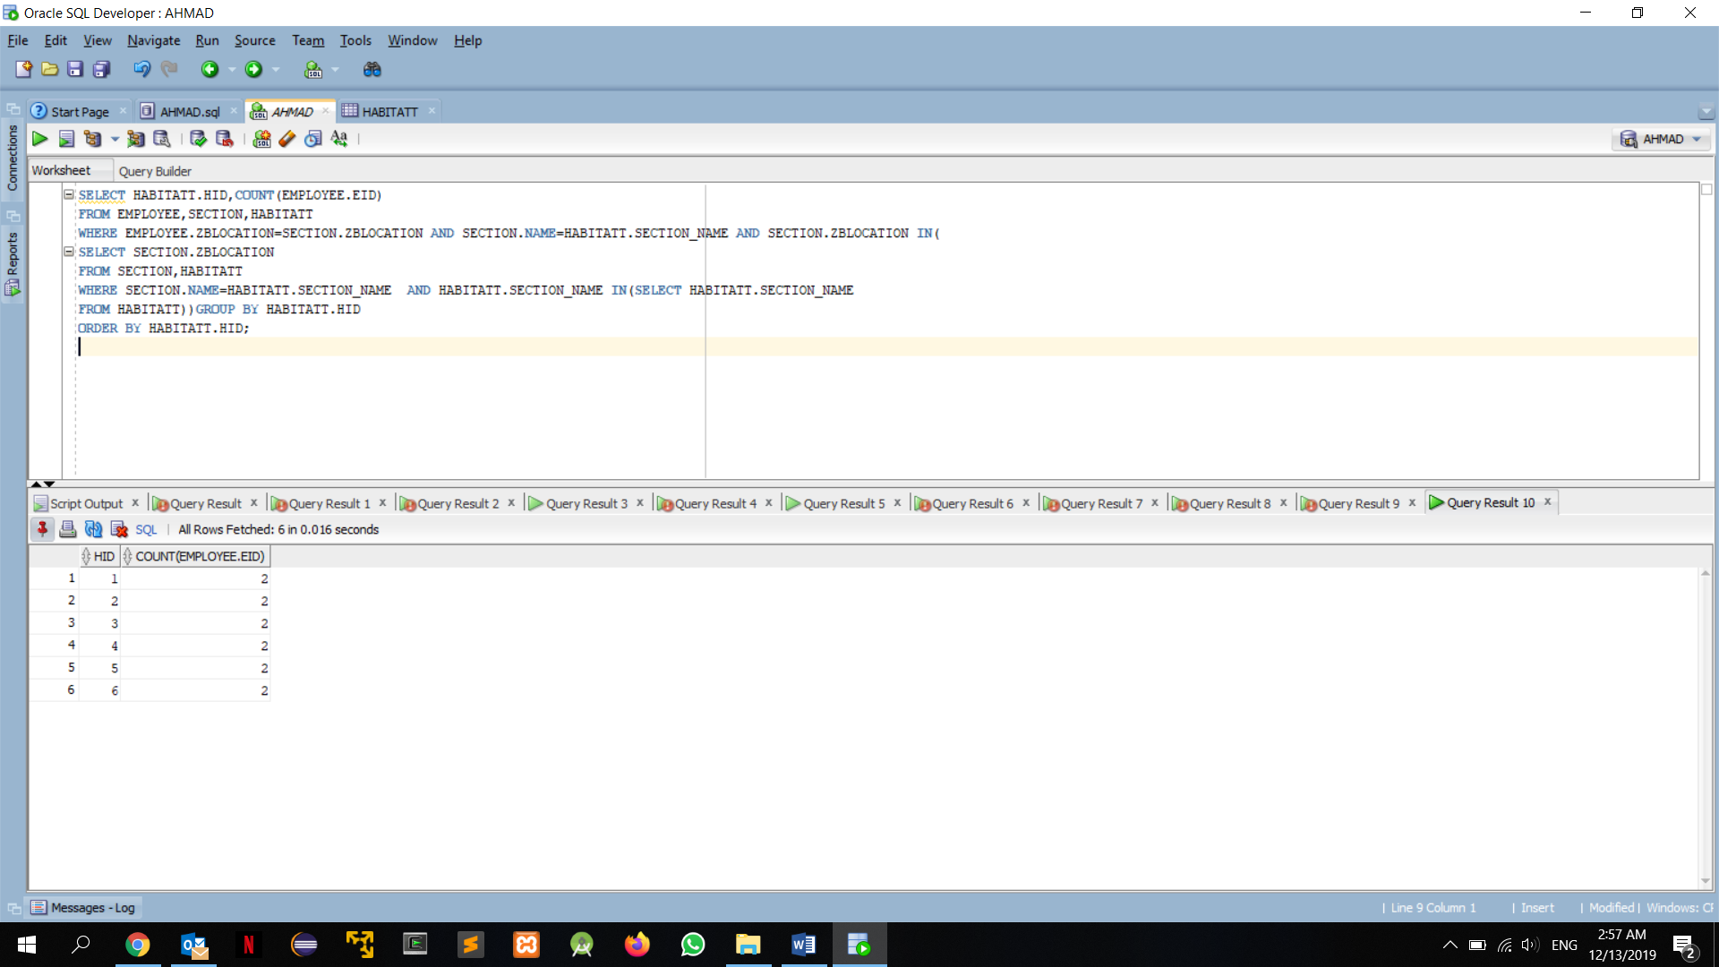

1. **Normalization**

**EMPLOYEE**

FD1

|  |  |  |  |  |  |  |  |  |  |  |  |
| --- | --- | --- | --- | --- | --- | --- | --- | --- | --- | --- | --- |
| EID | Date_Of_Birth | Country | City | Street | Building | Floor | | Status | Salary | | Sex |
| FName | MInitial | LName | Position | Hours | Type_Of_Work | | ZBLocation | | |

FD1

* **1NF is satisfied in EMPLOYEE since there is no multivalued or composite attribute in this entity.**
* **As for the 2NF all attributes depend on the Primary key EID and if the primary key is dropped the FD cannot hold.**
* **3NF is satisfied since there is no Transitive Functional Dependency in the entity EMPLOYEE, no non-prime attribute is transitively dependent on the primary key EID.**
* **This entity satisfies the 3NF and has no FD X->A such that X is not a super key thus the BCNF is satisfied.**

**ANIMAL**

**FD2 FD3**

|  |  |  |  |  |  |  |  |  |
| --- | --- | --- | --- | --- | --- | --- | --- | --- |
| AID | Date_Of_Birth | Residency | Age | Origin | Sex | Name | Type | HID |

**FD1**

* **1NF is satisfied in ANIMAL since there is no multivalued or composite attribute in this entity.**
* **Since 1NF is satisfied and all the non-prime attributes are fully dependent on the primary key AID thus the 2NF is satisfied.**
* **For the 3NF we know that there is a functional dependency between HID and TYPE**

**HID->TYPE but since neither HID is a super key nor TYPE is a prime attribute as well for the DATE_OF_BIRTH->AGE since DATE_OF_BIRTH is not a super key and AGE is a prime attribute then the 3NF is not satisfied.**

**ANIMAL-A**

|  |  |  |  |  |  |  |
| --- | --- | --- | --- | --- | --- | --- |
| AID | Residency | Origin | Sex | Name | HID | Date_Of_Birth |

**FD1**

**ANIMAL-B**

|  |  |
| --- | --- |
| Date_Of_Birth | Age |

**FD1**

**ANIMAL-C**

|  |  |
| --- | --- |
| HID | Type |

**FD1**

* **After the separation, the BCNF is satisfied since as we can see, in each table the FD X->A where X is a super key is satisfied.**

**SUPPLY**

|  |  |  |  |
| --- | --- | --- | --- |
| SUID | Type | Cost_Per_Item | Expiry_Date |

**FD1**

* **In the SUPPLY table there is no multivalued and composite attribute thus 1NF is satisfied.**
* **Since 1NF is satisfied and all Non-prime attributes are Fully Functional Dependent on the primary key SUID then the 2NF is satisfied.**
* **In the SUPPLY table the conditions are satisfied for the 3NF because it satisfies the 2NF and there are no nonprime attributes that are transitively dependent on the primary key SUID.**
* **The BCNF is satisfied since the 3NF is satisfied and There exists no FD X->A where X is not a super key.**

**STORAGE**

**FD2**

|  |  |  |  |
| --- | --- | --- | --- |
| STID | Space | Used_Space | Available_Space |

**FD1**

* **1NF is satisfied in STORAGE since there is no multivalued or composite attribute in this entity.**
* **Since 1NF is satisfied and all Non-prime attributes are Fully Functional Dependent on the primary key STID then the 2NF is satisfied.**
* **For the 3NF, There is a Functional Dependency between USED_SPACE AND AVAILABLE_SPACE-> SPACE and USED_SPACE AND AVAILABLE_SPACE are not super keys and SPACE is not a prime attribute thus the table should be separated.**

**STORAGE-A**

|  |  |  |
| --- | --- | --- |
| STID | Used_Space | Available_Space |

**FD1**

|  |  |  |
| --- | --- | --- |
| Space | Used_Space | Available_Space |

**FD1**

* **After the separation the BCNF is satisfied since as we can see, In each table the FD X->A where X is a super key is satisfied.**

**EQUIPMENT**

|  |  |  |  |  |
| --- | --- | --- | --- | --- |
| S/N | Maintenance | Cost_Per_Item | Type | Date_Of_Purchase |

**FD1**

* **1NF is satisfied in EQUIPMENT since there is no multivalued or composite attribute in this entity.**
* **As for the 2NF all attributes depend on the Primary key SERIAL NUMBER and if the primary key is dropped the attributes cannot hold.**
* **In the SUPPLY table the conditions are satisfied for the 3NF because it satisfies the 2NF and there are no nonprime attributes that are transitively dependent on the primary key .**
* **The BCNF is satisfied since the 3NF is satisfied and There exists no FD X->A where X is not a super key.**

**DEPARTMENT**

|  |  |  |
| --- | --- | --- |
| Extension | Name | Location |

**FD1**

* **In the DEPARTMENT table there is no multivalued and composite attribute thus 1NF is satisfied.**
* **The 2NF is not satisfied since we have two primary keys EXTENSION and NAME such that {EXTENSION,NAME}->LOCATION but if EXTENSION is dropped NAME->LOCATION still holds.**

**Department-A**

|  |  |
| --- | --- |
| Name | Location |

**FD1**

**Department-B**

|  |  |
| --- | --- |
| Extension | Name |

* **After separation of the table the 2NF is satisfied and 3NF is satisfied too since every FD X->A X is a super key or A is prime attribute and there is no transitively dependent function in these tables.**
* **BCNF is satisfied since there is no FD X->A such that X is a not a super key.**

**ZOO_BRANCH**

|  |  |  |  |
| --- | --- | --- | --- |
| Location | Zone | Email | Type |

**FD1**

* **1NF is satisfied in ZOO_BRANCH since there is no multivalued or composite attribute in this entity.**
* **Since 1NF is satisfied and all Non-prime attributes are Fully Functional Dependent on the primary key LOCATION then the 2NF is satisfied.**
* **In the ZOO_BRANCH table the conditions are satisfied for the 3NF because it satisfies the 2NF and there are no nonprime attributes that are transitively dependent on the primary key LOCATION.**
* **BCNF is satisfied since there is no FD X->A such that X is a not a super key.**

**SECTION**

|  |  |  |  |
| --- | --- | --- | --- |
| Number | Name | Zone | ZBLocation |

**FD1**

* **In the SECTION table there is no multivalued and composite attribute thus 1NF is satisfied.**
* **Since 1NF is satisfied and all Non-prime attributes are Fully Functional Dependent on the primary key SEC_NUMBER then the 2NF is satisfied.**
* **In the SECTION table the conditions are satisfied for the 3NF because it satisfies the 2NF and there are no nonprime attributes that are transitively dependent on the primary key SEC_NUMBER.**
* **BCNF is satisfied since there is no FD X->A such that X is a not a super key.**

**HABITAT**

|  |  |  |  |  |
| --- | --- | --- | --- | --- |
| HID | Capacity | Type | Zone | Section_Name |

**FD1**

* **1NF is satisfied in HABITAT since there is no multivalued or composite attribute in this entity.**
* **Since 1NF is satisfied and all Non-prime attributes are Fully Functional Dependent on the primary key HID then the 2NF is satisfied.**
* **In the HABITAT table the conditions are satisfied for the 3NF because it satisfies the 2NF and there are no nonprime attributes that are transitively dependent on the primary key HID.**
* **BCNF is satisfied since there is no FD X->A such that X is a not a super key.**

**MEDICAL_CENTER**

**FD2**

|  |  |  |  |  |  |
| --- | --- | --- | --- | --- | --- |
| Extension | Name | Number_Of_Room | Total_Number_Of_Rooms | Rooms_Used | Rooms_Available |

**FD1**

* **1NF is satisfied in MEDICAL_CENTER since there is no multivalued or composite attribute in this entity.**
* **The 2NF is not satisfied since we have two primary keys EXTENSION and NAME such that {EXTENSION,NAME}-> TOTAL_NUMBER_OF_ROOMS but if EXTENSION is dropped NAME-> TOTAL_NUMBER_OF_ROOMS still holds.**

**MEDICAL_CENTER-A**

|  |  |
| --- | --- |
| Extension | Name |

**MEDICAL_CENTER-B**

**FD2**

|  |  |  |  |  |
| --- | --- | --- | --- | --- |
| Name | Number_Of_Room | Total_Number_Of_Rooms | Rooms_Used | Rooms_Available |

**FD1**

* **After separation of the table, in MEDICAL_CENTER1 we have an FD such that {ROOMS_USED,ROOMS_AVAILABLE}->TOTAL_NUMBER_OF_ROOMS which we know that {ROOMS_USED,ROOMS_AVAILABLE} is not a super key neither TOTAL_NUMBER_OF_ROOMS is a prime attribute thus 3NF is not satisfied.**

**MEDICAL_CENTER-C**

|  |  |  |  |
| --- | --- | --- | --- |
| Name | Number_Of_Room | Rooms_Used | Rooms_Available |

**FD1**

**MEDICAL_CENTER-D**

|  |  |  |
| --- | --- | --- |
| Total_Number_Of_Rooms | Rooms_Used | Rooms_Available |

**FD1**

* **After the separation the BCNF is satisfied for all the tables of MEDICAL_CENTER since as we can see, In each table the FD X->A where X is a super key is satisfied.**

**MEDICAL_INFO**

**FD2**

|  |  |  |  |  |  |  |  |
| --- | --- | --- | --- | --- | --- | --- | --- |
| MEDID | Blood_Type | Height | Weight | Vaccine_Taken | Vaccine_To_Take | Medical_Center_Name | AID |

**FD1**

* **1NF is satisfied in MEDICAL_INFO since there is no multivalued or composite attribute in this entity.**
* **Since 1NF is satisfied and all Non-prime attributes are Fully Functional Dependent on the primary key HID then the 2NF is satisfied.**
* **For the 3NF we know that there is a FD VACCINE_TO_TAKE-> VACCINE_TAKEN and neither VACCINE_TO_TAKE is super key nor VACCINE_TAKEN is a prime attribute thus the 3NF is not satisfied and the table should be separated.**

**MEDICAL_INFO-A**

|  |  |  |  |  |  |  |
| --- | --- | --- | --- | --- | --- | --- |
| MEDID | Blood_Type | Height | Weight | Medical_Center_Name | AID | Vaccine_To_Take |

**FD1**

**MEDICAL_INFO-B**

|  |  |
| --- | --- |
| Vaccine_To_Take | Vaccine_Taken |

**FD1**

* **After the separation the BCNF is satisfied for all the tables of MEDICAL_INFO since as we can see, in each table the FD X->A where X is a super key is satisfied.**

**SCHEDULE**

|  |  |  |  |  |  |  |
| --- | --- | --- | --- | --- | --- | --- |
| EID | Start_Date | Type | Works_On_Weekends | Works_On_Holidays | Start_Hour | End_Hour |

**FD1**

* **In the SCHEDULE table there is no multivalued and composite attribute thus 1NF is satisfied.**

**SCHEDULE-A**

|  |  |
| --- | --- |
| EID | Start_Date |

**SCHEDULE-B**

|  |  |  |  |  |  |
| --- | --- | --- | --- | --- | --- |
| EID | Type | Works_On_Weekends | Works_On_Holidays | Start_Hour | End_Hour |

**FD1**

* **The 2NF is not satisfied since we have two primary keys EID and START_DATE but if START_DATE is dropped the FD still holds.**
* **In the SHCEDULE table the conditions are satisfied for the 3NF because it satisfies the 2NF and there are no nonprime attributes that are transitively dependent on the primary keys.**
* **BCNF is satisfied since there is no FD X->A such that X is a not a super key.**

**S_STORAGE**

|  |  |  |
| --- | --- | --- |
| SUID | STID | Quantity |

**FD1**

* **In the S_STORAGE table there is no multivalued and composite attribute thus 1NF is satisfied.**
* **Since 1NF is satisfied and all Non-prime attributes are Fully Functional Dependent on the primary key STID and SUID then the 2NF is satisfied.**
* **In the S_STORAGE table the conditions are satisfied for the 3NF because it satisfies the 2NF and there are no nonprime attributes that are transitively dependent on the primary key STID and SUID.**
* **BCNF is satisfied since there is no FD X->A such that X is a not a super key.**

**E_STORAGE**

|  |  |  |
| --- | --- | --- |
| STID | Serial_Number | Quantity |

**FD1**

* **In the E_STORAGE table there is no multivalued and composite attribute thus 1NF is satisfied.**
* **Since 1NF is satisfied and all Non-prime attributes are Fully Functional Dependent on the primary key STID and SERIAL_NUMBER then the 2NF is satisfied.**
* **In the E_STORAGE table the conditions are satisfied for the 3NF because it satisfies the 2NF and there are no nonprime attributes that are transitively dependent on the primary key STID and SERIAL_NUMBER.**
* **BCNF is satisfied since there is no FD X->A such that X is a not a super key.**

**WORKS_IN3**

|  |  |  |
| --- | --- | --- |
| EID | STID | Hours |

**FD1**

* **In the WORKS_IN3 table there is no multivalued and composite attribute thus 1NF is satisfied.**
* **As for the 2NF all attributes depend on the Primary keys EID and STID and if one primary key is dropped the FD cannot hold.**
* **3NF is satisfied since there is no Transitive Functional Dependency in the entity WORKS_IN3, no non-prime attribute is transitively dependent on the primary keys STID and EID.**
* **BCNF is satisfied since there is no FD X->A such that X is a not a super key.**

**WORKS_FOR**

|  |  |  |
| --- | --- | --- |
| EID | DNAME | Hours |

**FD1**

* **In the WORKS_FOR table there is no multivalued and composite attribute thus 1NF is satisfied.**
* **As for the 2NF all attributes depend on the Primary keys EID and DName and if one primary key is dropped the FD cannot hold.**
* **3NF is satisfied since there is no Transitive Functional Dependency in the entity WORKS_FOR, no non-prime attribute is transitively dependent on the primary keys DName and EID.**
* **BCNF is satisfied since there is no FD X->A such that X is a not a super key.**

**WORKS_IN2**

|  |  |  |
| --- | --- | --- |
| EID | MCNAME | Hours |

**FD1**

* **In the WORKS_IN2 table there is no multivalued and composite attribute thus 1NF is satisfied.**
* **As for the 2NF all attributes depend on the Primary keys EID and MCName and if one primary key is dropped the FD cannot hold.**
* **3NF is satisfied since there is no Transitive Functional Dependency in the entity WORKS_IN2, no non-prime attribute is transitively dependent on the primary keys MCName and EID.**
* **BCNF is satisfied since there is no FD X->A such that X is a not a super key.**

**COLOR**

|  |  |
| --- | --- |
| AID | Color |

* **Does not have non-prime attributes**

**ZPHONE**

|  |  |
| --- | --- |
| Phone | ZBLocation |

* **Does not have non-prime attributes**

**PHONE**

|  |  |
| --- | --- |
| Phone | EID |

* **Does not have non-prime attributes**